Dalmellington PS Homework Survey 2022
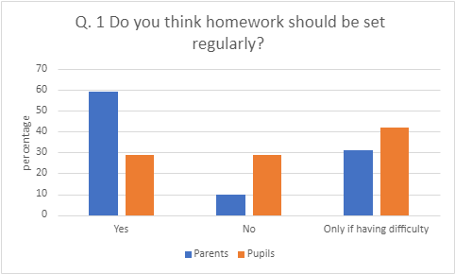
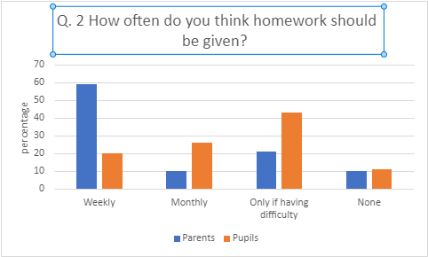
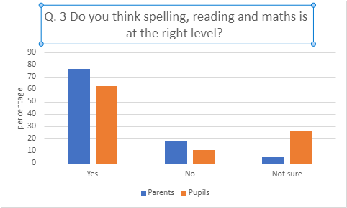
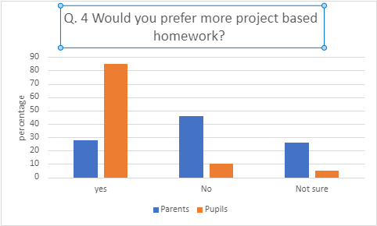
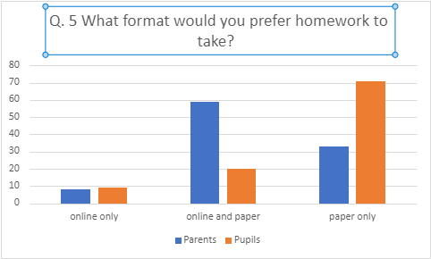
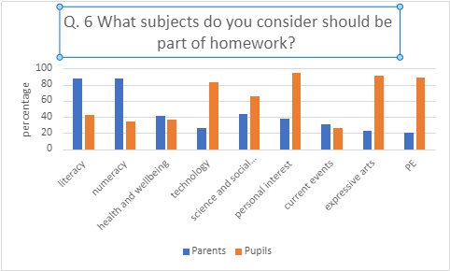
Parent Comments
Feel kids homework should consist of like health and well being like go walk with family. Learn life long skills like first aid lifesupport etc skills which are not currently taught in curriculum
Homework can be a battle particularly for working parents who sometimes are trying to persuade their child to do homework later at night as that is when they are home and able to help. Concentration should be on maths, reading and spelling not making posters etc
Nothing to say
I think homework is a good thing, but I think maybe the amount expected is a bit much ( age depending) my son (age5/6) can be challenging and have zero interest in homework esp after his long day at school.
Children do enough work at school within the hours provided. As a household of two working parents of long hours we find it very unnecessary to to be sitting doing homework with our child when we haven’t seen them all day.
I personally think P1 get for to much homework to be done between a Tuesday and Thursday especially for us working parents who's not home everynight
It certainly helps when homework is issued on a Monday and due in on a Friday especially with working parents and various after school clubs.
Homework takes about 20 minutes per week. Very repetitive- same tasks being set every week, no variety. Should be more.
After being at school all day I feel some weeks its not achievable. Other interests outside school and a busy family life can lead to homework being a stressful time.
Homework always sparks arguments. I have no idea how to teach. Not much guidance on homework.
Personally I think homework should be a group of homework class after school possibly from 3 to 4 2 days a week. Children learn more in a school environment an after school homework club would be ideal
I think for younger children homework need to be fun especially if they r already hating school or struggling to do the work
Children’s Comments
science make something explode
wildlife topic
reading to your parents
Science
Online
science, art and reading
project would be fun to experience new things
flipping the learning
more time for homework due to busy weeks
learning different languages
outdoor learning
clubs
free choice reading
grid to pick activities from
homework too easy
1 homework free week every week

