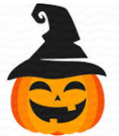
Dalmellington Primary School and ECC
Halloween Homework Challenge

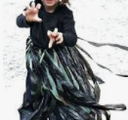
In a dark dark village
Was a dark dark street.
In the dark dark street
Was a dark dark school.
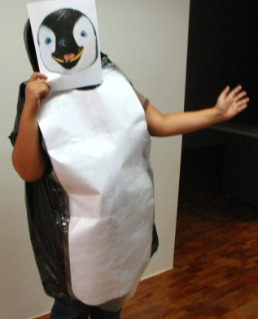
In the dark dark school
There were dark dark classrooms.
In the dark dark classrooms
Some little monsters learned…
…All about Halloween.

To replace our normal homework, this week we are setting a whole school Halloween Homework Challenge.
We are hoping our pupils can use their creative skills to make their own Halloween costume using a black bin bag and other recycled materials found around the home.
We would ask that photographs of pupils wearing their finished costumes are sent into class no later than Thursday 28th October 2021.
Photos for Primary 6/7 can be sent to either claire.stevenson@eastayrshire.org.uk or tracy.wallace@eastsyrshire.org.uk or uploaded to our Class Team on Glow.
You can also upload your photograph to our school Twitter page @DalmellingtonPS using the hashtag #ZeroWasteHalloween.

We cannot wait to see the spooktactular designs!

