September You said …. We did
Primary
Thank you for your feedback to our September evaluation question. Here is the feedback received.
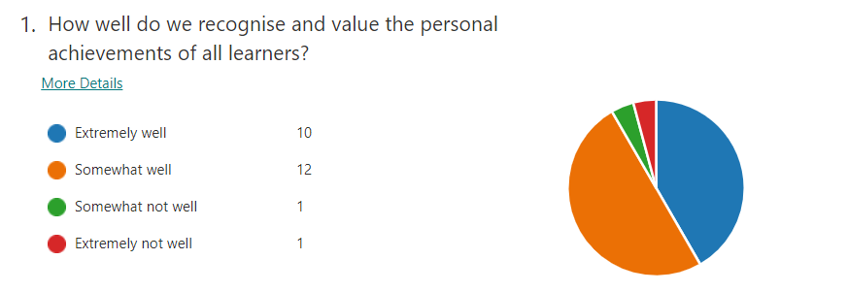
- From the feedback we received we have created a wider achievement display to recognize pupils’ achievements at home.
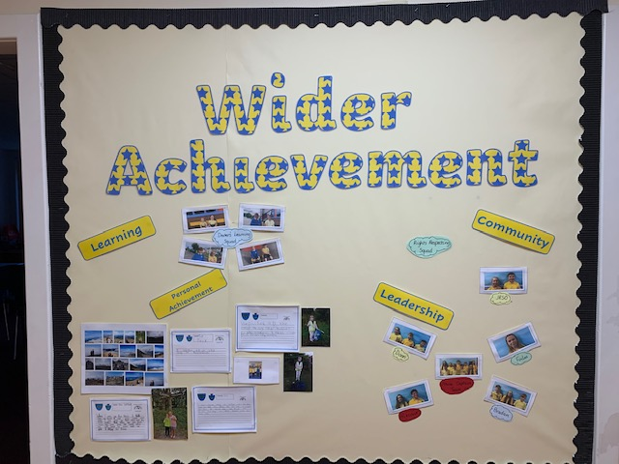
- We have introduced House Point Competitions throughout the session with a wider focus for pupils’ achievements.
Term 1 – Maths Quiz and Art Competitions
Term 2 – Literacy and Expressive Arts Competitiona
Term 3 – Spelling Quiz and Sports Day
- Introduced a tracking sheet to ensure all children’s work is shared on the What’s On over the session.

ECC

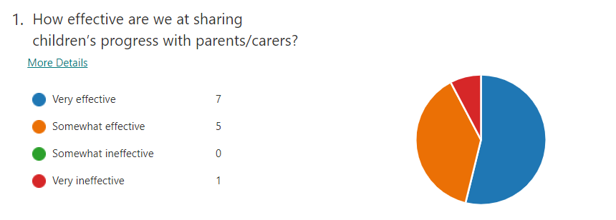
We will continue to look at how we use the learning journals to share information on children’s progress.

