Primary 2/3 Term 1

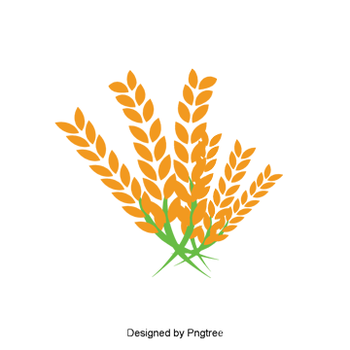

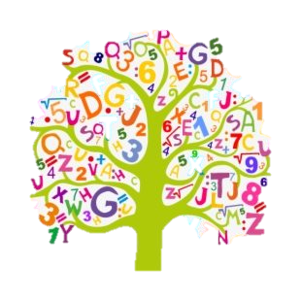

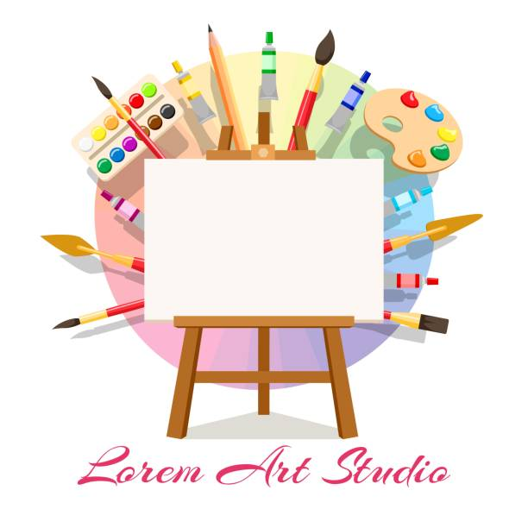

**The Curriculum**

The totality of all that is planned for children and young people throughout their education.

Flower Show Artwork on display

Involvement in our Harvest Assembly

Involvement in our class introduction video

Actively involved on the class blog

Personal targets discussed

Outdoor learning

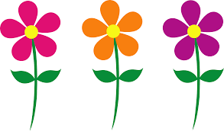

**Curriculum areas and subjects**

**Ethos and life of the school as a community**

**Opportunities for personal achievement**

**Interdisciplinary Learning**

Numeracy – One more/One Less

Place Value

Numbertalks

Literacy – Phonics

Writing

Health and Wellbeing – PATHs

SHANARRI

Modern Languages – French

Artwork displayed in community

Participation in the school Harvest assembly

Pupils work shared on weekly roundup and blog

Participation in class introduction video

Ben and the Three Bears

The Day the Crayon Quit

The Owl who was Afraid of the dark

Transport

Harvest

Significant individuals

Human Body

Nativity