Primary 1

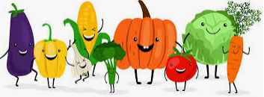



Flower Show Artwork on display

Taking part in our Harvest assembly

Taking part in our class introduction video

Being included on the class blog

Target setting discussions

**Curriculum areas and subjects**

**Ethos and life of the school as a community**

**Opportunities for personal achievement**

**Interdisciplinary Learning**

**The Curriculum**

The totality of all that is planned for children and young people throughout their education.

All About Me

The Very Hungry Caterpillar / Mini-beasts

People Who Help Us

Harvest

Noah’s Ark / The Story of Moses



Phonics / Rhyme / Syllables

Number / Patterns / Money

PAThS

STEM

SHANARRI

Learning New Routines

Our art work is on display in our community

We are taking part in the school Harvest assembly

Our class is included in the weekly roundup and on Twitter

We will be part of our class introduction video