P2/3 Remote Learning 16:03:21

Please find below the Learning Grid for Tuesday through to Thursday below.
If there are any questions or problems please email at the address below and I will do my best to help. Any e-mailed completed work task would be greatly appreciated.
Take care and stay safe.
Mrs Gormanley.

eaagnes.gormanley@glow.sch.uk

Literacy | Numeracy | Other Curricular Areas
Writing  Write a description of The Wonky Donkey. Give your writing a title. Write at least 4 sentences beginning with noun, pronoun, pronoun, noun.  e.g. The Wonky Donkey…….  He………  He………  The Wonky Donkey……  Think about number, colour, shape and size for each of the sentences. Remember Capital letters and Full Stops. Write independently using Fred Spelling. Read over your writing to check your work.  Spelling  Check up on how well you can spell Red Tricky Words independently.  http://www.tarvin.cheshire.sch.uk/serve_file/164219  10 words from SET 1 or  Chilli Challenge – 15 words from SET 2  Giglets  Log in to check for your individual reading books this week. Click the Library Tab and the first book shown is the reader for this week. | Skip Counting With Arrays  Watch the video clip at - https://www.nagwa.com/en/videos/908173656715/  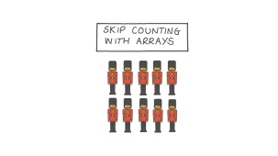  Complete Lesson Worksheet  Practise Skip Counting in 3’s with this song  https://www.youtube.com/watch?v=V96IZWctZYA  Play ‘ BUZZ ‘ for the stations of 3.  Counting from 0 to 30 each person takes a turn to say the numbers in order but if the number is 0,3,6,9,12,15,18,21,24,27,or 30. Then they must say BUZZ instead of the number.  Log in and try out your Sumdog challenges set for this week. | HWB  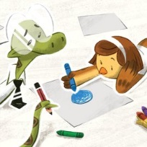  A Story About Friends with Differences  https://www.youtube.com/watch?v=JEJms2ZaQiA  Listen to the story and try out an activity suggested at the end of the book.  This Friday’s Assembly will be all about Inclusion and Respect. Talk at home about what you understand as to the meaning of these words. Draw a picture to show a time when you showed someone respect. Write a sentence below to tell about the picture.  e.g. I showed respect when…….  Note :  Mrs. Agnew will post additional activities for P2/3 on the Blog to look out for

