P2/3 Remote Learning 15:03:21

Good morning P2/3 and I hope you are all well. I have tweaked Monday’s lessons to suit remote learning. I will do the same for Tuesday through to Thursday tomorrow and post on Blogs. If there are any questions or problems you have please do not hesitate to email at the address below and I will do my best to help.
Take care and stay safe.
Mrs Gormanley.

eaagnes.gormanley@glow.sch.uk

- Reading Books have been assigned for the class on Giglets.

- Phonics (Read Write Inc. Set 3) - The sound ‘aw’

Watch the video clip at - https://www.youtube.com/watch?v=Jhk31bdvaN4

Sound out these words and write them down – saw, law, yawn, dawn. Use these four words to write sentences.
Chilli Challenge – Can you think of 2 more words with this sound.

- Number Work - Counting by Fives up to 100

Watch the video clip at - https://www.nagwa.com/en/worksheets/264179049897/
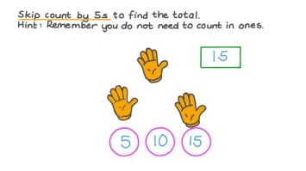Complete - Lesson Worksheet

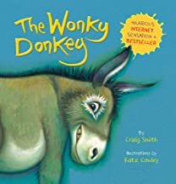
- Literacy – Listen to the song of ‘The Wonky Donkey.’

https://www.youtube.com/watch?v=SDeQT9zCvi4

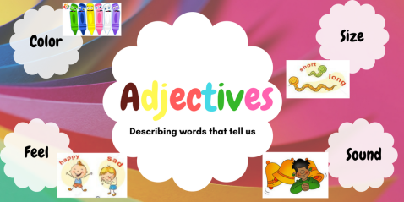
An adjective is a word which describes something or tells us what something is like.

After listening to the Wonky Donkey draw the donkey and write down some of the adjectives used to describe him around your picture.

