Wb 01.03 21
You may like to do some work on these areas for homework. This work can take any form you like.
Learning plan in Primary One
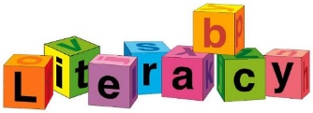  Focus :  Reading books – Black Hat Bob  Tug, Tug  Phonics – air  Recap set 2 sounds  (assessment)  Handwriting – upper/lower letters  Writing - Description bubble (intro)  Wanted poster  Hold a sentence.  Capital letter, full stop  and spaces. | 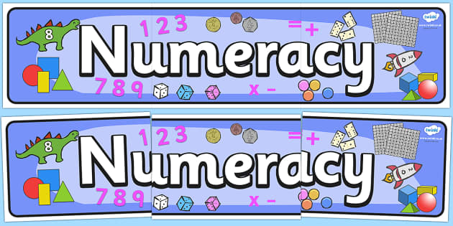  Focus :  Odd and Even numbers  Odd : 1, 3, 5, 7, 9 – all numbers ending with  these five are odd.  Even : 0, 2, 4, 6, 8 – all numbers ending with  these five are even.  Skip counting in 2s from odd/even numbers.  Sharing into 2 sets.  Number bonds to 10. | 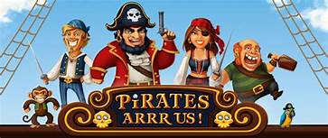  Focus :  Pirates – floating and sinking (science)  - Who, when and where (history)    People Who Help Us  Health/medical  Police  Fire Brigade  Rescue  School and Education  Community  Value - resilience
  Focus: Emotional health + wellbeing  PATHS – Self control  Caring + sharing  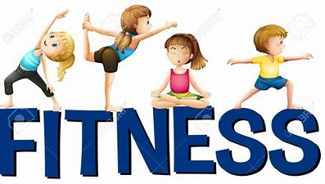  PE – reactions game - colours  - directions game  - ball skills | 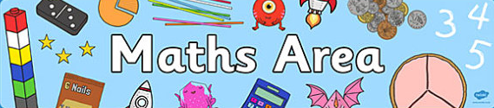  Focus : Positional language  Follow instructions to travel from one point to another, using the language below:  Forward Backward  Left Right  Half turn Whole turn  Imoves. |   Focus :  Music – rhythms  - pirate songs/sea shanties  Drama – retelling stories in character  Hotseating – questioning characters  Art – Spring - daffodils

