P2/3 Remote Learning 15:02:21

Welcome P2/3 and I hope you all had a restful holiday. We have a very short learning grid this week and hopefully we will be returning to class very shortly to continue our learning. If there are any questions or problems please email at the address below and I will do my best to help.
Take care and stay safe.
Mrs Gormanley.

Our ‘Feel Good Friday Day’ will remain this week and you may again wish to complete/ revisit favourite tasks or choose some suggested fun activities. listed below.

eaagnes.gormanley@glow.sch.uk

Literacy | Numeracy | Other Curricular Areas
Writing  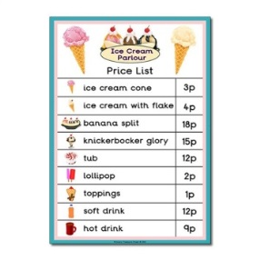  Shop Price List  This week I would like you make a Price List for your Home Shop. Include 10 items in your list and price each item between 3p and 15p. Remember to put in the ( p ) after each cost which stands for pence.  Giglets  Log in to check for your individual reading books this week. Click the Library Tab and the first book shown is the reader for this week.  Phonics  Revision of all SET 3 Sounds.  https://www.youtube.com/watch?v=n-Y4Ha4e7j4  Can you spot the new sound covered at the very end? | Money  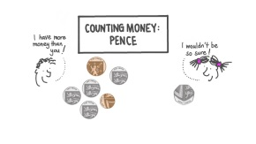  https://www.nagwa.com/en/videos/134167679365/  6666688/  Complete the Lesson Worksheet for this Lesson. (It may help to watch the Video Lesson again.)  This week we will investigate giving change within 20p Watch BBC Schools - Numbertime Money - Change from 20p using the link below -  https://www.youtube.com/watch?v=0HbPUZtUGrk  In your home shop price each item under 10p. Take turns at being the customer and the shop keeper. Buy 1 or 2 items at a time. Add up the total cost. Can you use a 20p coin in the money you use to buy the items. Make sure you give/receive the correct change.  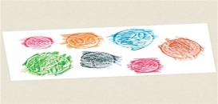  Make coin rubbings of the head and tail faces of each of the coins. | Feel Good Friday  Suggested choice of Activities  - Join in with Our School Friday Assembly  - JRSO Competition  Design your own safety cycle helmet.  Download a template or sketch your own helmet to design & colour .  - Detective Digiduck Storytime – Trusting information online  https://vimeo.com/510174028  - Home Shop Role Play  - Find out all about how the Chinese New Year is celebrated by watching a selection of video clips.  https://sway.office.com/AziYAPm75FxvA6rQ?ref=email  - Catch Up/ Revist

