P2/3 Remote Learning 08:02:21

Good morning P2/3 and I hope you are all well. Thank you for all the super work that you have emailed over the past few weeks I appreciate that everyone is working so hard to help us all continue our learning. If there are any questions or problems you have, please do not hesitate to email at the address below and I will do my best to help.
Take care and stay safe.
Mrs Gormanley.

This week we will change our Number focus from Time to Money. We will also expand on our Internet Safety Topic by revisiting our friends ‘Sid the Superhero Protector’ and ‘Constable Solosalve’ from Hectors World.
Last week our remote learning blog was related to Health and Wellbeing and this will be continued by introducing a ‘Feel Good Friday Day’ this week. On Friday you may wish to complete/ revisit favourite tasks or choose some suggested fun activities listed below.
On our Learning Grid this week highlights important tasks. Count the you complete this week.
A sample daily timetable for working on P2/3 weekly tasks which may be of some help to structure the learning for some children although I am aware that this way of working may not suit everyone.

eaagnes.gormanley@glow.sch.uk

Literacy | Phonics | Reading
Writing  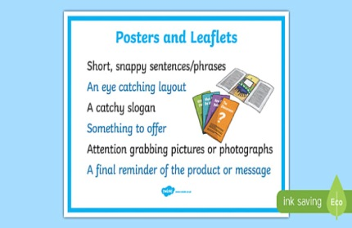  Internet Safety Poster  This week I would like you make a poster that teaches other children how to stay safe online. The poster should include four or more safety instructions. Consider how to set out your poster. Give your poster a heading and set out the instructions by using bullet points or numbers. The writing should be neat and clear. You may wish to use Capital Letters in parts of your poster. Bold colours and illustrations will make the poster more visible to the reader. Display your poster in a suitable place for all to see. | Check up with some revision of SET 3 sounds.  https://www.youtube.com/watch?v=s7eeOx58JQs  More revision this week with revisiting the split digraphs (a-e, i-e, o-e and u-e).  Click on the link to watch Simply Phonics  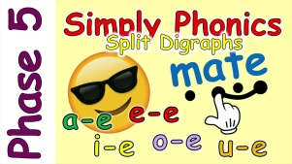  https://www.youtube.com/watch?v=L7faYbILI1s  Write down 2 words for each of the digraphs and mark with sound button. e.g. -  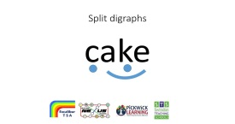  Choose from your words and write a good sentence for each of the 5 digraphs. | Green Words – Speed Sounds Set 2  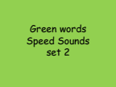  This link is for the Power Point above.  https://www.rushmerehallprimaryschool.com/uploads/8/4/3/9/84392750/quick_swipe_green_words_2.pdf  How many Green Words can you read ? Focus on the words you found tricky.  Giglets  Reading books will not change this week. Click the Library Tab and the first book shown is the reader from the previous week. After reading over your book from last week choose one or more books from your library to revisit and enjoy.  Alphabet & Handwriting  Listen to the Alphabet Song. 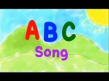  https://www.youtube.com/watch?v=75p-N9YKqNo  Write out the 26 letters of the Alphabet in small letters and then in CAPITAL LETTERS.

Numeracy | Numeracy | Numeracy
Money  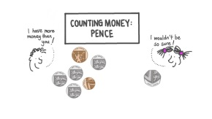  In this video, we will learn how to count in 2s, 5s, 10s, and 20s within 100 to find the value of a group of coins in pence. (17 mins)  https://www.nagwa.com/en/videos/134167679365/  Continue practising counting up in 2’s, 5’s and 10’s to 100. This will help us with our work on Money.  Set up a home shop. You may choose to sell toys, groceries, clothes, stationery etc. Price each item under 10p. Take turns at being the customer and the shop keeper. Buy 1 or 2 items at a time. Add up the total cost. Can you use real coins to pay the exact cost for the totals? Open the shop every day for at least 15 minutes. (make sure you are a good timekeeper)  Chilli Challenge – Price the items up to 20p | 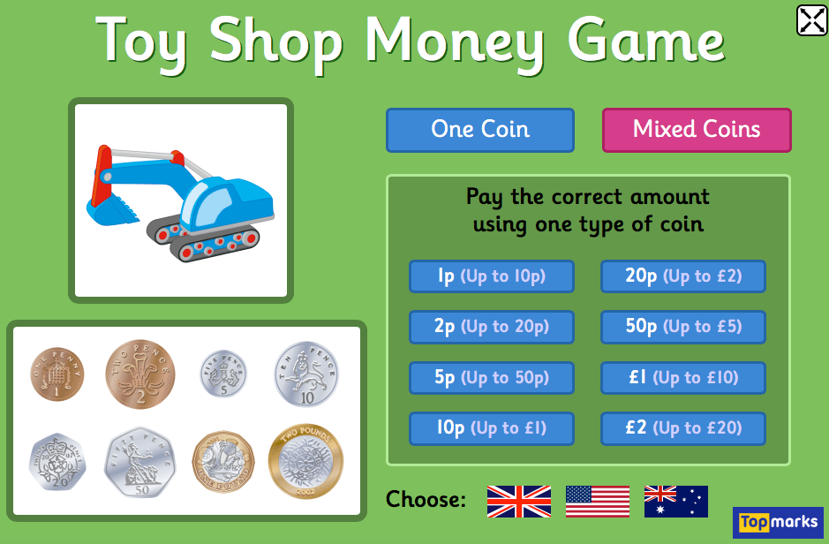  Google - Topmarks Toy Shop Money Game  Play the game up at your own level to pay the correct amounts using coins up to £1.  Copy and complete these sums which add 3 numbers –  0+1+1= 0+5+1=  1+1+1= 5+2+1=  0+2+2= 5+1+1=  2+2+2= 2+1+5=  2+1+2= 3+4+2=  Can you spot which sums have the same answer?  Can you explain why? | Sumdog  I have set some Money challenges to complete in Sumdog this week. Log into Sumdog to find them. Any issues with log in details, please email.

Other Curricular Areas | Other Curricular Areas | Other Curricular Areas
Internet Safety  Sid the Protector  Use the link below to watch again the Lee & Kim cartoon  https://www.youtube.com/watch?v=-nMUbHuffO8  Superhero Sid Top Tip 3  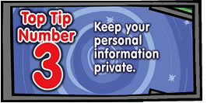  Personal Information is information which belongs only to you, and we shouldn’t share it with anyone we don’t know, including those online. Note down or discuss examples of personal information you should not share with anyone you don’t know. Check below to see if these were examples you thought of.  Constable Solosalve  Visit Constable Solosalve in Hector world –  Episode 1 - Details, details  https://www.esafety.gov.au/educators/classroom-resources/hectors-world/your-personal-information-online  Draw a picture of yourself and underneath write two sentences to say what is special about you.  Think of a good Nickname you might use to play games online but remember to keep it safe.  Internet Safety  Examples of Personal Information.  Your real name, where you live, your birthday and age, what school you go to, your telephone number, after school clubs and activities you attend etc.  Adults we can trust.  This adult –  - makes you feel better when you feel sad or hurt.  - doesn’t scare you.  - is someone you can talk to about anything without feeling worried.  - is an adult you feel close to.  - may have helped you with something before.  EAC Live Family Fun Sessions  Join in for a range of live online sessions starting Monday 8th February. The sessions include –  Music & Rhythm, Listening in Nature, Dance Fitness, Drama & Media, Valentines arts & crafts and Fun Family Literacy Games.  For more information on Family Sessions please refer to the School App. | Internet Safety  Sid’s line in the song says ‘and if you get butterflies in you tum, always remember to tell someone’  Superhero Sid Top Tip 4  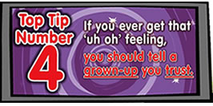  If you ever feel worried or sad about something whilst working online you should always tell an adult you trust. Note down or talk about what you know or understand about adults you can trust. Check below to see if your ideas match those listed.  Use 4 or 5 strips of paper draw and write on each the name of an adult that you trust. Join the strips together to make a trust chain.  Click on the link below to complete the  SMART rules quiz and find out how much you now know about Internet Safety.  https://www.childnet.com/young-people/primary/smart-rules-quiz  This is only a suggestion therefore please feel free to structure the learning as suits your family.  Monday - Green Words & Reading Book (20 mins)/  revision of SET 3 sounds/Money Lesson Clip / Counting up in 2’s, 5’s & 10’s/Choose 2 Internet Safety activities.  Tuesday - Green Words & Reading Book (20 mins)/ Revision of split digraphs/ Set up Home Shop/ Choose 2 Internet Safety activities.  Wednesday - Green Words & Reading Book/ Writing Task/Spelling words & sentences/Topmarks /  Home Shop/ Choose 2 Internet Safety activities.  Thursday - Green Words, Reading Book/ Alphabet Song/ Writing alphabet in small & capital letters / copy sums/ Sumdog/Home Shop/ Choose 2 Internet Safety activities.  Friday – Choose from Suggested Feel Good Friday Fun Activities | Feel Good Friday  Suggested choice of Activities  - Join in with Our School Friday Assembly  - Build Your Happy Place Game  https://www.childline.org.uk/toolbox/games/build-your-happy-place/  - Storytime– Breathe by Scott Magoon  https://www.youtube.com/watch?v=dEpFSVlDxZo  - Home Shop Role Play  - Squiggle Drawings – (draw a squiggle and use your imagination to turn it into a picture.)  - Catch Up/ Revist  How many stars did you collect this week?  Please share with Mrs Gormanley at  eaagnes.gormanley@glow.sch.uk

