Counting This week let’s just have some fun with different kinds of counting:  https://www.youtube.com/watch?v=agWr-b__9_g  Learn to Count with fun Counting Games for KS1 Children (topmarks.co.uk)    Choose a number and count that number of lego bricks, pebbles, pasta shapes etc and create something with that number of items. It could be a tower or picture.  This flower is made from number 8.  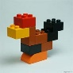  This bird is made for number 9. | Time Have a look at a calendar.  Kids vocabulary - Calendar - Months and Days - Learn English for kids - English educational video - YouTube  Try to practise the months of the year in order. Just focus on one per day:  https://www.youtube.com/watch?v=lPeAo1hz8GA  https://www.youtube.com/watch?v=rMhZXxQP5fo  https://www.youtube.com/watch?v=omkuE6Wa5kQ  https://www.youtube.com/watch?v=SSl-SbVz2oA  Start with a few of the months and add on 1 or 2 until you become more confident. | 2-digit numbers 2-digit numbers are made up of 2 numbers. That’s what digit means – number. In 2-digit numbers we split the numbers into tens and ones. We can see this using tens frames: 10 = 1 ten and 0 ones  11 = 1 ten and 1 ones 12 = 1 ten and 2 ones 13 = 1 ten and 3 ones 14 = 1 ten and 4 ones 15 = 1 ten and 1 ones 16= 1 ten and 6 ones 17 = 1 ten and 1 ones 18 = 1 ten and 8 ones  19 = 1 ten and 9 ones 20 = 2tens and 0 ones  https://www.youtube.com/watch?v=HTGj0CEWtPA  https://www.youtube.com/watch?v=0zJTAfb1yFk  https://www.youtube.com/watch?v=i-7_pSFdhp4
Adding/Taking away We are continuing work on adding and taking away with some fun activities.  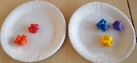  Using cards, dominoes and dice write different equations. Use a number line to help from previous work or using the didax website.    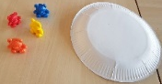  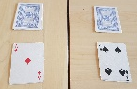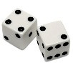  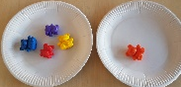  4 + 1 = 5  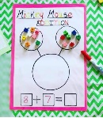  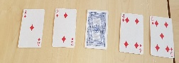  6 + 2 = 8 2 + 6 = 8  8 – 2 = 6 8 – 6 = 2  2 + 1 = 3 4 – 1 = 3  Choose a number between 0 and 20. Write this number in the middle of the page. Now write all the add/subtract equations which equals that number – 3…… 2+1, 4-1, 5-2, 1+2, 10–7 and so on. | Time Days of the Week  https://www.youtube.com/watch?v=3tx0rvuXIRg  https://www.youtube.com/watch?v=8GKmCQOy88Y  https://www.youtube.com/watch?v=vflM4PNo284  On strips of paper/cardboard from a cereal box, write out the 7 days of the week. Mix them up then put them in order from Sunday to Saturday and from Monday to Sunday. Now put them in a stack and turn over one at a time and play the before and after game. E.g. If you turn over Monday you say “Before Monday is Sunday and after Monday is Tuesday.”  Place day cards in a row and turn over 1 or 2 and guess the days which you can’t see.  High Frequency Word Games - days of the week and months of the year (roythezebra.com) | 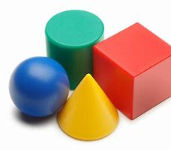  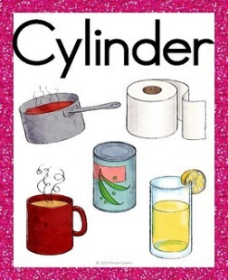  3D Shape Make a poster of 3D shapes using a magazine or a catalogue to cut out pictures. Sort the pictures into groups for your poster. So your poster might be about just one 3D shape, or it might have a set of cubes and cuboids or cones, spheres and cylinders, or groups of pictures for all of these shapes. You could also draw your own pictures for your poster. The poster should have a clear title – which would be the name of the shape or shapes. If it’s about all the shapes the title could just be “3D shapes”.
Virtual Manipulatives for Math (didax.com) – a good website to get digital number frames, number lines, cubes, counters, numicon

