Reading Please log on to class 1  Oxford Owl for School and Home  Username: dalmel  Password: fred  The book I would like you to read and practise is called ”Will’s Net”  Giglets books assigned this week are – “Little Pig” and “Little pig’s calendar”  Red words  Sightwords - Teach Your Monster to Read  The Dinosaur's Eggs - High Frequency - Sight Words (ictgames.com)  Practise these red words.  Watch out for the 2 new ones at the bottom of the table.  You could play bingo with these words!  said the to  no I he  your my be  we *do *I’ll | Handwriting This week’s letters some capital letters. Write each capital letter followed by the lower case letter like this : Aa Bb Cc Dd Ee  Capital letter are all tall letters. Only focus on the first 5 for this week.  Writing : Keeping a diary  This week can you keep a diary? Can you write 1 sentence about something you enjoyed doing on that day of the week:  Today I liked doing my sounds.  Remember to start with a capital letter and don’t forget your stopper.  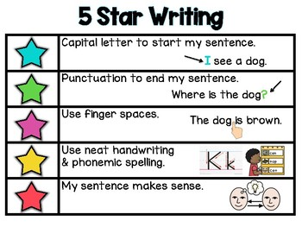  Also space your words out | This week we continue to look at set 2 sounds. ir and air are the ones we will look at in our videos, but you should continue to engage with the online ones produced by RWI.  (179) Set 2 Lessons - YouTube  Play pairs, guess my word, guess my sound, give a meaning, I spy… etc.  ir air  sir air  bird fair  girl hair  dirt lair  third pair  twirl chair  whirl stair  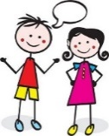  Listening and talking  This week we are going to be thinking in our literacy about the components of a story. I shall be making a video to help with this and this will be part of our writing tasks too. You will be able to apply this to any book but we shall be using the book “Owl babies” to get started. Thinking of these questions Who? Where? When? What is happened? Ending?  The children will then be able to transfer these skills to any story and consider them when retelling or making up their own stories.
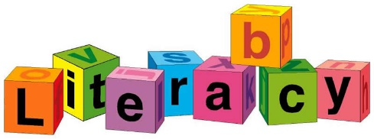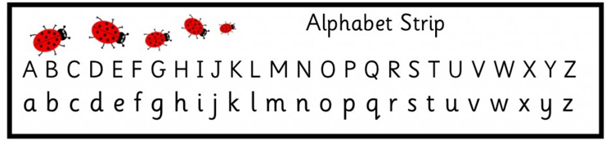
WB 08.02.21

