Wb 08.02 21
Learning Across the Curriculum
  Health & Wellbeing    Feel good Friday.  Let’s make Friday a day where we look after our mental health properly.  Mrs Greig will be posting a virtual assembly to share with families.  Factor in lots of chill time – play games, do some mindful colouring or art work. Put your feet up, snuggle up on the couch and share favourite books.  Let’s give our busy brains a rest so that we are relaxed and in a good place to start our weekend! | 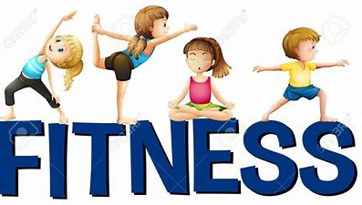  It is important for us to take a little time each day to keep active.  Peace out – relaxation / meditation :  Peace Out Guided Relaxation for Kids | 14. Cloud Story - YouTube  Joe Wicks Workout – M, W + F  Outdoor walks / outdoor play  Timed challenge – skips, hops, jumps, sit ups, touch toes, plank etc in one minute. Extend time to 2 mins if you feel up to it. You could add your challenges to your daily diary if you wanted to.  Monday – 20 hops Tuesday – 22 hops etc. | 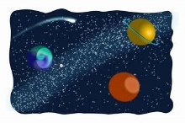  Space  This week’s question for further research is from Ellis and Fraser. Ellis wants to learn about the sun, moon and stars, Fraser wants to find out if there is a man living on the moon. Space | DK Find Out!  https://www.youtube.com/watch?v=6fn2lXKzddg  https://www.youtube.com/watch?v=cwZb2mqId0A  https://www.youtube.com/watch?v=B-b4XvuQo1Y  In the songs below you can learn about the different shapes of the moon.  We can explore this by keeping a  moon diary. Look at the moon each  night and draw what you see.
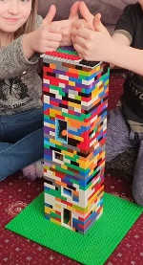  Technology This week we are going to create a model of a building. This could be made from Lego (and the like) or it can be a junk model. It could be a simple house or a famous landmark. Here is a link on pinterest which might give you some ideas for your model. Here’s our model of a police tower with multi windows, doors and inside stairways.  (218) Pinterest  How To Build A Mini Lego Taj Mahal - Mini Buildings of the World - YouTube  How to Build a LEGO House: 12 Steps (with Pictures) - wikiHow | ICT It is internet safety day on Tuesday 9th February. We would like you to take a bit of time to chat about keeping safe when playing games online. With remote learning, children are faced with a much greater amount of on-screen time. They must be made aware of simple things such as – taking a break when they get tired or if their eyes feel strained, not sharing computer details or passwords. Here are some links which will help you to do this:  https://www.youtube.com/watch?v=-nMUbHuffO8  Safer Internet Day 2021 | Safer Internet Centre Click advice centre and select parent/carers for info.  Using computers in our everyday lives - KS1 Computing - BBC Bitesize Click on classroom ideas for a game.  Digital literacy - KS1 Computing - BBC Bitesize | Music Moon – learning facts through fun songs  https://www.youtube.com/watch?v=nZcL_2djtAc  https://www.youtube.com/watch?v=K3YfLAAi3Vc  https://www.youtube.com/watch?v=DEHBrmZxAf8  https://www.youtube.com/watch?v=xuZ3M7UghIM  https://www.youtube.com/watch?v=c90IGZXBpKc  https://www.youtube.com/watch?v=vt_LtIJyISQ  Art  Why not visit Little Art Village for some mindfulness drawing and painting activities – thanks again to Jaxon and his mum for sharing this with me!😊  The Little Art School - YouTube

