P2/3 Remote Learning 01:02:21

I hope you are all well P2/3 and all set for our home learning for this week. Thank you once again for all the super work that you are sending me and I know all the children, with myself included, very much appreciate all the help they are being given at home.
Helpers. - We couldn’t do this without you!
I appreciate how challenging remote learning must be for most families therefore do not hesitate to contact me if I can help in any way.
Take care and stay safe.
Mrs Gormanley.

This week our remote learning blog is related to Health and Wellbeing and a selection of your work may be collected throughout the week to be shared in our Weekly Roundup.
On our Learning Grid this week highlights important tasks. Count the you complete this week.
I have also included a sample daily timetable for working on P2/3 weekly tasks which may be of some help to structure the learning for some children although I am aware that this way of working may not suit everyone. Let me know how you find the suggested daily timetable or whether it is best to do what you can, when you can.

Please get in touch if you are having any problems.

eaagnes.gormanley@glow.sch.uk

Literacy | Phonics | Reading
Writing  Formative Writing  This week I would like you to design and write a Health dinner menu. The menu should include a Starter, Main Course and Desert. For the trickier words to spell perhaps you may find them written on food labels at home to copy. Consider how to set out your menu to make it look more attractive to the diner. You may wish to add some illustrations of your dishes. Perhaps your menu will be so appealing that it can be a home ‘menu of the day’ this week for the family and you can help in the kitchen to prepare it.  Chilli Challenge –  You may wish to challenge yourself to write a choice for each course. | 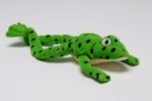  Check in on Fred this week by using the link below. Fred is helping with some revision of SET 2 sounds, some green words and red words too.  https://www.youtube.com/watch?v=NVx8bDv3eAw  Our new sound this week is ure. ure is a trigraph (three letters which make one sound)  Click on the link to watch the lesson. (15 minutes)  Note – alien words are nonsense words which reinforce known phonics.  https://www.youtube.com/watch?v=0hj36ailI44  Spelling – Use the method above to practise spelling  these words –  sure, cure, pure, picture, mixture  Use your spelling words and write 3 good sentences or challenge yourself to write 5. | Red Words –‘ Look & Say ‘words  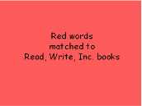  This link is for Power Point above.  https://slideplayer.com/slide/12568648/  Practise reading the Red Tricky words. Work on words up to and including Purple Books. Children may read on as the words relate to the reading books we used in class preschool closure.  Giglets  Log in to check for your individual reading books this week. Click the Library Tab and the first book shown is the reader for this week. Please let me know how easy/difficult you find your book. There has also been a Reading Task set, which will show in Giglets, relating to your book this week.

Numeracy | Numeracy | Numeracy
Time  In this video, we will learn how to tell time to the half hour on both analogue and digital clocks. Watch the video and complete the Lesson Worksheet.  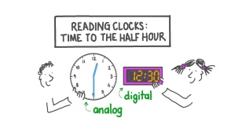  https://www.nagwa.com/en/lessons/305130746920/  Revise counting up in 5’s and try to reach up to at least 60. Let us see how this relates to our work on time. This song clip will help.  How to Tell Time! 60 Minutes is an Hour! (count by 5's)  https://www.youtube.com/watch?v=zVpqZSzoe5I  Use an analogue or digital clock to note down the time you do certain tasks during the day.  e.g. Get up, have breakfast, start school work,  have lunch……. | Slapshlearn is a fun practise maths site. Sign in for free and practise your number skills with this game –  https://uk.splashlearn.com/maths-skills/year-3/number-sense/count-by-5-s  Copy and complete these number patterns –  O 2 4 _ _ _ (up to 20)  0 5 10 15 _ _ _ (up to 50)  0 10 20 30 40 _ _ _ (up to 100)  How many add or subtract sums can you set down which give the answer 10?  Chilli Challenge –  How many add or subtract sums can you set down which give the answer 20? | Sumdog  I have set you some challenges to complete in Sumdog this week. Log into Sumdog to find them. Any issues with log in details, please email.

Other Curricular Areas | Other Curricular Areas | Other Curricular Areas
Health & Wellbeing  Physical  Staying healthy will help you to feel happier and stronger. Explore this BBC Bite Size site to find out more about the importance of Exercise, Diet and Sleep.  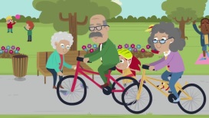  https://www.bbc.co.uk/bitesize/topics/z9yycdm/articles/zxvkd2p  Note down the time you go to bed each night of the week and what time you get up at to find out how many hours you sleep each night. Write a sentence to tell what makes it easier for you to sleep well.  Social & Emotional  Play I spy Emotions Game with your family. (see below)  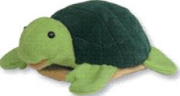  Go with Twiggle for an Outdoor Scavenger Hunt. Record what you find on the attached Grid below.  I-Spy Game  I spy with my little eye something that makes me feel…………  Sad Calm Scared  Excited Angry Happy  EAC Live Family Fun Sessions  Join in for a range of live online sessions starting Tuesday 26th January. The sessions include –  Music & Rhythm, Outdoor Learning, Dance Fitness, Drama & Media and Literacy Games.  For more information on Family Sessions please refer to the School App. | Mental Health  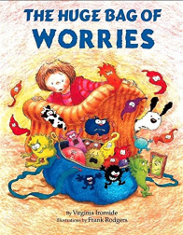  This book is one of Mrs. Gormanley’s and Mrs. Leslie’s favourite books for children. We hope you enjoy it too. Listen to the clip and talk about the story with your family.  https://www.youtube.com/watch?v=qBcakxX9LTM  Internet Safety  This cartoon focuses on online safety messages for children.  https://www.youtube.com/watch?v=-nMUbHuffO8  Can you remember Sid’s 4 Top Tips for Staying Safe using the internet? Write them down and  post them close to where you do online learning.  Now you are a Protector like Sid. Design and make your own Protector Badge to wear.  This is only a suggestion therefore please feel free to structure the learning as suits your family.  Sample Daily Timetable  Monday - Red Words & Reading Book (20 mins)/revision of SET 2 sounds/Time Lesson Clip and worksheet/Physical Health activities.  Tuesday - Red Words & Reading Book (20 mins)/New ‘ure’ sound clip/ Counting in 5’s and song/ Note down times for daily tasks/Social & Emotional Health activities.  Wednesday - Writing Task/Sumdog Challenges/Complete number patterns/Mental Health activity/Gratitude Card.  Thursday - Red Words, Reading Book & Reading Task (30 mins)/ Spelling words/ Writing sums / Internet Safety/ The Skeleton Dance.  Friday – Revisit revision of SET 2 sounds & Reading Book(20 mins)/Splashlearn & Sumdog/revisit Skeleton Dance/ ICT & Science activities. | Music and Dance -The Skeleton Dance  Learn the words of the song and perform the dance for The Skeleton Dance. (link below)  https://www.youtube.com/watch?v=Jpvuqj5nv6U  ICT & Science  Type these words into Google to find where these bones are.  skull, pelvis, femur, backbone, rib cage.  Draw, copy or print out a basic skeleton picture and label with the words.  Expressive Arts  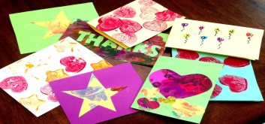  Design and make a Gratitude Card to say thank you for someone special who has given you a great deal of help over the past few weeks.  How many stars did you collect this week?  Please share with Mrs Gormanley at  eaagnes.gormanley@glow.sch.uk
