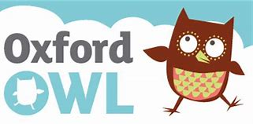  Reading Please log on to class 1  Oxford Owl for School and Home  Username: dalmel  Password: fred  The book I would like you to read and practise is called,” Let’s Go” It is a nonfiction book.  Giglets books assigned this week are – “Baby Bear’s Week” and “Hello”.  A writing task has been set up for you too.  Red words  Sightwords - Teach Your Monster to Read  The Dinosaur's Eggs - High Frequency - Sight Words (ictgames.com)  Keep on practising the red words in these PowerPoints.  Practise reading these words in a more fun way by playing a game of bingo! | Handwriting This week’s letters are zig zag letters. They are all short letters which start at the top and mostly go down in a diagonal.  Z is the only letter which goes across first before it goes down a diagonal slope.  How to write zigzag letters - BBC Bitesize  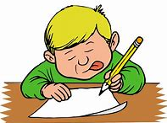  Writing  After reading “Baby Bear’s Week” can you write 1 or more sentences about some of the things you do :  On Sunday I………  Remember to start with a capital letter and don’t forget your stopper.  Also space your words out.  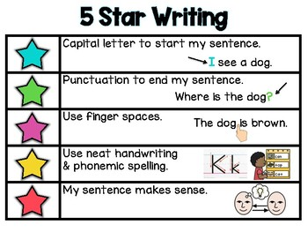 | This week we continue to look at set 2 sounds. or and ou are the ones we will look at in our videos, but you should continue to engage with the online ones produced by RWI.  If you feel the pace is too quick please recap using the set 1 sounds.  (179) Set 2 Lessons - YouTube  Play pairs, guess my word, guess my sound, give a meaning, I spy… etc.  or ou  or our  for out  sort shout  fork loud  short found  horse mouth  snort round  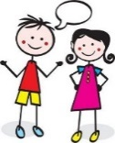  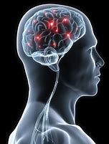  Listening and talking Our talking point this week is about all the things our brain helps us to do. Our brain is like a small computer inside our skull which controls everything that we think, say and do. Discuss all the things we think our brain helps us to do. Have a chat about how important our brain is and why it is so important to keep it healthy.
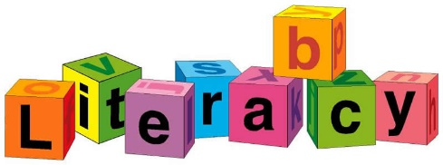
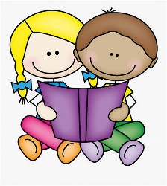 WB 01.02.21 