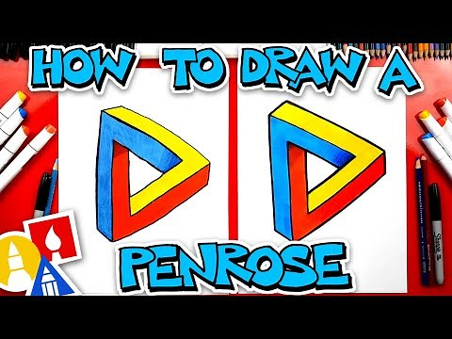

https://www.youtube.com/watch?v=sCqQ3d1k3Vc

How To Draw A Penrose Triangle - Optical Illusion
Learn how to draw a crazy Penrose triangle! This is a fun optical illusion to draw. You can even memorize the steps and draw it again! p )b
www.youtube.com

