P2/3 Remote Learning 25:01:21

Welcome Primary 2/3 and I hope you all had a good weekend. I do very much appreciate all the super work that you are sending me and I hope that you can manage to keep up the effort. If you have any suggestion or ideas of how I can be of any more help with your work, please let me know and I will do my best to accommodate.
Take care and stay safe.
Mrs Gormanley.

This week our remote learning blog is related to Science Topics and a selection of your work may be collected throughout the week to be included in our whole school Weekly Roundup.
On our Learning Grid this week highlights important tasks. Count the you complete this week.
I have also included a sample daily timetable for working on P2/3 weekly tasks which may be of some help to structure the learning for some children although I am aware that this way of working may not suit everyone. Work through the Grid whichever way suits best your individual situation.

Please get in touch if you are having any problems.

eaagnes.gormanley@glow.sch.uk
Remember -

Literacy | Phonics | Reading
Writing  Descriptive Writing  This week I would like you to write about a recent outdoor experience. It may have been a village walk, playing in the snow, trip to the shops or playing in the park. Using the 5 senses words (see, hear, smell, taste, feel) write 5 interesting sentences to tell me about the experience.  e.g  I saw……. I heard……. I could smell…. I tasted…. I felt……  Support can be given for spelling of more challenging words but where possible ‘Fred Fingers’ for spelling words should be encouraged. Give your writing a heading and include a picture to illustrate your work. Remember Capitals and Full Stops. | Phonics  Revision of digraphs (two letters which make one sound) Listen to this clip 2 or 3 times until you can join in.  Digraphs - Phonics Song: For Children (Abi Online Teach ...  Our new sound this week is ear. ear is a trigraph (three letters which make one sound)  Click on the link to watch the introduction of the sound.  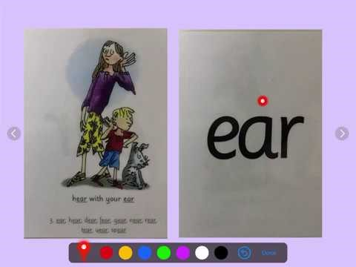  https://www.youtube.com/watch?v=y5KaOrbwY0o  Spelling  Use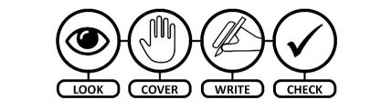method to practise  Spelling these words –  ear, hear, clear, fear, tear, spear  Use your spelling words and write 3 good sentences or challenge yourself to write 6. | Red Words –‘ Look & Say ‘words  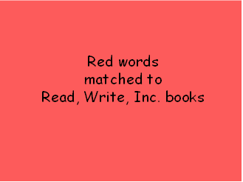  Double Click on the Power Point above and practise reading the Red Tricky words. Most children should work on words up to and including Purple Books, Others may go further as the words relate to the reading books we used in class preschool closure.  Giglets  Log in to check for your individual reading books this week. Click the Library Tab and the first book shown is the reader for this week. Please let me know how easy/difficult you find your book.

Numeracy | Numeracy | Numeracy
Time  In this video, we will learn how to tell time to the hour on both analogue and digital clocks. Watch the video and complete the Lesson Worksheet.  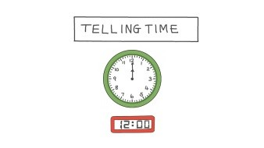  https://www.nagwa.com/en/videos/693153935858/  On the same page as this video click under Course Menu on right hand side. Click Number Patterns then counting in twos, fives and tens up to 100. Complete the Lesson Worksheet.  Use an analogue or digital clock to time how long it takes you to complete some of your work tasks this week. Did it take more or less than half an hour/30minutes. | Hit the Button  Sharpen up your Number Doubles up to 10 or challenge yourself with from 5 to 15 with some games online of Hit the Button on the Top Mark’s website online.  Practise writing out all the double sums up to 10 or 20 using the + and = signs. e.g.  - + 0 = 0 | Sumdog  I have set you some challenges to complete in Sumdog this week. Log into Sumdog to find them. Any issues with log in details, please email.

Other Curricular Areas | Other Curricular Areas | Other Curricular Areas
Science  The Five Senses -  Sight, Taste, Smell, Hearing, and Touch  Watch this video to find out all about our 5 senses.  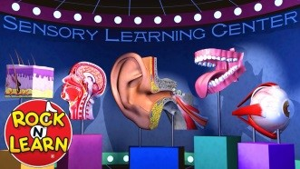  https://www.youtube.com/watch?v=52_w0PIIfjs  Sight experiment  Make and see your very own rainbow.  Hold a CD in the sunshine. Or if it's a cloudy day, turn out the lights and shine your flashlight at the CD. Hold a piece of white paper so that the light reflecting off the CD shines onto the paper. The reflected light will make fabulous rainbow colours on your paper.  Taste & Smell experiment  Get an adult to blindfold you or close your eyes really tight (no peaking). Get a small piece of fruit, banana works really well. Ask your child to pinch their nose. Offer them a small piece of the banana to taste with their nose pinched. Can they tell what it is? Repeat without pinching your nose. Can you tell now? Offer them a few different flavours of the food. Can he or she identify it? (They might want a drink of water between the different foods.)  HWB  P.E.  Try Joe Wicks 5 minute move workout every morning to get that body moving.  20 Star Jumps  20 Squats  20 Burpees  20 Touch the Foot, Touch the Sky  Repeat and continue for 5 minutes.  Competition Time  Safety Selfie  Out JRSO Officers have invited us to take a selfie whilst doing something safe! Please email your photographs and I will forward them on.  RSPB Big Garden Birdwatch  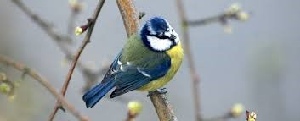  Find out how to take part in the Big Garden Birdwatch and help protect our wildlife by visiting the following site:  https://www.rspb.org.uk/get-involved/activities/birdwatch/everything-you-need-to-know-about-big-garden-birdwatch/ | Technologies  P2/3 are joining P3/4 this week with our Design & Technology Challenge. As the cold winter weather continues the challenge is to design and make something to help keep Miss Wallace and my ears warm. Please send any pictures which I can share with Miss Wallace.  Touch experiment  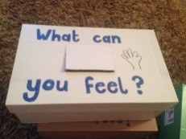  Make a feely box.  Cut a hole in the box.  Have one child find an object and place it inside the box. Cover the box back up (and don't let anyone peak) Have a different child describe what he/she feels inside the box. Have child try and guess what is inside the box. Open the box to see if the child is correct!  This is only a suggestion therefore please feel free to structure the learning as suits your family.  Sample Daily Timetable  Monday - P.E. /Red Words & Reading Book(20 mins)/Watch introduction of new sound/Time Lesson Clip/Choose 2 tasks from ‘Other Curricular Areas.’  Tuesday - P.E. /Red Words & Reading Book(20 mins)/Phonic Song & Spelling words/ Time Lesson Worksheet/ Choose 2 tasks from ‘Other Curricular Areas.’  Wednesday - P.E./ Writing Task/Sumdog Challenges/ Number Patterns Worksheet/Choose 2 tasks from ‘Other Curricular Areas.’  Thursday - P.E. /Red Words & Reading Book(20 mins)/ Phonic Song & Spelling words/ Play Hit the Button Doubles/ Choose 2 tasks from ‘Other Curricular Areas.’  Friday - P.E. /Red Words & Reading Book(20 mins)/Spelling word Sentences/Write out double Sums/ Choose 2 tasks from ‘Other Curricular Areas.’ | Science  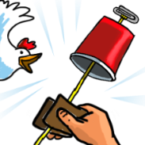  Sound experiment  Make a Clucking Chicken.  Cut a piece of string or wool about 20cm long. Ask an adult to carefully punch a hole in the centre of the bottom of the cup. Tie one end of the string to the middle of a paper clip. Push the other end of string through the hole in the cup and pull it through as shown in the picture. Get a piece of paper towel about the size of a playing card, then fold it once and get it damp in water. Now it’s time to make some noise! Hold the cup firmly in one hand and wrap the damp paper towel around the string near the cup. While you squeeze the string, pull down in short jerks so that the paper towel tightly slides along the string. If all goes well - you hear a chicken!  Topical Science  Our Super Hero Doctors and Nurses are so important in our lives at the present time. They rely on their knowledge of Science to help others.  What areas of Science may they rely on within their work?  Click on the link and find out more about what is means to be a doctor.  https://www.bbc.co.uk/teach/class-clips-video/proud-to-be-a-doctor/z7kfbdm  How many stars did you collect this week?  Please share with Mrs Gormanley at  eaagnes.gormanley@glow.sch.uk

