Counting Try counting from 0 to 10 in 2s – missing out every other number :  0, 2, 4, 6, 8, 10. Start on 0 and jump over the next number to land on 2, then jump over the next number to land on 4 and so on.    Now extend this to numbers to 20 if you feel confident.  This Photo by Unknown Author is licensed under CC BY-NC-ND  Paint the Squares - Interactive Number Charts (topmarks.co.uk)  Learn to Count up to 10 with Underwater Counting Maths Game (topmarks.co.uk)  Duck Shoot - tablet friendly (ictgames.com) | Number formation and recognition  Continue with some number formation as children often reverse numbers or take a lot of time to recognise them. Play snap and dominoes but identify the numbers/patterns before play moves on to next player.  https://www.youtube.com/watch?v=rsAmz08nBV4  Helicopter Rescue - Mental Maths for 4 to 8 Year Olds (topmarks.co.uk) | Before and after numbers  Write a number in the middle of a line on paper or a board. Now ask your child to think about the number which comes before this number and write it in front of the middle number. Then ask them to think of the number which comes next and write this number after the middle number. Use cards or dice and ask the before and after questions. Do lots of practise as this is tricky learning for many children.  https://www.youtube.com/watch?v=QrVRFcrdTRs
Adding Continue with number bonds to 10. Bondsnwhich make up 10 – 9 and 1, 8 and 2, 7 and 3, 6 and 4, 5 and 5 and 0 and 10.  If you find this is too easy, then do the same for other numbers within 10 – bonds for 7, 8, 9 and so on. Also try writing these number bonds as equations – 8 + 2 = 10 2 + 8 = 10  This Photo by Unknown Author is licensed under CC BY-NC-ND  Screened equations – 5 + ___=10  This Photo by Unknown Author is licensed under CC BY-NC-ND  This Photo by Unknown Author is licensed under CC BY-NC-ND  ___+ 7 = 9. You can use the count on strategy.  mathszone.net/mw/number/NumberBalance/index.html Hit the Button - Quick fire maths practice for 5-11 year olds (topmarks.co.uk)  Number Bonds 20 | Math Playground | 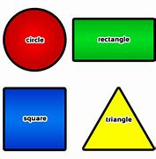  2DShapes Talk more about 2D shapes. Try to make patterns by drawing 2 shapes in different ways or use the bottom link to do this digitally.  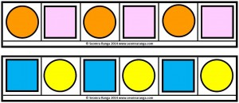  Shape Patterns (topmarks.co.uk)  Shape Monsters - 2D Shapes Matching Game (topmarks.co.uk)  Pattern Shapes by the Math Learning Center | 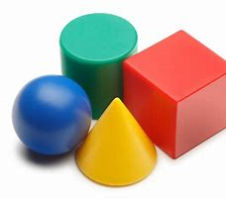  3D Shape  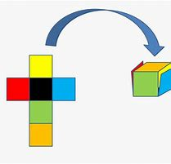  3D shapes are the chunky shapes made up of 2D shapes. Look around your home for these chunky shapes and ask your child to identify the 2D shapes they can see in each chunky shape. https://www.youtube.com/watch?v=zPZegz690Mg A great practical activity is to find an empty box and pull it apart or cut it to see what shapes it is made from. It could be a cereal box, toothpaste box etc.
Virtual Manipulatives for Math (didax.com) – a good website to get digital number frames, number lines, cubes, counters, numicon

