Reading Please log on to class 1  Oxford Owl for School and Home  Username: dalmel  Password: fred  The book I would like you to read and practise is called,” The Get Fit Club” It is a nonfiction book.  If you sign into Giglets you will find primary 1 have 2 books assigned to enjoy with the family – “Little Red Riding Hood” and “Dark Night”.  Red words “You can’t Fred a red.”  The Dinosaur's Eggs - High Frequency - Sight Words (ictgames.com)  Practise all the red words in these PowerPoints. The selector is a fun one. When you start show click ‘s’ key to stop the word. You can only move on once you read it. Click s to stop and s to start.  your  want  you  like  of  no | 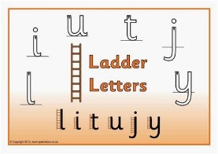  Handwriting This week’s letters are long ladder letters. All these letters start at the top and then down.  Remember j and y hang below the line. Also i and u are short letters but start at the same point and go in the same direction.  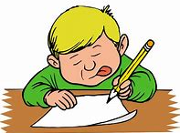  Writing  After reading “The Get Fit Club” can you write 1 or more sentences about how you keep fit and draw pictures :  I can run. I can swim.  I can go on my bike.  Remember to start with a capital letter and don’t forget your stopper.  Also space your words out.  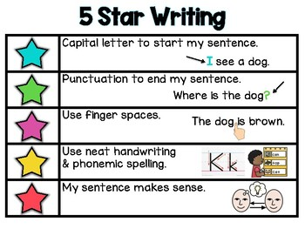 | This week we continue to look at set 2 sounds. ow and ar are the ones we will look at in our videos, but you should continue to engage with the online ones produced by RWI.  If you feel the pace is too quick please recap using the set 1 sounds.  (179) Set 2 Lessons - YouTube  Play pairs, guess my word, guess my sound, give a meaning etc.  ow ar  bow car  tow far  blow park  grow dark  snow star  show start  crow shark  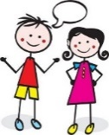  Listening and talking Play the shopping game. This helps us to listen and remember different things.  I went to the shop and I bought a…..You can choose any item you would buy at the shop. The next person repeats – I went to the shop and I bought a…. first they must remember what the first person said then add on another item.  I went to the shop and I bought a banana.  I went to the shop and I bought a banana and an orange.  I went to the shop and I bought a banana, an orange and a tin of soup.  Play continues until someone can’t remember the full list.
WB 25.01.21 