Wb 25.01 21
Learning Across the Curriculum
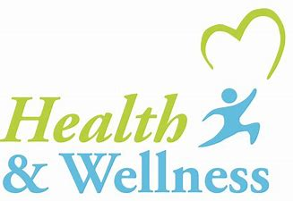  Health & Wellbeing  Our JRSO (Junior Road Safety Officers) have organised a new virtual competition which you may be interested in taking part in. It is called “Safety Selfie”. This involves you taking a selfie when doing something safe. Check for more info: | 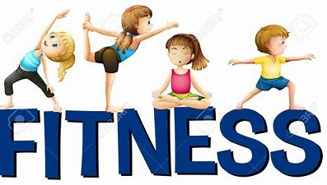  It is important for us to take a little time each day to keep active.  Yoga – astronauts (starts 5mins into video)  https://www.youtube.com/watch?v=26fk7LFLI5Q  Joe Wicks Workout – M, W + F  Outdoor walks  Check out the live family sessions on the blog | 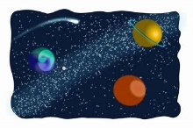  Space  This week’s question for further research is from  Jamie. He wants to learn about astronauts and how they travel in space and the job they do.  Space | DK Find Out!  Who was Neil Armstrong? - BBC Bitesize  https://www.youtube.com/watch?v=eT1PtaRA7ZM  https://www.youtube.com/watch?v=jhD8GFwy734  Story time from space : If I were an astronaut https://www.youtube.com/watch?v=9wV8yw7iV8w
Science This week we are going to learn about gravity.  Gravity – explore gravity with these simple experiments:  What is gravity? - BBC Bitesize  Easy Science Experiments for Kids: Gravity Activity with Paperclips - Buggy and Buddy  Gravity Science Experiments and Activities for Kids (littlebinsforlittlehands.com)  KS1 Forces | Friction and Gravity (educationquizzes.com)  https://www.youtube.com/watch?v=-EUEYStS8G4  https://www.youtube.com/watch?v=6OyvxY8z3cA | 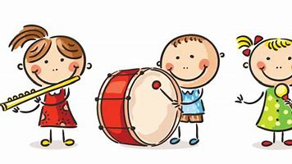  Music  Clap the syllables in each of our 2D shapes :  Square – 1 beat Cir – cle – 2 beats  tri – an – gle, rec – tan – gle – 3 beats  Follow the 2D rhythms here…  Make some 2D shape rhythms of your own.  Here is a good clapping video if you need a wee brain break:  https://www.youtube.com/watch?v=9sS0OeABaFs  Day and night song:  https://www.youtube.com/watch?v=4XP0zdN8icM  Gravity song:  https://www.youtube.com/watch?v=H1kVro7P1KE |   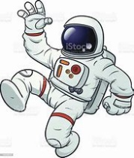  Art  Draw an astronaut using one of these step-by-step videos which are in order of challenge:  https://www.youtube.com/watch?v=dXY394tEAFY  https://www.youtube.com/watch?v=xQPcFCQKV-c  https://www.youtube.com/watch?v=W2r-wFCb9Gk  Here’s some more Science if you want to learn about why we have day time and why we have night time.  Day and night - KS1 Science - BBC Bitesize  https://www.youtube.com/watch?v=Wr-CRKsTYGs  https://www.youtube.com/watch?v=Iz4KtSy_81k  Earth and space - KS1 Science - BBC Bitesize
Lego STEM challenge - https://www.youtube.com/watch?v=Wr-CRKsTYGs

