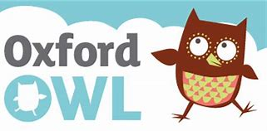  Reading  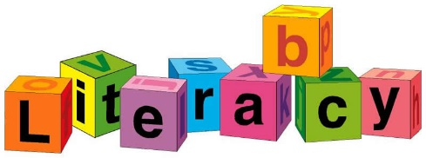 WB 18.01.21 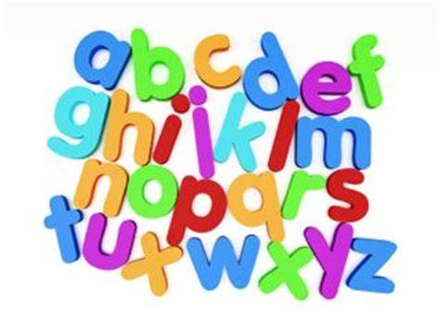 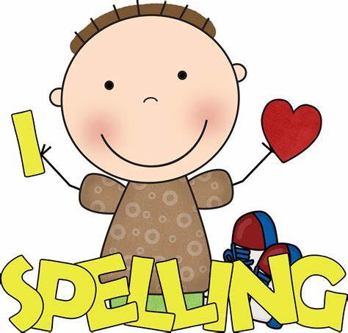  Please log on to the oxford owl Oxford Owl for School and Home  Username: dalmel  Password: fred  The book I would like you to read and practise is called,” Hands” It is a nonfiction book.  There are lots of free books to enjoy and read with and to your children. Class log in class 1 as above.  Also keep practising the words in the sound books this will help improve rapid recall of words and help with fluency.  If you sign into Giglets you will find primary 1 have 2 books assigned to enjoy with the family. Goldilocks and The 3 Craws. | 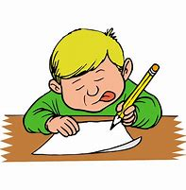  Writing  This week’s letters r, m, n, p, h, b and k All these letters have the same starting point. (small case letters this week no capitals). Start at the top down up and over. These are one-arm robot letters.  Letter-formation-chart.pdf  Remember h b and k are sunshine letters…. tall letters.  Remember letter practise should be every day, little and often is the motto.  Even just tackle 1 or 2 letters per day to give daily practise. | This week we continue to look at set 2 sounds. ee and igh are the ones we will look at with Mrs Forsyth’s videos, but you should continue to engage with the online ones produces by RWIN, there are daily videos which run for 24 hours on utube These are Read Write Inc videos which is the phonic programme the children are familiar with. The children love them as they are exactly the way they are taught in school.  If you feel the pace is too quick:  please feel free to recap using the set 1 sounds. (these are available daily too) Remember we will be working on set 2 sounds for a few weeks before moving on to set 3. Plenty of time to practise and become confident.  (179) Set 2 Lessons - YouTube  Some examples. You could make your own word cards.  ee igh  see light  been high  seed might  sleep night  feed fright
Red words  Here are some additional high frequency red words to practise reading and writing Please remember “You can’t Fred a red.” you could try these games  The Dinosaur's Eggs - High Frequency - Sight Words (ictgames.com)  said  she  was  to  me  they | 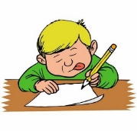  Writing  After reading the book hands ……. Can you write about all things you do with your hands and draw me a picture?  You will be a writer and an illustrator.  i.e. Hands can wave.  Hands help us.  Remember to start with a capital letter and don’t forget your stopper.  Step to being successful  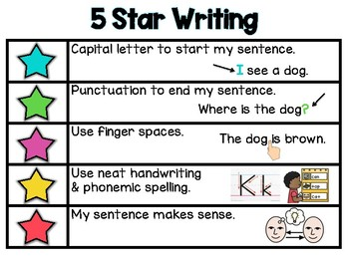 | Listening and talking  Our speaking this week is learning to recite our chosen Burns programme. We look forward to seeing your efforts. We know you will all be fabulous.  Please remember steps to success:  - Eye contact with your audience.  - Take your time - Speak clearly.  - You can put in some actions.  - Have fun and njoy!!!!!!!!  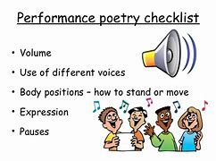  Here are some fun language things associated with our Scottish themed week. Log into  Scots Language Centre –  Why don’t you have a go.? I like popping the balloons best.

