Expressive Arts - Art

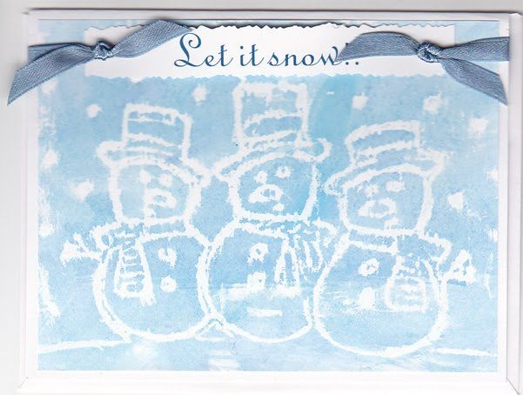

Wax crayon water paint frosty pictures.

The rain has come and washed the snow away and our snow painting might not be possible. Let’s magic some snow back with our art work this week. We have used wax resist technique in class before therefore using a crayon or even a wax candle draw a fun winter picture and using a watery paint or water with a touch of food colouring to make it appear. Perhaps you can even write a secrete message in white crayon that can only be revealed when washed over.

