Please log on to the oxford owl and look this week at the ditties.  A man and a dog  Pup sits in the mud.  Please practise until fluent.  There are lots of free books to enjoy and read with and to your children. | This week let’s practise our circular letters. All these letters have the same starting point. c o a d g q ( small case letters this week no capitals). They start top right and move in an anti-clockwise direction.  WB 11.01.21 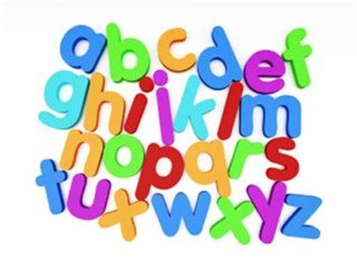  Letter-formation-chart.pdf | This weeks sounds are from set2 oo - poo at the zoo, oo as in look at a book, ar and or  There are daily videos which run for 24 hours on Youtube These are Read Write Inc videos which is the phonic programme the children are familiar with. The children love them as they are exactly the way they are taught in school. They could also recap using the set 1 programmes - also running daily. (179) Set 2 Lessons - YouTube
Red words  Here are some high frequency red words to practise reading and writing Please remember “You can’t Fred a red .” you could try these games  The Dinosaur's Eggs - High Frequency - Sight Words (ictgames.com)  said  he  me  I  my  the | Writing  Draw and write a short sentence each day about  how you are feeling.  Challenge 1 : Use the word ‘and’ if you are feeling more than 1 feeling.  Challenge 2 : Use the word ‘because’ to say why you feel this way.  Ask an adult at home how they are feeling and why. | Listening and talking  What was your favourite part of the Xmas holidays? Talk to someone about it or send us a wee  clip telling us all about your favourite day.  Mrs Forsyth’s was the snowy day and building a snow man.  Mrs Agnew’s favourite part of the holidays was eating Christmas dinner with her family and playing the new games on Christmas night.

