Welcome back Primary 2/3 and I hope you all had a lovely Christmas. It is unfortunate that I won’t be able to hear all your exciting news in person but for now we all have to keep safe and hopefully this will help us all return to school before too long.
Missing you all lots!
Mrs Gormanley.

Every week until we are back in the classroom, I will update your remote learning blog with more activities. I will post these each time under P2/3 within GLOW Blogs. Try to complete what you can. There will be additional tasks and suggestions posted daily on the Blog too – look out for these. The school App will also be updated regularly by Mrs Greig.

Please get in touch if you are having any problems.

agnes.gormanley@easyayrshire.org.uk

Remember - You are doing great!

Primary 2/3

Literacy

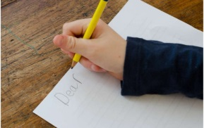

Writing
A Letter to Mrs Greig
This week I would like you to write a letter to our new head teacher, Mrs Greig. In the letter you should tell her about yourself. You should also tell her about what you are looking forward to in 2021.

This is your chance to practise ‘Fred Fingers’ for spelling words by yourself. Can you write at least 4 sentences in your letter. Write a sentence to tell your name. A second to tell your age. A third to say about what you enjoy best at school and a final sentence to say what you are looking forward to in 2021. Remember to use a Capital letter at the beginning of each sentence and at the end of each use a Full Stop.

Numeracy
Watch this five minute video which teaches telling the time to the hour in words.
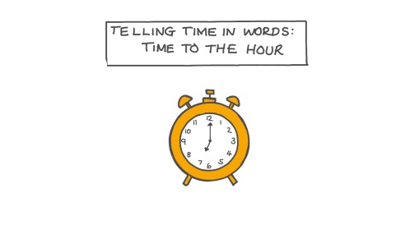

https://www.nagwa.com/en/videos/560145035706/

Topmarks has a fun game called Clock Splat which matches analogue times to
digital equivalents. There are three levels and you can choose to work at your own level of difficulty.

https://www.topmarks.co.uk/r.aspx?sid=5574

Hit the Button

Sharpen up your Number Bonds up to 10 or challenge yourself with up to 20 with some games online of Hit the Button on the Top Marks website online.

Ten Snap Card Game – (rules for game set out below)
Sumdog
Log in and continue to practice and improve personal targets within Sumdog. Any issues with log in details, please email.

Other Curricular Areas

Technology

Make Some Noise With DIY Instruments!

Unfortunately circumstances have limited our singing to outdoors recently at school.

However wouldn’t it be great to use our own musical instruments to accompany our music lessons when we return. Use your imagination and recycling skills to create your very own musical instrument.

Giglets

Hopefully you all still have your own log-ins safe for personal Giglets accounts. Log in to check for your own activities for this week. Any issues with log in details, please email.

Phonics
Revise Set 2 sounds using your Homework sounds sheets and then have a look at this clip to practise.

RWI Set 2 Sounds - YouTube

Taking the first 6 sounds from the video can you write down at least 2 words for each sound independently using ‘Fred Spelling’?

The link to this Phonics lesson lasts about 20 minutes and could be viewed on alternative day.

Lesson 31 - Year 1

Expressive Arts - Art
Outdoor Ice Art

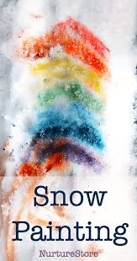

Weather dependant try this art activity outdoors.
The cold weather seems to have left snow and ice on the ground for most of the week. Can you brighten the snow outdoors by adding paints or food colouring to make a bright colourful picture. Perhaps you may wish to paint a rainbow, sunshine or flowers.
Please remember to take a photograph as I would love to see the pictures.

Robert Burns
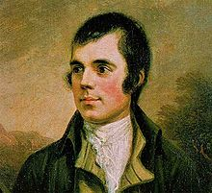
January is the time when we remember and celebrate the works of Robert Burns and this year should be no different.

As part of this year’s celebrations, you should choose a Scottish poem to learn and recite. This year P2/3 have the choice of 2 poems.
This week have a read of the poems and take a look at some recitals of these on YouTube. We will continue to work on these over the coming weeks.

The Puddock by John M. Caie

Crocodile by J K Annand

Things to check out on TV and online

- Joe Wicks is back with workouts on YouTube.

- Little Art School continue to add to their channel on YouTube – don’t forget to share your artwork on Teams.

- BBC2 are running educational TV shows in the mornings – let us know what one was your favourite this week.

Rules for - 10 Snap
Resources: Cards - Ace to 10 (remove the picture cards)
No of Players: 2 – 4
Object: Make 10 snap Rules:
• Take the picture card out of the deck (keep the Ace as number 1).
• Deal the cards out equally between each player.
• Players must not look at their hand.
Each player takes turns to place a card down.
• A snap is achieved if two cards add to make 10.
• Winner is the person with the most cards.
Things to talk about as you play:
• How many different ways can you think of to make 10?

