Crosshouse Primary School
Communication Centre and
ECC
Improvement Plan
2018/19

School  Improvement Plan | Crosshouse Primary School, Communication Centre and ECC
Head Teacher | Mrs
Senior Education Manager | Mr Ian Burgoyne
Date Submitted | 26th June 2017
Session | 2017-18

School’s  Vision and Values | 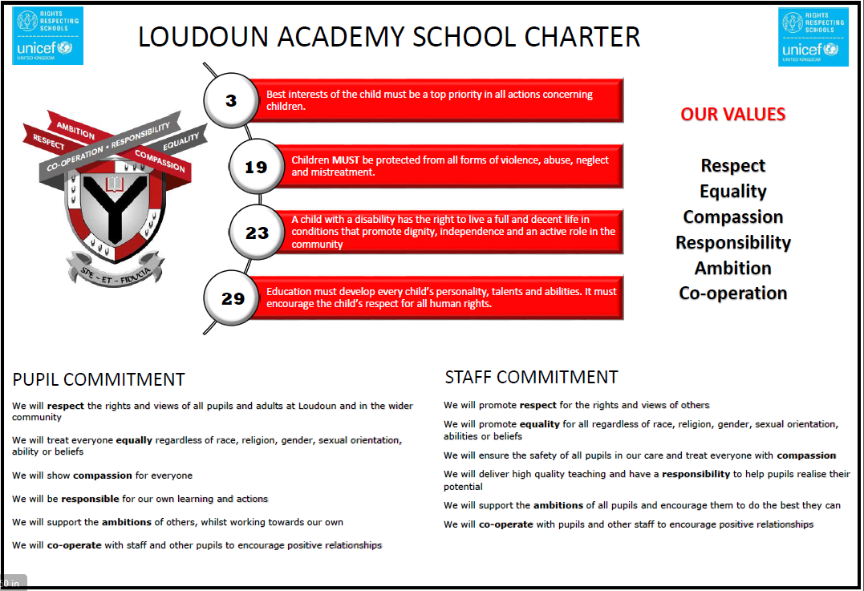
Consultation on improvement plan includes the following stakeholders: | Completed |  | Content of plan | Completed
Children and Young People | x |  | Takes account of strategic priorities outlined in the education authority’s Annual Plan. | x
Parent Council and Forum | x |  | Takes account of the strategy for parental involvement under section 2 (4A) | x
Teachers, practitioners and ALL school/centre staff | x |  | An audience-friendly summary of the SIP is available and contained in this document and will be provided to parents, children and young people. | x
Volunteers/ Community partners | x |  | Appropriate cognisance has been made of the links between the plan and the working time agreement for teaching staff | x
Local bodies representing teachers, staff, volunteers and any parent bodies further associated to the school/centre. | n/a |  | Scottish Government Tackling Bureaucracy working group recommendations have been considered when planning for improvement and in the improvement activities specified | x
 |  |  | HGIOS 4 and HGIOELC are used as the frameworks to inform the content of SIPs | x
Head Teacher/ Head of Centre Signature | Linda McAulay-Griffiths |  | There is clear focus throughout the plan on measures to reduce of inequalities of outcome as a result of socio-economic disadvantage. | x

Pupil and parental strategic involvement

For session 2017-18, please describe below how children and young people will be involved in decisions relating to the operation of the school/centre | For session 2017-18 , please describe below how parents will be involved in decisions relating to the operation of the school/centre
The young people have been extensively involved in creating this plan and used the national improvement framework as a basis for discussions. EVERY young person in the school had a chance to come up with positive ideas as to how we could move as a school relating to all four NIF priorities.  In 2017-18 we will recommence our strategic assembly meetings, whereby ALL young people get a chance to scrutinise and discuss particular aspects of school policy and practice.  In addition, our young people will continue to be part of self-evaluation throughout ALL areas of school life and we will continue to operate a senior and junior pupil council, who will discuss operational issues.  A senior prefect and house captains group will also continue to run, these pupils will have a key focus on the school improvement plan.  Every young person will also be entitled to at least three formal learner conversations in every subject area as they progress through school and will have the chance to respond to issues around teaching and learning. | As in 2016-17, our parents will have strategic involvement in the operation of our school.  It is intended that our model for parental consultation operates via the parent council as the main strategic body, who will in turn, understand their duty to consult the wider parent forum and organise events to involve more parents in such decisions.  In addition it is intended to make wider use of social media to support survey –type responses whereby parents can access decision-making without the necessity for meetings.  Parent council members will continue to be involved in our strategic education groups to allow then to develop specialisms in key areas of the NIF. The parent council will also handle complaints, enquiries or praise directed at the school via their social media feeds and liaison with the school as appropriate. We will also continue to ensure that the parent council are represented on key appointment panels and authority reviews as deemed appropriate.
Improvement Priority  The numeracy and literacy levels of our learners in BGE and senior phase will increase as a results of intervention in key aspects of both. |  | Rationale for improvement priority based on evidence  - SSLN results indicate weakness in formal writing.  - Writing levels in S3 (2017) are lower than reading, listening and talking levels, based on TJS  - 6% of pupils at L2 in S3 Numeracy (2017) according to TJS  - 95.% of leavers attain L4 Numeracy (2016)  - 98% of leavers attain L4 Literacy (2016)
NIF Priorities  Improvement in attainment, particularly in literacy and numeracy | NIF Driver  Assessment of children’s progress | HGIOS 4 QI’s for self-evaluation  1.1.2, 1.1.3  2.2.3, 2.3, 2.5.3, 2.6.3  3.2.1, 3.2.3

What actions are required to reach the desired outcome? | Who | When
The school will undertake a focus on formal writing across the curriculum to ensure a consistent approach and support is available to all learners in literacy.  The school will undertake a focus on financial education as a key aspect of pupil numeracy (where appropriate to subject area). Where this focus is not appropriate to the subject area, another focus will be agreed with PT Numeracy to directly impact on pupil outcomes, particularly at level 3. | S Robertson  PT English  PT Literacy  SIG  S Robertson  PT Maths  PT Numeracy  SIG | August 2017 – May 2018  August 2017- May 2018
Evidence of Impact against outcomes for learners

- SNSA results indicate alignment with teacher judgement survey results and show improvement in writing levels (s3)
- SNSA results indicate alignment with teacher judgement survey results and show improvement in numeracy levels (s3)
- Staff have a greater knowledge and confidence in teaching literacy and numeracy and young people understand the applications of same across the curriculum
- Monitoring and tracking data reflects continual improvements in the literacy and numeracy levels of young people from p7 to s3
- Senior phase literacy and numeracy results continue to improve, with a focus on 100% of leavers attaining level 4 literacy AND numeracy
- Self-evaluation of learning an detaching indicates greater teacher confidence in delivering literacy and numeracy
- Greater levels of family engagement with literacy and numeracy schemes via events and workshops
Improvement Priority  Positive destinations for our leavers are consistently above 95% |  | Rationale for improvement priority based on evidence  - Initial leaver destinations 2015-16 94.8%, rising to 97 % at follow-up.  - Positive destinations for S4 leavers are 88.12% (2016)  - 4.82 % of leavers in unemployed seeking category (pre- follow up)  - Only 12.7% of YP directly accessing employment (behind VC,EA and Nat)  - Lack of common language of skills required in school to demonstrate progression and better align to pathways
NIF Priorities  Improvement in employability skills and sustained, positive school leaver destinations | NIF Driver  Teacher Professionalism | HGIOS 4 QI’s for self-evaluation  1.1.2, 1.2.2,1.2.3, 1.3.2, 1.3.3  2.2.1, 2.2.2, 2.2.3, 2.2.4, 2.3, 2.4.3, 2.6, 2.7  3.1.3, 3.3

What actions are required to reach the desired outcome? | Who | When
The school will embed a new skills framework, better aligned to the 3-18 career standard to ensure that young people and staff can monitor progression in skills throughout the BGE and inform pupil pathways  ALL areas of school will ensure a wider range of partnerships with 3rd sector, business, college, universities and develop sector leading curricula in BGE and SP that meets the needs of our young people and leads to improved destinations. | T Lennox  ALL depts  PTPS  SIG  SDS  T Lennox  ALL depts  PTPS  SDS  SIG | Jan 2018  Jan 2018
Evidence of Impact against outcomes for learners

- Increase in overall positive destinations rate in all year groups, with a 100% positive destination for most vulnerable S4 leavers
- ALL young people receive an education using a consistent language of skills throughout the curriculum, leading to alignment with pupil pathways
- An increase in young people directly entering employment upon leaving school
- Direct increase in partnership engagement in ALL areas, in comparison to figures in 2016-17
- Increased usage of non-traditional qualifications across the curriculum

Improvement Priority  Our young people will be more included in our school community |  | Rationale for improvement priority based on evidence  - 2015-16 exclusion rate of 3.4 % and 5.2 per 100 pupils.  - Repeated exclusions for certain young people in 2016-17  - Lack of key accommodation and staffing to support learners at risk of exclusion from educational entitlement  - SHANARRI survey evidence across school  - S4 leaver data (2015-16) indicates 70% of leavers are SIMD 1-4
NIF Priorities  Improvement in children and young people’s health and wellbeing | NIF Driver  Teacher Professionalism | HGIOS 4 QI’s for self-evaluation  1.1.2, 1.1.3, 1.2.2, 1.2.3, 1.3, 1.4, 1.5 (PEF)  2.1, 2.3, 2.4, 2.5, 2.6, 2.7.3  3.1, 3.2,

What actions are required to reach the desired outcome? | Who | When
The school community will embed the new positive relationships policy and school charter and ensure staff and pupil access to restorative approach training across the school  The school will open a new inclusion hub to ensure that vulnerable pupils can be included in all aspects of school life (PEF target). ALL areas of school will review approaches to inclusion.  The school will launch its’ “ready to learn” facilities for all young people to facilitate daily effective contact with PTPS and access resources as necessary | B Hendry  L Whiteside  SIG  B Hendry  PT Inclusion  L Whiteside  SIG  L Whiteside  PTPS | May 2018  Sep 2017  Sep 2017
Evidence of Impact against outcomes for learners

- Reduction in high-level referrals for young people
- Reduction in exclusions in % and per 100 pupils terms
- Increased attendance of “at risk” pupils and greater attainment for same
- SHANARRI surveys (focussed on respected and included) to indicate greater level of pupil and staff relationships
Improvement Priority  Our young people will attend and achieve in Loudoun Academy |  | Rationale for improvement priority based on evidence  - Superb introduction of assertive monitoring and tracking (2015-17)  - S4 (2015-16) SIMD 1: 301 av tariff pts v SIMD 8 :477 (local measure)  - S5 (2015-16) SIMD 1: 617 av tariff pts v SIMD 8: 932 (local measure)  - S4/5/6 (2015-16) SIMD 1:392 tariff pts v SIMD 8: 1334 (national measure)  - S4 leaver data (2015-16) indicates 70% of leavers are SIMD 1-4  - Some attendance figures for young people <20%
NIF Priorities  Closing the attainment gap between the most and least disadvantaged children | NIF Driver  Performance information | HGIOS 4 QI’s for self-evaluation  1.1.2, 1.1.3, 1.2, 1.3, 1.5 (PEF)  2.1, 2.2.1, 2.3.3, 2.3.4, 2.4, 2.5.2, 2.6.1,2.6.2,2.7  3.1, 3.2

What actions are required to reach the desired outcome? | Who | When
ALL areas of school will make better use of monitoring and tracking data to ensure swift and effective intervention for ALL learners, but with key foci on SIMD 1-3. Monthly QA meetings will require ALL departments to report on progress of “at risk” pupils (PEF Intervention)  ALL areas of school will adopt a key focus on pupil attendance to ensure that ALL young people have the chance to achieve. The school community will connect with the SAC and EAST teams, our Home Link Worker, PT Inclusion, PTPS and our vulnerable young people. | L McAulay-Griffiths  G Johnston  SIG  L McAulay-Griffiths  G Johnston  PTPS/ HLW  SIG | Sep 2017  Sep 2017
Evidence of Impact against outcomes for learners

- Evidence of clear INTERVENTIONS based on tracking data via QA meetings
- Evidence of systematic approaches to non-attendance
- Increased attendance of young people at ALL stages
- Team around the child meetings convened and implemented for non-attenders
- Increased attainment in BGE and senior phase as a direct result of increased attendance
- Reduction in referrals to ASG for non-attendance
Raising Attainment , particularly in Literacy and Numeracy | Increased in sustained positive destinations and employability skills
- Key focus on formal writing across the curriculum in respect of literacy  - Key focus on financial education across the curriculum in respect of numeracy | - Embedding skills programme across the curriculum to support the development and progression of skills in our young people, aligned to 3-18 careers framework  - Continued strategic development of sector leading curricula and business, community, college and university links
Ensuring the health and wellbeing of all young people | Closing the poverty related attainment gap
- The development of inclusive and restorative approaches across school to enhance inclusion and reduce exclusion  - Embedding of the positive relationships policy  - The launch of the “Ready to Learn” scheme | - Continue to monitor and develop tracking mechanisms to ensure availability of ROBUST data leading to effective interventions, based on tracking  - Connectivity around Scottish Attainment Challenge Home Link Worker and ALL school staff to improve pupil attendance

