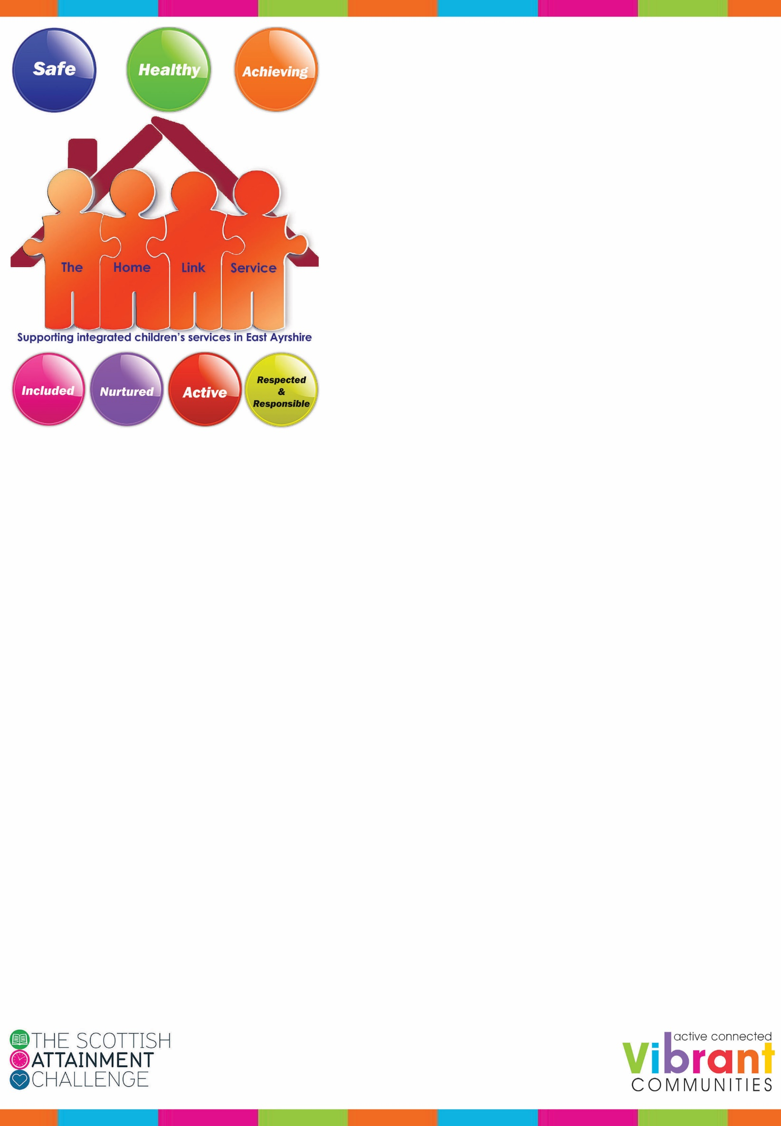

***Parent Drop-In Cafe***

Sensory Hut

Crosshouse Primary School

***Would you like to learn more about:***

* ***Behaviour Management***
* ***Change and Loss***
* ***Family Literacies/Homework***
* ***IT***
* ***Volunteering Options***

***Or anything else***

Please come along on Wednesday afternoons commencing 18th April 2018. 1.45pm – 3.00pm for a coffee/tea and an informal chat.

All Welcome

**If you need to get in touch, contact:-**

Name: Lesley Wilson – Home Link Worker

Tel: 07384211640/01563 549988

Email: lesleywilson42@east-ayrshire-gov.uk

[](http://www.google.co.uk/url?sa=i&rct=j&q=&esrc=s&source=images&cd=&cad=rja&uact=8&ved=0ahUKEwjfuo-ThMPWAhWPZVAKHcRZAM4QjRwIBw&url=http://longbridgebaptist.org.uk/whats-on/weekday-activities/our-coffee-morning/&psig=AFQjCNG-ZvqVx3TVGsyox5RvZ4hgRrlC_w&ust=1506521160421784)