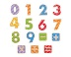  Numeracy | Literacy | 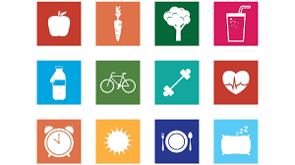  HWB | Other
Education City  Play Fruit Frenzy on Education City and complete the Fruit Frenzy worksheet. | Education City & Giglets  Try some literacy activities. | Cosmic Kids Yoga  Search ‘cosmic kids yoga’ online and join Jamie on one of her adventures. (Article 31) | School values poster  Read over the school values poster attachment with an adult. Create a poster on what being respectful means to you.
More or less  Visit Topmarks website > Chopper Squad > one more or less > 1 to 20, 1 to 50 or 1 to 100. | Reading  Read a book and complete some activities on Giglets. | Safety poster  Can you think of places that have special rules about safety, such as a swimming pool or train station? Choose one and design a safety poster. (Article 19) | Who keeps you safe?  Draw some of the people whose job it is to help you stay safe and protected or colour some of the attached sheets. (Article 19)
Halves and doubles  Practise your quick recall of your doubles e.g. 4 + 4. Play ‘Share Bears’ on Education City. Now complete the Share Bears worksheet. | Writing  Watch Julia Donaldson’s ‘The Singing Mermaid’ on the Scottish Book Trust > authors live on demand > heroes and villains with Julia Donaldson.  Think of a character that you would like to see perform in a circus. What can they do? What do they look like? What costume do they wear? Draw a picture and write about them in your jotter. | Feelings song  Think about the feelings we have when we know we are safe and cared for. Create a song to describe how this feels. (Article 19) | Gypsy Roma Traveller Month  June is Gypsy Roma Traveller month. Read through the PowerPoint with an adult and use the worksheet to design a caravan in a traditional Romani style. (Article 29)
Shape maze  Use chalk or water to draw 2D shapes in rows on the ground. You jump from shape to shape and the shape you start on is the shape you follow to the end of the maze. 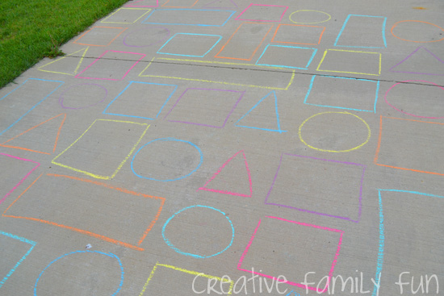 | Phonics  In your jotters write out your spelling words in pencil. Now draw around each letter 5 more times using a different coloured pencil. Worksheets for consonants and vowels groups. | Online safety  What do you know about being safe online? Have a conversation with the adults you live with about online safety. (Article 19) | Respect board game  Print off and play the Respect board game with an adult in your house. (Article 29)

