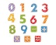  Numeracy | Literacy | 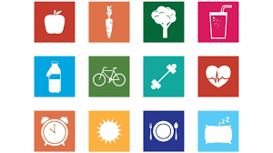  HWB | Other
Education City  Try playing some numeracy games and activities. | Education City  Try some literacy activities. | Take part in Joe Wicks morning workouts.  (see our class blog for link) | Complete your own poster or powerpoint about your favourite animal. Include lots of interesting facts.
Maths Time  Complete White Rose Maths activity sheets.  Play this time game online.  https://mathsframe.co.uk/en/resources/resource/116/telling-the-time | Spelling  Complete the common words and ‘oi’ words activity sheets. | P.E.  Healthy Hearts Challenge Card Watch the short video that explains the exercises before you complete them.  https://www.youtube.com/watch?v=Uj4ytgX77bM | Starters for STEM  Choose one or more activities from the starters for STEM activity sheet.
Sumdog  Your password for Sumdog and username are on our class blog page. | Writing  Write a letter to us, tell us about 3 of your favourite activities you have been doing in Lockdown. Include 2 or 3 questions for us in your letter. You can send us these letters by email. | Health & Wellbeing  My A-Z of nature challenge sheet. | Science  Lava Lamp experiment (see attached sheets)
Information Handling  Complete the Lockdown Information Handling Bar Graph | Listening & Writing  Listen and watch ‘For the Birds’ animation and complete the activities. | Art & Design  Guess the image. Use the Guess the image collage sheet to guess what each picture is of.  Challenge – Have a go at creating your own one. We could guess yours! | RRSA – School Values (2 week task) Article 15  Complete your whole school task from last week- See attached sheet

