 Primary 1 Registration 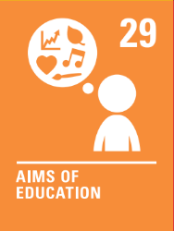
Registration Week for Primary 1 is Monday 8 January 2024 until Friday 12 January 2024
Under the Education (Scotland) Act 1980, children who are five years of age between 1 March 2024 and 28 February 2025, and whose parents wish them to attend school, should be registered for education during the week commencing Monday 8 January 2024 until Friday 12 January 2024.
How to register
You will require to have a Customer Account to complete your online School enrolment/Primary 1 registration form.
https://www.east-ayrshire.gov.uk/schooladmissions
To complete the online registration you will require to upload:
- a copy of your child's birth certificate
- two proofs of your residency within the catchment area, for example, Council Tax Notice and utility bill, which should be no more than three months old.
Should you require a copy of your child’s birth certificate for registration, this can be obtained at Certificates.Scot.
Any Placing Requests should also be completed online. The deadline for these is 31st January 2024,

