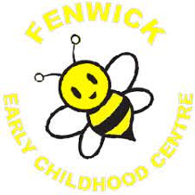

Throughout the year, the ECC staff engage in the self-evaluation of our performance, acknowledging successes and recognising there are things we could change in our on-going commitment to improvement.

As part of the self-evaluation process is to improve how the ECC works for children and families, we gather the thoughts of our parents and children through questionnaires and surveys. We all really appreciate the time and thought that has gone into completing these.

You said:

You are happy with our ECC and the work that we do. We are delighted with this.

We will:

Continue to seek your views as we strive for excellence and providing the best education for your child.
Continue to ensure that all children feel safe, healthy, achieving, nurtured, active, respected, responsible, included.
Continue to provide a warm, welcoming atmosphere for all children.

