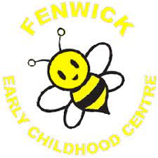
Parent/Carer Survey

We had 3 responses from 18 families. We are delighted with the positive comments.

Question | Yes | No
I find Fenwick ECC welcoming. | 100%
My child is happy and likes attending the ECC. | 100%
My child feels safe. | 100%
My child is treated fairly and with respect. | 100%
My child enjoys the learning experiences we offer. | 100%
We offer a variety of different learning activities. | 100%
The experiences offered, meet my child’s needs. | 100%
I feel staff know my child as an individual and the staff support my child. | 100%
The termly targets, give me a helpful and accurate picture of my child’s progress, strengths and next steps. | 100%
My child’s learning journal provides a helpful and accurate picture of learning, progress, strengths and next steps. | 100%
My child enjoys snack and lunch. | 100%
I am happy with the provision for outdoor experiences. | 100%
The blog is used well to communicate and share experiences and learning. | 100%
Do you feel that curriculum workshops would be beneficial to you? | 66% | 34%
Are you happy with Fenwick ECC? | 100%
Please add any comments you wish to add about any of the above questions. Thank you. | ‘You are all brilliant, thank you.’  ‘We are very pleased with the warm, welcoming environment at Fenwick ECC. The staff know the children well and provide good quality learning experiences for the children.’
.

