Food Policy

The purpose of this policy is to clearly set out the responsibility of all staff in providing high quality safe mealtime experiences for children.

Who is responsible?
- It is the overall responsibility of the SMT to ensure that staff preparing and serving food have a good working knowledge of food hygiene and follow the procedures within this policy.

- It is the responsibility of all staff to ensure that children are provided with mealtimes that are safe, happy and nurturing.

How will this policy be implemented?

- All staff who prepare snack will be trained to the REHIS Elementary Food Hygiene standard as soon as possible from starting within their post. New staff will be closely supervised by experienced staff to ensure that the required procedures are followed prior to any training taking place.

- Hand Washing
- Liquid hand cleanser will be provided at all sinks for staff, children, parents/carers and visitors to use when needed.
- All cuts and sores must be covered with a waterproof plaster.
- Jewellery on hands and wrists should be removed and nail varnish is not permitted. Staff with nail varnish must wear gloves.
- Any individuals suffering from sickness and/or diarrhoea should not be involved in food preparation until at least 48 hours after symptoms have stopped.
- Staff must wash hands on arrival at the centre, before handling food, after handling raw food, after using the toilet, after blowing own/child’s nose, after touching waste bucket/cleaning and at other appropriate times. The six step hand washing method should be followed (see below).
- Staff involved in the preparing or serving of snacks/meals should not deal with nappy changing or sick children during this time.

Six step hand washing method
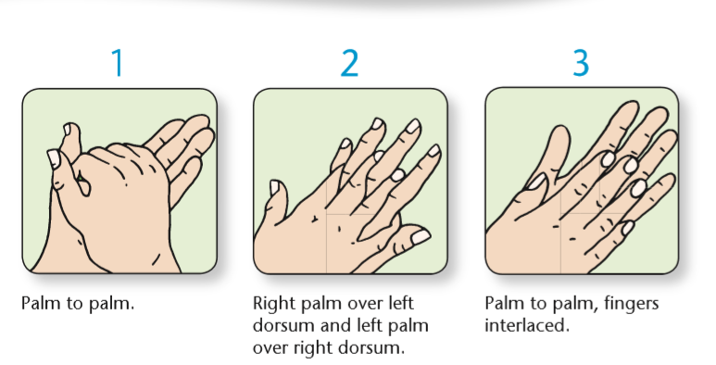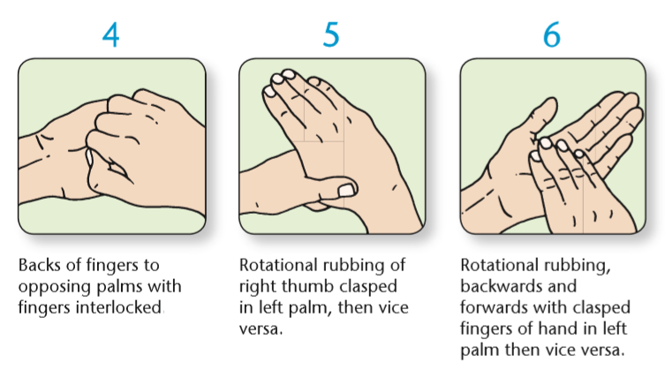

- Food Storage
- If packets are opened and not all content consumed, these should be placed in an air tight container and labelled with the date it was opened, the use by or best before date according to the instructions on the packet and the allergen information contained in the product.
- The fridge and freezer temperatures should be recorded daily. Fridges should be between 2 and 5 degrees at all times and freezers colder than -18 degrees. If this is not the case, staff must record this and take note of the corrective action. If the temperature does not resume to a safe level within a reasonable timescale, items may have to be disposed of in the bin.
- The fridge and freezer must both have a working thermometer at all times.
- Staff should store food effectively by covering raw food, including meat, and keeping it separate from ready-to-eat food.
- Raw and ready to eat foods should be stored in their designated areas.
- High risk food should be stored in the fridge.
- Make regular checks to ensure the shelf life has not exceeded and the food has not deteriorated in quality.

- Food Preparation and Handling
- All areas that are used for food preparation will be sprayed with disinfectant/sanitiser and wiped dry with blue roll before preparation begins. The disinfectant/sanitiser will conform with BS 1276 and this should be sprayed directly onto the surface, ensuring an even coverage. Always allow sufficient contact time, as recommended by the manufacturer, before drying the surfaces with a disposable paper towel or blue roll.
- Staff must wash their hands and put on an apron before handling food, and change in between preparing different food groups if needed. Surfaces should be wiped at this time again as above. If staff leave the area for any reason, their apron must be disposed of. On return hands must be washed again and a fresh apron applied before continuing to prepare food.
- Unwashed fruit and vegetables are now classed as a raw food and must be kept separate from ready to eat food until they are thoroughly washed. Particular care must be taken with any vegetable which is visibly dirty with soil. When dealing with fruit and vegetables staff should unpack, handle and peel if required in the raw area.
- All unwashed fruit and vegetables should be placed in the basin until washed. This should happen as soon as possible. Once washed it may be treated as ready to eat.
- After washing, wash your hands and transfer to the ready to eat area and use ready to eat equipment. Once finished, sink and work areas must be cleaned following the two step method. All equipment used in the preparation of raw food must be washed in the dishwasher on the highest temperature.
- Extra care is required when dealing with visibly soiled vegetables. In addition to following the above procedure, change and dispose of you apron once the vegetables have been peeled and washed before handling any ready to eat food. Promptly clean the area following the two step method.
- Staff must ensure they use the appropriate chopping board and cooking utensils when preparing different foods. Different utensils, plates and chopping boards should be used for raw and cooked food.
Yellow – cooked meats
Green – salads and fruit
Brown – Vegetables
White – dairy products
- Separate knives should also be used for each chopping board/food group.
- Keep preparation time short to ensure that high risk food is not left at ambient temperatures for excessive periods of time.

- Heating and Probing
- When heating food it must be heated to 75 degrees. If food is being reheated it must be heated to a temperature of 82 degrees and checked in several places in the food. Allow to cool to a temperature that is safe for the children to eat without burning themselves and serve immediately. Care should be taken to handle the food as little as possible.
- Ensure your probe is disinfected before and after every use to avoid contamination.
- Any unused heated food should be discarded – never cool and refrigerate/put in the freezer.
- Never place hot food in the fridge as it can cause condensation and bring the temperature up for other foods already being stored.
- The following foods should never be reheated:
  - Celery, spinach, beets
  - Mushrooms
  - Eggs
  - Potatoes
  - Rice
  - Chicken
Please ensure if raw meat such as poultry is being used from frozen, it must be completely thawed before cooking and left to defrost in an entirely separate area from other foods in a cool room.
Food defrosted must be immediately refrigerated and used within 24 hours. Handle as little as possible.

- Mealtimes
- The 14 food allergens as identified by the Food Standards Agency, should be cross checked with all foods provided and allergen information shared with parents. Parents should be updated of any changes to the daily menu as and when required.
- Information in relation to children’s cultural and dietary needs should be displayed clearly with the child’s photograph within the kitchen area of the ECC and a copy made available for staff. This information must be gathered in consultation with parents during induction.
- Information about medical and allergy needs must be shared with staff prior to a child starting within the service. Children should only receive foods/drinks which are deemed safe for them by parents/carers. Care must be taken when preparing foods to minimise any contamination for children with specific allergies such as gluten. Meals for children with allergies should be labelled and checked by both the catering team and ECC staff before served to children.
- Foods provided are healthy, low in sugar and salt and meet national nutritional guidelines.
- Staff must wash hands and put on an apron before beginning to serve food. Staff sitting at the table with the children during mealtimes must do the same.
- The table where food is eaten must be cleaned before and after meal provision.
- Staff serving hot food must ensure it is never served over a child’s head. Hot foods in the form of a liquid such as soup or custard should be served from a jug with a lid at all times from the side of a child directly in to the bowl.
- Opportunities to promote children’s independence skills should be provided.
- Water must be freely accessible to children throughout the day – (Health & Social Care Standard 1.39).
- Cow’s milk (free through the SMHSS) will be offered with mealtimes.
- Opportunities should be provided for children to enjoy sitting and eating with others and helping one another with their food and drink. A member of staff should be seated at each table to encourage this.
- Staff should encourage and support all children to follow appropriate hygiene routines by promoting good hand hygiene at all times. Children should be encouraged to wash their hands on arrival to the ECC, before eating, on return from outdoor play, after touching animals and after using the toilet or blowing their nose.
- If children help prepare snack they should wash their hands prior to handling food and wear a disposable apron.
- Children should be encouraged and supervised whilst brushing their teeth at all times.

- General hygiene
- Cleaning chemicals must be stored separately from food and equipment within a safe area in the kitchen and/or laundry room.
- The bins within the kitchen must be emptied daily to prevent food waste from accumulating.
- Daily and weekly cleaning checklists should be completed within all areas.

- Dishwasher
- Dishes and utensils should be cleaned in the dishwasher on the highest setting.
- If no dishwasher is available, dishes and utensils should be washed in hot water with washing up liquid and dried with blue roll soon afterwards. Water temperature should be at least 60 degrees (optimum temperature for killing bacteria). Children helping to dry dishes should wash their hands beforehand to minimise transfer of bacteria.

Guidance used to inform this policy:
- Setting the table - Nutritional guidance and food standards for early years childcare providers in Scotland, NHS Health Scotland, 2015.
Accessed at: http://www.healthscotland.com/documents/21130.aspx
- Food Matters, Care Inspectorate, 2019. Accessed at: https://hub.careinspectorate.com
- Health & Social Care Standards, 2017, 1.33 – 1.39 – Eating & Drinking.
Accessed at: www.newcarestandards.scot
- Food Standards Scotland. Accessed at: https://foodstandards.gov.scot
- Eatwell Guide – NHS. Accessed at: https://www.nhs.uk
- Infection Prevention and Control in a Childcare Setting - https://www.hps.scot.nhs.uk/web-resources-container/infection-prevention-and-control-in-childcare-settings-day-care-and-childminding-settings/

