**Infection Control Policy**

**Who’s Responsible?**

1. It is the overall responsibility of the SMT to ensure that the setting adheres to all infection prevention and control expectations to ensure children, staff and visitors are kept safe when in the ECC.
2. It is the overall responsibility of the SMT to ensure that all staff fully understand the procedures outlined within this policy and the NHS/HPS guidance ‘Infection Prevention and Control in Childcare Settings: Health Protection Scotland (HPS)’, May 2018.
3. It is the responsibility of all staff to promote good hygiene, ensuring areas are cleaned properly and the correct measures are taken to ensure that the spread of infection is minimised at all times.
4. It is the responsibility of all staff to care for children attending the service. In the event of a child becoming unwell or injured, staff must follow appropriate infection prevention and control procedures at all times.

**How will this policy be implemented?**

1. This policy should be read in conjunction with the setting’s health and safety policy, nappy changing procedures and food policy.
2. **Arrangements for hand washing:**

Staff must encourage children to wash hands at the following times:

* + On arrival at the centre
  + After blowing noses, coughing or sneezing
  + Before and after eating
  + After using the toilet / nappy changing
  + After touching animals and pets
  + On return from outdoor play
  + When hands are visibly dirty

Where possible staff and children should always wash their hands using warm running water and liquid soap and hands should be dried thoroughly using paper towels. Communal bowls with shared water should never be used when washing hands and a designated, lined bin that the children can operate easily should be provided for disposal of hand towels.

When participating on an outing and there is no running water available, hand wipes may be used as a short term measure, however children and staff should wash their hands at the first available opportunity.

1. **Staff hygiene:**

All visible cuts and abrasions should be covered with a waterproof dressing and staff should ensure they follow the arrangements for hand washing as detailed above throughout the day. Staff should refer to the food policy in relation to hand hygiene when preparing and handling food. If staff have nail varnish on they should always wear gloves when handling food. The wearing of wrist jewellery (including watches), false nails and nail products are not recommended for staff involved in preparing/serving foods.

PPE should always be worn when preparing food, dealing with spillages and waste as well as when changing nappies, please refer to each policy for specific expectations.

Staff should ensure they report their own sickness to management in relation to infectious diseases and adhere to exclusion timescales as set out within the NHS exclusion criteria which can be found within the appendix section of Infection Prevention and Control in Childcare Settings (Daycare and Childminding settings) (2018). This guidance is due to be updated.

If a member of staff becomes ill while on duty, they may be required to leave the centre and go home.

1. **Nappy changing/potties:**

Staff should follow the guidance set out in the nappy changing policy. All potties should be sprayed with anti-bacterial solution and dried using disposable paper towel after every use.

1. **Cleaning Arrangements:**

All areas within the setting which are considered high risk of germs being present should be cleaned on a regular basis. A member of the SMT should spot check regularly to ensure cleaning arrangements are in place and being adhered to by staff.

Cleaning schedules should be in place, detailing actions needed and frequency of cleaning for each item/area, this should be kept up to date at all times. Staff should record, sign and monitor when toys and resources have been washed and records for all other areas will be signed when duties are complete. Areas should be monitored for any further actions needed throughout the day.

At the beginning and end of snack and mealtimes, tables must be thoroughly cleaned with appropriate anti-bacterial solutions and dried with disposable drying material such as blue roll. Staff should not use reusable cloths or towels to clean surfaces or equipment in the setting.

1. **Cleaning up spillages and waste:**

Staff will deal with blood and body fluid spillages as quickly as possible and keep children away from the spill. Staff should ensure that PPE (disposable gloves and disposable apron) are worn before the cleaning process begins.

* Ensure appropriate PPE is worn including disposable gloves and a disposable apron.
* Prepare a solution of general-purpose neutral detergent and a solution of disinfectant (prepared according to the manufacturer’s instructions)
* Use paper towels (or kitchen roll) to soak up the spillage then place into a disposable, leak proof plastic bag.
* Apply disinfectant solution to the spillage. Wipe off any disinfectant solution left after cleaning up the spillage.
* Wipe down area with paper towels (or kitchen roll) soaked in detergent solution then wipe dry with paper towels or kitchen roll
* Remove PPE and put into the plastic bag, seal bag and place in waste bin.
* Wash hands thoroughly.

Do not use chlorine-based disinfectants e.g. household bleach directly onto spills of urine spillages (as this can release a chlorine gas). Soak up urine first with paper towels before using a disinfectant solution.

Once the cleaning process is complete staff should remove PPE and put into the plastic bag, secure and seal the bag then place it in the waste bin. Staff must ensure they wash their hands with liquid soap and running water.

When a mop is used to clean up spills from water trays etc, it should be rinsed thoroughly after every use ensuring cleaning solution and dirt are rinsed away and the mop is completely clean. Cleaning solutions used should be prepared as stated on the manufacturer’s instruction label and only approved solutions should be used. Mops should be stored away from the playroom in a cool dry place. Mop heads should be replaced regularly and when visibly dirty. Mops should only be used for a specific area ie playroom or toilets. Mops should be clearly labelled and placed in separate buckets which are also labelled.

Bins should have a pedal and always lined in each of the areas where waste is produced e.g. food areas, nappy changing areas.

Waste bins should never be overfilled and bins should be emptied at the end of the day and during the day if needed. Staff must always wear appropriate PPE when emptying and cleaning bins. Immediately afterwards PPE should be removed and hands washed with liquid soap and running water.

1. **Sharps:**

Sharp objects (‘sharps’) i.e. needles must be disposed of in an approved sharps container, made to UN3291 standards. Arrangements for collection should be put in place by contacting EAC environmental health team. The sharps container must be kept in a safe and secure place away from children and visitors at all times.

1. **Linen/Laundry:** Soiled clothing

Carefully dispose of any soiling (faeces) found on clothing / linen into the toilet e.g. from reusable nappies.

Staff should not rinse soiled clothing by hand (including reusable nappies). These should be placed directly into a named, plastic bag and sealed to prevent further handling. All soiled clothes should be stored in a container used only for soiled clothing and given to the parent or carer when collecting their child.

Soft furnishing such as pillows and blankets not used for sleeping arrangements should be washed regularly or if visibly dirty. Any ECC items contaminated with bodily fluids, must be removed immediately and washed on its own at the highest temperature.

1. **Sleeping arrangements:**

If children are sleeping during their time in the ECC, blankets and sheets should be washed after every use and mats wiped down using antibacterial spray. All linen must be washed at the hottest temperatures specified on the fabric and staff should ensure fresh linen is kept in a clean, dry area separate from used linen at all times.

1. **Caring for children who become unwell:**

* Staff must report immediately to the SMT if any child has the following signs or symptoms (early signs of infection):
  + Appears unwell (feels hot or looks flushed) or complains of feeling ill for example muscle aches and headaches.
  + Diarrhoea and/or vomiting
  + Blood in their faeces
  + An unexplained rash
* Contact should be made with the child’s parent/carer to inform them that their child is unwell and ask for them to be collected as soon as possible.
* Staff must ensure that children who are sick have limited contact with other children until they can be collected by their parent/carer.
* Children who become unwell during the session should be made comfortable and be cared for by a member of staff they are familiar with until they are collected by parents and carers.
* Staff should wear PPE as appropriate whilst awaiting the child to be collected.
* Staff must clean any equipment/toys/resources that have been used by a child who has a suspected infectious disease and record this on the appropriate cleaning schedule.
* If the parent/carer cannot collect their child and the person collecting is not known to the staff, a password should be agreed with the parent/carer to confirm at collection.
* All suspected infectious illnesses must be reported to a member of the SMT who will advise of any exclusion periods required to be followed.

1. **Outbreak of infection:**

It is important to keep an up-to-date list of the following when managing an outbreak:

* The names of those children/staff who are ill
* The symptoms, if known (for example, vomiting and diarrhoea)
* When the children/staff became ill and when first noticed or reported (if known)
* The date they last attended the childcare setting
* When the parents were contacted
* What time the child was collected
* Who was informed about the outbreak
* The advice received
* Advice given to parents/guardian

An outbreak is considered when two or more, or a higher than expected number of cases are confirmed or suspected, affecting people using the service. A member of SMT will seek advice from the local Health Protection Team when an outbreak is suspected. A member of the SMT will contact the Care Inspectorate immediately to report the outbreak.

NHS Ayrshire and Arran Health Protection Team

Phone: 01292 885 858

Out of hours: 01563 521133

Email: [hpteam@aapct.scot.nhs.uk](mailto:hpteam@aapct.scot.nhs.uk)

1. **Accidents and Incidents:**

If a child or adult within the setting is subject to an exposure injury or bite, the following protocol should be followed;

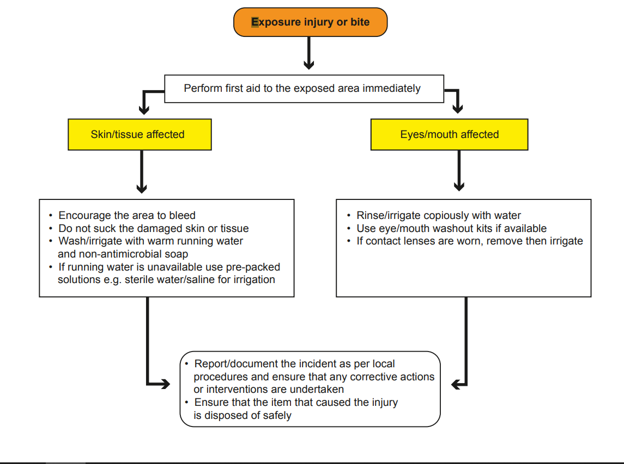

**This policy considers:**

* <http://www.washyourhandsofthem.com/children's-pack.aspx>
* Keep it clean and Healthy (copies are provided during pre registration training) [www.dettol.co.uk](http://www.dettol.co.uk)
* Disposal Gloves: use and management [www.careinspecotrate.com](http://www.careinspecotrate.com)
* Infection Prevention and Control in Childcare Settings (Daycare and childminding settings) updated 2018 [www.documents.hsp.sct.nhs.uk](http://www.documents.hsp.sct.nhs.uk)
* Exclusion Criteria for unwell children can be found

<http://hub.careinspectorate.com/media/120865/hps-exclusion-criteria-childcare-a3-2011-12.pdf>