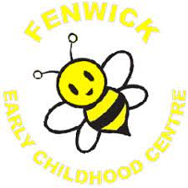

Minutes of ECC Eco Group Meeting 30/11/22

Present: Mrs McKillop, all children in the E.C.C.

* Mrs McKillop had some rubbish with her. The children talked about what the rubbish was and where it should go eg. Plastic for recycling.

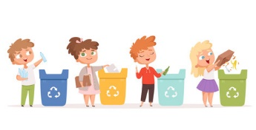

* We talked about the turtle and bee that Mrs McKillop brought and how we could look after them.

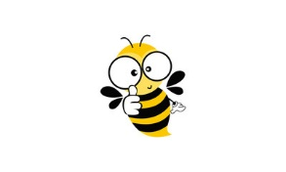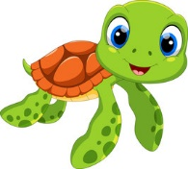

* Some of the children were able to talk about how to help keep our animals safe.
* We decided what we could do to save our planet.