Establishment |  |  | Fenwick E.C.C. 1-3 Kirkton Road, Fenwick, 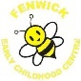
Lead Young People |  |  | ECC Eco Group
Supporting Adults |  |  | Staff and Parents
Theme | Planned Actions/Ideas | Who is Involved? |  | Timescale | Review/Update
Energy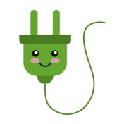 | - Use more natural light instead of turning lights on. | - All children  - All staff |  | June 2023
Waste | - Have recycling bins in playrooms for paper and plastic.  - Litter pick in the local community. | - All children  - All staff  - Mr Risk (Janitor) |  | June 2023
Natural Environment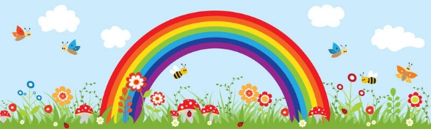 | - Maximise outdoor learning area.  - Planting flowers in local community.  - Make animal homes eg. Hedgehog house, bug hotel. | - All children  - All staff  - Parent Helpers  - Members of the Community |  | June 2023

