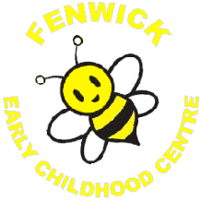

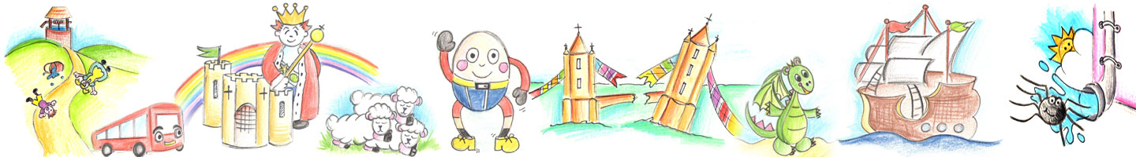

Realising the Ambition: Being Me (Education Scotland, 2020)

States the importance of Early Literacy skills through out childhood.

What is your favourite Nursery Rhyme?

Can you create a drawing, collage or picture of your favourite rhyme?

You can post a photo of it on your Learning Journal or bring your creation into the ECC to be displayed on the wall.

Sheet attached if you wish to use this.

Fenwick Early Childhood Centre

Literacy Home Link Experience

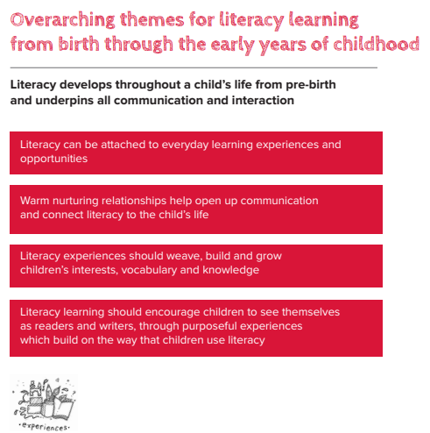

Curriculum for Excellence Links

Literacy 01a –

I enjoy exploring and playing with the patterns and sounds of language and can use what I learn.



Name:

Fenwick Early Childhood Centre

Literacy Home Link Experience