
Standards and Quality Report
For session 2025~26
Catrine Primary School
and
Early Childhood Centre

Catrine PS – blue
Catrine ECC – red
Both - green
Establishment Context
Catrine PS and Catrine ECC are both situated in the semi-rural village of Catrine, in separate buildings more than a mile apart. The ECC was extensively refurbished, moving back to their own establishment in January 2023 and are now fully settled in their beautifully updated premises.

In session 2025-26 our school roll had dropped to 122, a reduction of 16 pupils from session 2024-25 with 138 pupils. This year we have managed to retain our 7 x straight class structure for the second year running. Term 4 of this session has been quite fraught throughout the school as we discovered in March 2026 that, due to a drop in pupil numbers for session 2026-27, we would be moving from a 7 x straight class to a 5 x composite class structure in August 2026 and would be losing 6 x members of staff at the end of June 2026. For a relatively small school, this had a major impact and it has taken Term 4 for staff, pupils and our community to come to terms with this major upcoming change.

We were a Quartile 1 school but were moved to Quartile 2 status in September 2024. Currently, 75% of our pupils are in SIMD 1 and 2, an increase of 15% from session 2023/24. Of our remaining pupils, 21% are in SIMD 4, with 1% in SIMD 5 and 3% in SIMD 6. 30% of our pupils are entitled to Free School Meals, which has been a consistent figure from session 2021/22. 26% of our pupils are on our ASN log and we have 3 Care Experienced pupils.

PEF funding was once again used to secure additional Classroom Assistant hours, meaning we had 3 x Classroom Assistants spread over 7 x classes, although one CA was predominantly working in P3 to support 2 x ASD pupils. This additional CA resource resulted in targeted support of pupils identified through our assessments, tracking and monitoring procedures and professional discussions, more focused timetables and clearer, consistent pastoral support for identified pupils.

We started our very successful ECC-P1 Transition programme in January 2026, inviting our pre-schoolers to school assemblies and events, sports activities in the school grounds and Literacy, Numeracy and HWB mornings organised by their P6 Buddies before implementing our timetabled programme of regular small group visits into the P1 classroom with their Buddies. The feedback from our P1 parents about our Transition programme is always very positive and complimentary, stating that they felt their child settled into P1 quickly due to having visited the school and teachers so many times whilst still at ECC.

We also had 4 x P7 pupils involved in the Enhanced Transition programme between P7-S1 at the Robert Burns Academy in Cumnock. These pupils had 5 x extra visits to their new school from October 2025 onwards, as well as participating in the 2 x full days for all new S1s with their peers. Again, these extra days have resulted in these pupils feeling much more positive about their upcoming move to secondary school as they know teachers, the school layout and their routines.
We held in-school Parents Evenings in October and March, with 98% parental attendance at both events, for the third year running. We’ve hosted a wide range of very successful events ranging from school shows, Christmas Fayres, school discos, season assemblies, prizegiving and services, Open Days and Sports Day – all very well supported by our ECC and PS community who are so invested in both establishments are we are at the heart of village life. Both establishments provide detailed event calendars at the start of the school year so that parents/carers are notified in advance of upcoming events and we use both our GLOW and app on a daily basis to ensure clear communication with our wider school community.

Both the ECC and PS have fully incorporated our CATRINE Values, referring to them in our conversations with both children and parents/carers to ensure a clear understanding of our standards and expectations. We take pride in the role we play in our village and children of all stages can regularly be seen out and about in Catrine, visiting places of interest, researching historical figures and people, making maps and future plans and enjoying our lovely, local environment. We also regularly work alongside community groups taking part in litter picking, donating food items from our Harvest Service to Ma Broon’s Food Larder in the Institute, creating artwork for display in shop windows, singing Christmas Carols in the Square and presenting our Scots Verse poems at the 12 O’clock Gang Lunch Club for pensioners.

Establishment Vision, Values and Aims
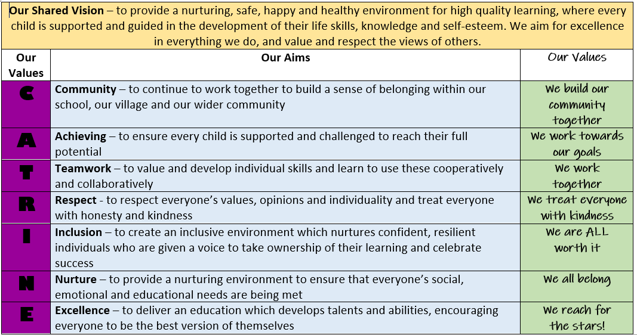

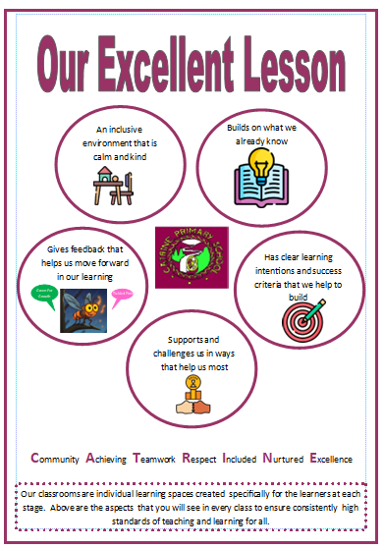

Improvement Priority  Catrine PS | Rationale – as a whole staff team we will continue to build upon our improvements and successes in offering our pupils a chance to participate in a wide range of high quality and diverse learning experiences through our Discovery Dens.  Our staff will also continue to develop their own personal leadership skills through their involvement in CLPL for specific curricular areas, focusing on upskilling both themselves and their colleagues through collegiate training dates and the dissemination of information. | Education Service Improvement Plan 1:  Our Leadership  We actively support, promote and enact leadership at all levels. Our young people are supported to be leaders of their learning in our centres, establishments and wider life experiences. All staff have ready access to appropriate CLPL and experiences to promote leadership in every classroom, playroom and centre.
Our Leadership

Progress and Impact | Health and Wellbeing – Jill Ferguson and Jacqueline Hasson Primary (jobshare) and Chloe Russell Primary 5  Aims  To continue to embed understanding and compliance with Rights Respecting School legislation with both pupils and wider school community To implement Discovery Dens across all stages, focusing on Metaskills and targeting pupils’ interests To plan and implement a Health Week (8th – 12th June 2026) involving existing partners and establish new community links  Actions and Impact  RRS poster created highlighting Right of the Month from October 2025 to June 2026. Articles from RRS discussed in detail during monthly Home Circles in mixed stage focus groups and a BIG question set for pupils to answer, with older pupils assisting younger pupils to provide their answer ensuring everyone is involved. Answers are displayed in corridors and posted onto school GLOW blog monthly to inform parents about focus and understanding of the RRS Articles (all work contained in Home Circles jotters)  Discovery Dens – timetable created for 8 x sessions from September 2025 to May 2026 from 2.00-2.50pm. All pupils participated in all 8 x sessions and the Metaskills covered were highlighted by staff in preparation for future focus next session  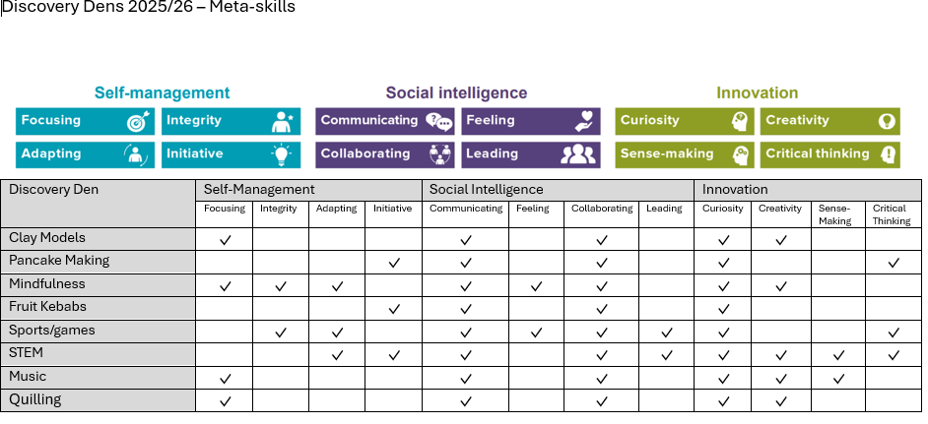  Discovery Dens: Pupil Voice The following statements are a selection of data gathered from Pupil Voice discussions relating to experiences and skills learned through Discovery Dens in session 2025-26  Matthew P4 - I hadn’t tried quilling before. I liked it but it was a wee bit hard.  Logan P4 - I liked the pancakes because I’ve never done it before.  Carson P4 - I liked making fruit kebabs because I got to try fruit I’d never had before. I learned that your taste buds change every 7 years.  Charlie P2 - I tried to make things with clay for the first time. I had to be creative.  Riia P2 - I learned how to make pancakes. I learned how to flip them and I know to be careful not to burn my fingers.  Leah P3 - Discovery Dens made me feel I can do new things.  Jaxson P3 - I liked how they were all different.  JayJay P3 - I liked mixing with other classes.  Maddisen P7 - I liked making the batter and flipping them by yourself. I learned independence.  Brody P7 - I liked making my own things at clay modelling – it was creative.  Health Week – another very successful Health Week was organised with a wide range of visitors timetabled to highlight the importance of HWB and a healthy lifestyle. Activities included food tasting/preparation with two local restaurants, visits from Police Scotland and Scottish Fire and Rescue Service, visits from RNLI volunteers, visits from Shaw Eyecare optometrist, team games with Ayrshire 360 staff and a whole lot more!  The Outdoor Den Building Day on 11th June 2026 was attended by 56 parents/family members who all built dens in our school hall and then ate lunch with our pupils in the den – see Catrine PS GLOW blog for photos.
Next steps | Health and Wellbeing – Jill Ferguson and Jacqueline Hasson Primary (jobshare) and Chloe Russell Primary 5  Continue to build on RRS implementation by devising another calendar for Right of the Month to ensure all RRS Articles are outlined to pupils Organise another round of Discovery Dens focusing on embedding understanding of Metaskills covered and aiming to widen range of skills offered to pupils through carefully chosen activities from all curricular areas Continue to involve parents and wider school community in HWB/Health Week activities to promote adoption and understanding of healthy lifestyles and highlighting clubs and activities in our local area that can be accessed
Progress and Impact | Literacy – National Writing Improvement Programme – Tammy Withers, Primary 3  Assessed 18 x P3 pupils in September 2025 – 55% on target for achieving 1.2 Tools for Writing so target of 77% by June 2026 was set.  Writing sessions take place 3 or 4 times every week and decision was made to not focus on genres, purely focus on Tools for Writing.  DHT and Mrs Withers attended National Writing Improvement Programme (NWIP) training in Glasgow in September 2025 and attended regular online twilight sessions from October 2025 to May 2026 to discuss progress and strategies with colleagues. NWIP was introduced in September 2025 with Target 1 being identified using a Pareto, which showed to prioritise punctuation: capital letters, finger spaces and full stops. By 31.10.25 100% of P3 pupils were achieving this target regularly.  Target 2 started in November 2025 focusing on adding a conjunction to sentences and by 11.12.25 more than 90% were able to consistently and appropriately add a conjunction in their writing.  Target 3 began in January 2026: the use of different openers. By April 2026 over 90% were able to use different openers on request.  Target 4 began in April 2026: making sense. This is an ongoing target; children are encouraged to check their conjunctions have been used correctly and that they have all the words in the correct order. Currently 70% on target for consistently making sense and, in some lessons, increased to 88%. Our aim is to have 95% by June 2026.  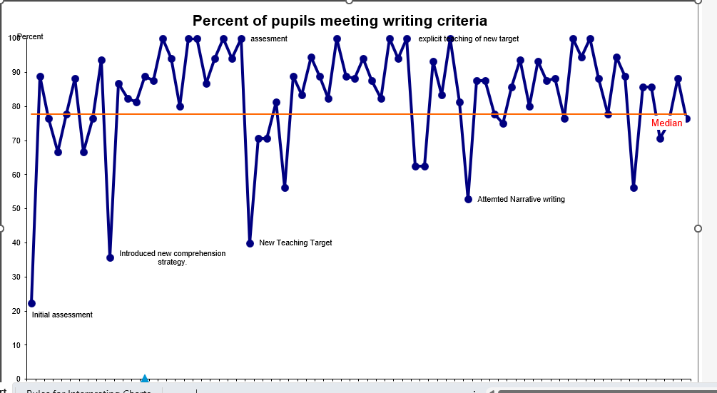  % of pupils meeting writing criteria – chart shows P3 progress in Writing from September 2025 to May 2026
Next Steps | Literacy – National Writing Improvement Programme – Tammy Withers, Primary 3  Next session, as Primary 4 pupils, continue with Target 4 to work towards aim of 95%  To begin to use Tools for Writing skills and strategies in short paragraphs
Progress and Impact | Leaders of Learning – Fiona McCaig, Primary 7  Aims of Pupil Focus Group which met termly throughout the session  To develop a consistent approach to high-quality learning and teaching through clear learning intentions and success criteria across all curricular areas  To develop understanding of creative ways to use ICT to support differentiation and meeting learners needs  To embed our ‘Excellent Lesson’  Actions  Staff survey completed to gather information on use of, and confidence with, creating LI and SC  Audited teaching of language and resources used to ensure consistency across school  Created Excellent Lesson feedback sheet for use by pupils to assist with QA processes so that feedback was being provided at all levels  Regular pupil focus groups meetings to review progress and set next targets  Developed a mascot (Felix the Feedback Firefly) for use by the whole school to create consistency  Created stickers following staff discussions and pupil group consultation to support whole school feedback policy  Impact  Age and stage appropriate LI are more consistently and confidently used across the school, and are written in jotters frequently to ensure pupil understanding and relevance  Staff and pupils are developing their confidence in co-constructing their SC  Pupils are more familiar with the language and terminology of LI and SC and speak with greater confidence about their learning  P6 and P7 pupils are now part of the Classroom Observation process and their feedback is shared with staff  A school mascot was created and every class has a Felix on display  Pupil focus group created a bank of feedback statements and these were used on the Felix stickers, used in jotters throughout the school, to support whole school feedback policy  The consistent approach, feedback policy, Excellent Lesson and the continuous development of LI and SC has combined to create a clearer and more consistent learning experience for all pupils
Next steps | Leaders of Learning – Fiona McCaig, Primary 7  To create a planned calendar of pupil observations using the Excellent Lesson template To continue to develop awareness of all aspects of the Excellent Lesson with pupils and parents To implement observation feedback conversations between teachers and pupils to create a greater depth to feedback and its importance Through further collegiate training, continue to increase staff awareness in the use of Teams to support learner’s needs in school
Progress and Impact | Numeracy – Multiplication Masters  Fiona McCaig Primary 7, Cheryl Burleigh Primary 6, Lauren Campbell and Kirsty Mair Primary 2 (jobshare)  Aims  To improve speed and accuracy of table recall across all stages To ensure 70% of all pupils are confident with appropriate times tables at each stage  Actions and Impact  Accurate data was unable to be collected due to functionality errors with spreadsheets which led to some data being overwritten, therefore not providing a clear picture of progress made  100% of classes have flashcards, access to laptops and manipulatives  100% of P2-7 pupils have times table passports within their numeracy jotters  Reflect on 3/2 teaching approach to MM and NT to assess greatest impact and make relevant changes – This happens consistently in some classes and not in others. Discussion as a full staff and SLT re: how MM is facilitated moving forward to ensure maximum impact  Evaluate the ‘make’ aspect of MM so it’s stage appropriate – The ‘make’ aspect of MM is not always being utilised to the maximum. Pupils often deviate from task and key learning is missed, particularly in upper stages. P6 and P7 made decision to deviate from the ‘make’ and implement a focus around fact families linking multiplication and division facts, which has proved useful and will be formalised next session.  Collate end of session data to evaluate impact and develop next steps -  After collegiate discussions, it was decided that a new method to capture data and track progress was needed. The NWP have developed a new spreadsheet for each stage that will follow them throughout their primary journey across all stages and levels. This will provide a clear picture of the progress made within the year and over time. It will also allow us to capture those who are exceeding and ensure that they are being challenged accordingly. From here we will be able to capture more accurate attainment data and provide transition information each session.
Numeracy – Multiplication Masters
Fiona McCaig Primary 7, Cheryl Burleigh Primary 6, Lauren Campbell and Kirsty Mair Primary 2 (jobshare)
Roll out new spreadsheets to all staff and provide training on data input and utilisation Formalise the new ‘fact family’ aspect of MM (activities and materials) Discuss the 3/2 teaching approach and ensure ALL classes follow Develop challenge activities for pupils exceeding their age/stage Continue professional discussions re current numeracy planners being used with potential to move to one page progression framework which shows all levels, to support pace and challenge

Progress and Impact | Literacy – National Improving Writing Programme – Laura McKenna Primary 4  Mrs McKenna’s second year of implementing programme in P4, with current P4 class involved since August 2025. Aim set in September 2025 for all P4 pupils to achieve First Level Tools for Writing by end of P4.  Pupils have been writing 3 x times per week for 15 minutes, with a particular focus on Tools for Writing. Pupils then self-check or peer assess their work.  Data has been collected regularly on children’s progress with a clear focus on improving one aspect of writing at a time.  Pupils have been involved in the process of collecting and analysing data on a run chart and have a clear understanding of how their progress is monitored and how it impacts on their next steps in learning.  Pupils have worked hard to meet their own individual targets and have all made progress, with June 2026 ACEL data showing 88% are on track and 12% are exceeding national targets in Writing.  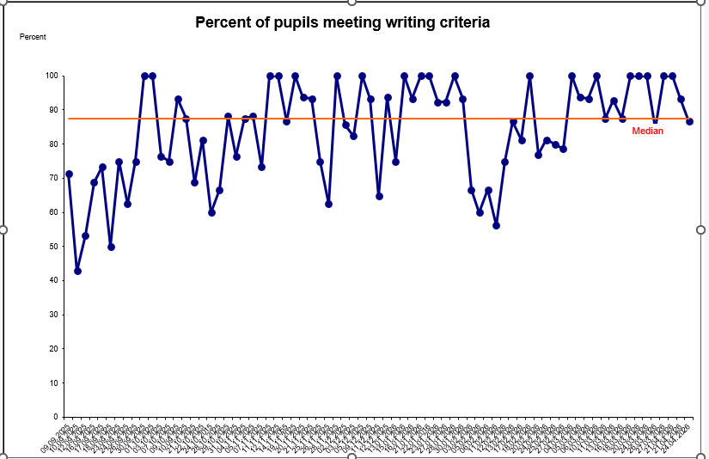  % of pupils meeting writing criteria - chart shows P4 Writing progress from September 2025 to May 2026
Next steps | Literacy – National Improving Writing Programme – Laura McKenna Primary 4  To introduce the programme with new P3 pupils starting in August 2026 For current P3 and P4 pupils to continue to build on skills as they move into P4 and P5 from August 2026 with P5/6 teacher starting NIWP training in January 2027

Improvement Priority  Catrine PS | Improvement Priority  Rationale: To work with all stakeholders to review and update our Curriculum Rationale to reflect our improvement priorities, new learning and teaching approaches, new resources and assessment priorities | Education Service Improvement Plan Priority 2: Teaching and Learning Together  Our young people should experience a teaching, learning and curriculum offer that meets their needs, and those of our local and national context. All staff should be supported to deliver in new and innovative ways by accessing CLPL relevant to their needs and those of our young people.
Teaching and Learning Together
Progress and Impact | Curriculum Rationale - At February 2026 in-service all staff were involved in professional discussions reviewing our current Curriculum Rationale, which was last updated in session 2018-19. Over the previous two years we have reviewed and updated our Values, Vision and Aims and this was the next logical step.  We had a selection of CRs from other establishments to look through and take guidance from and then we brainstormed our Catrine priorities. We discussed using our Excellent Lesson display format for consistency and we started to list what should be included in each section. We made copious notes and have a clear way forward for completion.  At Home Circles on 19.03.26 we asked our pupils ‘Our Curriculum: our curriculum is all of the things that we learn about in school, like Reading, Writing, Numeracy, Science, Learning Outdoors, PE and a whole lot more… What other things would you like to learn about in school and why?’  We received a wide variety of answers from our pupils, including  - Spanish because if we go on holiday to greet them properly  - Acting because it would be cool to learn  - How to grow and keep a plant alive  - More science experiments  - More coding on laptops  - What Catrine used to look like  - Reading and Writing because I like telling stories  At Home Circles on 29.04.26 we asked our pupils ‘What makes a quality teacher?’ and ‘what makes a quality pupil?’  At our Parents Night in October 2025 we also posed BIG questions to our parents/carers – some examples of answers collated below.  We’re updating our Curriculum Rationale this session.  How do you think we can best support your child’s learning goals together?  - Encourage her along the way  - Fantastic support in place for pupils already. Keep up the good work  - More activities to do at home  - Getting them extra help from East Ayrshire  - Keep up the great communication  What do you hope your child achieves or improves upon in school?  - More confidence and be happy  - Improves their manners, social skills and keeps being happy  - For a happy child  Are there any specific skills or subjects you would like us to focus on in school?  - Focus on money but how to manage it  - Cooking skills is a fab idea!  - Maths and English  - Maths and learning to listen  - Cooking skills  - Teamwork, manners and social skills  - Life skills and practical skills  - More maths, free choice (kid’s answer!), savings to be good with money, cost of living  Our Excellent Lesson and Feedback policies, which were created by our pupil focus group, were shared with all pupils and wider school community from August 2025. We have posters in every classroom and around the school and Felix, the Feedback Firefly is displayed as a mascot and on stickers.  We focused on our Excellent Lesson in Home Circles in September 2025 to ensure our pupils had a clear understanding of the five elements:  Please also see Priority 1 for Excellent Lesson and feedback information  Whole school continued focus on:  Handwriting – ongoing using Nelson Handwriting resources at all stages. P7 pupils were praised by RBA staff during their transition visits for their high quality handwriting and presentation skills.  Multiplication Masters – please see Prioroity 1 for information  Spelling – DHT Roberta Schendel and P4 teacher Laura McKenna attended training in Glasgow in March 2026 for the National Spelling programme initiative and Mrs McKenna has subsequently changed her spelling programme. She highlighted the new approach she plans to take at our collegiate night in April 2026.
  What makes a quality teacher? | What makes a quality pupil?
  Supportive – has a calm and inclusive manner | Using your feedback to get better at your work
  A happy and fun teacher | Following our Excellent Lesson rules
  Gives us lots of challenges | Pupils that are kind and show respect
  Listens to me and helps me | Pupils that listen to staff and other pupils
  Likes to learn stuff with you | Pupils that try their best
  Shows respect and is kind | A caring pupil
  A teacher who understands you | Following our CATRINE Values
  An inclusive classroom that is calm and kind | Builds on what we already know | Has clear LI and SC that we help to build | Supports and challenges us in ways that help us most | Gives feedback that helps us move forward in our learning
  The calm crate | Our assessments | Felix the firefly | Overlays and fidgets | Tickled Pink and Green for Growth
  Catrine Compliments | Times tables masters | Tickled Pink and Green for Growth | Staff support | Check your SC
  No shouting and being quiet | Go over what we learned before | Displays in rooms | Help from teachers and Cas | Felix the firefly
  Being respectful | Prior knowledge | So we know what to improve on | Multiplication squares and rekenreks | Use Felix’s Foundations to check the basics
  Letting people join our groups | Questioning | Using Felix’s Foundations | Core and challenge questions | Fixing mistakes means that you’re learning
  Class charter | Working to get better at what we know | We know what we are learning | Not too easy and not too hard
  CATRINE Values |  |  | Using laptops
Next Steps | Curriculum Rationale – at the February 2026 in-service day, not all of our teaching staff were present due to being jobshare so it was agreed that we would consult with our pupils at Home Circles, gather their views and then pick up the discussion again at October 2026 in-service when all staff members would be present to ensure that all were consulted.  We will also refer back to the answers collated during Home Circles and from parental consultation (see table above) to inform our language choice and to highlight that our pupil voice is both listened to and acted upon. Through their involvement in the updating and creation of our Curriculum Rationale, we intend for pupils, staff and our wider school community to have a better understanding of WHAT they’re learning, WHY they’re learning it and HOW they learn best.  Excellent Lesson – we will continue to highlight our Excellent Lesson across our school community and focus on its elements during Home Circles to ensure a sound understanding of its principles by all pupils. We will also continue to refer to Felix’s Foundations in an age/stage appropriate context before each lesson to ensure consistency across the school in jotter standards and presentation.  Tickled Pink and Green for Growth will continue to be used as our feedback policy and will be highlighted each week at assembly during our Excellent Work Wall presentation.  Spelling – Mrs McKenna and DHT will continue to audit spelling resources in order to update our whole school spelling approach and assessments, incorporating GL Assessments to ensure consistency and to provide data to inform next learning targets for individual pupils and groups.

Improvement Priority  Catrine PS | Improvement Priority  Rationale: to ensure all pupils are reaching their full individual potential in our school by focusing on their mental, emotional and physical wellbeing by using a variety of strategies and resources, analysing the data they provide, and putting supports in place, with parental involvement and engagement, if required | Education Service Improvement Plan Priority 3: Our Wellbeing and Belonging  We want all of our young people to feel supported by people who know them well and feel included in all of our establishments and centres. Our staff need to be supported in their working with our young people, especially in times of adversity. As a key universal service, it is our vision that all young people attend our establishments on a full-time and regular basis to support them in their development at all stages.
Our Wellbeing and Belonging
Progress and Impact | Attendance Tracker – Headteacher and Senior Clerical Assistant, Mrs Robertson, worked together to implement the EAC Attendance Tracker programme, meeting regularly to log attendance data and discuss each PAR collation. A system of phone calls, letters and invitation to meetings was devised, using some of EAC’s template letters and incorporating our own wording, where required. We focus on attendance below 90% with letters and phone calls.  If a child is absent, Mrs Robertson texts at 9.30am and again at 1.15pm if there has been no answer/response. We also have a list of children that we phone if they are absent to ensure we have a physical check-in with parents/carers due to a variety of reasons. All phone calls/responses are logged onto SEEMiS.  We also regularly posted attendance information on school BLOG site, highlighting the number of days missed at school that regular absence adds up to. HT also regularly highlighted attendance at weekly whole school assemblies to ensure pupils are aware of its importance and how regular absence means they’re missing out on important school teaching time and events.  Attendance across the school has remained relatively steady for each cohort:  As with all school, parental decisions to take pupils on holiday during school times means that 100% attendance is difficult to attain. A number of factors, including personal circumstances for some families, has affected families. Various support systems have been put in place including Barnardo’s, Exchange Counselling and SW support for parents to help with home routine and boundaries. This has informed systems and processes moving forward.  All interventions documented on SEEMiS pastoral notes.  Implementation of PASS surveys – all classes completed a PASS survey from GL Assessments in January/February 2026 for the first time. During Tracking and Monitoring professional discussions, teachers commented that they felt that most pupils completed the survey well but due to time pressures we were unable, as a collegiate staff team, to spend time analysing the results and using the data provided to inform our next steps.  Wellbeing Webs – every pupil completed a Wellbeing Web in November 2025 with teachers writing down comments from pupils when they have scored themselves 6 or less in any category. Teachers then shared these comments with SLT and future actions were decided. For example, one pupil chose 1/10 for ‘feeling safe in school’ and when the teacher asked him why he felt this way, he said ‘there’s broken glass on the path I walk to get to school and I’m scared I fall in it and cut myself’. After these conversations, we phoned parents to inform them of any worries/concerns that their child had.  Respectful Relationships – as a staff, in May 2025 we reviewed our current Respectful Relationship policy and looked at other establishments policies for guidance, making notes about which direction we wanted to go in when updating our RR policy. Throughout this session we have consulted our pupils in their Home Circles about a wide variety of issues that we feel should be included in our policy – see table below.  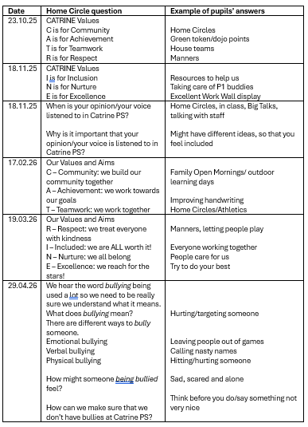  ‘Keep The Promise’ training – both ECC and PS staff attended ‘Keep the Promise’ Session 1 training delivered by Catriona O’Neill, EAC Senior Education Manager, at the October 2025 in-service. We learned the correct terminology to use with SEEMiS notes and discussed the absolute need for a GIRFEC approach. We focused on the five areas that The Promise is built on  - Family  - Scaffolding  - Voice  - Care  - People  and found out about the CELTS (Care Experienced Lead Teachers) in EAC that we could contact for advice and guidance when dealing with Care Experienced children. We set the target of reviewing our Keeping the Promise training up to date by refreshing staff training every three years. Staff then completed the e-learning modules and related quiz.  Inclusive Classroom checklist – all teaching staff, in liaison with Classroom Assistants, complete the Inclusive Classroom checklist in August/September to ensure an inclusive environment for all pupils is being provided. SLT then elements of this checklist during the first teaching observation session to clarify that all elements highlighted are in place. Professional discussions take place after observations if any elements require clarification.
   | Sep 2025 | May 2026
  Primary 1 | 94% | 94%
  Primary 2 | 92% | 93%
  Primary 3 | 95% | 94%
  Primary 4 | 92% | 92%
  Primary 5 | 92% | 93%
  Primary 6 | 83% | 90%
  Primary 7 | 90% | 89%
  For reference, pupils completed HMIE pupil questionnaire in April 2026 | Date/  no. of responses | Strongly agree | Agree | Disagree | Strongly disagree | N/A
  - I feel safe when I am at school. | April 2026  102 forms | 47% | 49%  (96%) | 2% | 2%
Next Steps | Attendance Tracker – HT and Senior Clerical Assistant will continue to closely monitor attendance using new EAC system of four weekly PAR dates. We will use data from session 2025-26 to identify a group of pupils for further scrutiny and aim to raise cohort attendance for all stages to 94% by June 2027. Catrine PS, as part of the Barony Education Group, is also going to be part of the pilot scheme to introduce/trial Parent Portal to replace the current school app – this group will be led by David Falconer, starting in September 2026.  Implementation of PASS surveys – the completion of PASS surveys is on our Assessment Overview for January/February 2027 and collegiate time will be dedicated to analysing the data as a whole staff team to ensure a solid understanding of reading the graphs/tables provided. We will also create a way of recording how we deal with any issues which are highlighted to ensure that that we can show what we did and how it positively impacted the pupil involved.  Wellbeing Webs – we will continue to complete these annually in November as they are simple and easy to use and it’s a good way for us to find out about concerns that pupils might have and seek ways to resolve them (see example above). Teachers also emphasise that they enjoy the one-to-one conversations with pupils when reviewing the Webs as pupils like to talk about their positive scores and why they’ve chosen them.  Respectful Relationships – we intend to collate the ideas in session 2026-27 and produce a final version by December 2026 to be shared with pupils, staff and our school community  ‘Keeping the Promise’ training – Headteacher and Depute Manager at Catrine ECC to collate list of staff members who have completed the requirements and inform Catriona O’Neill in order to obtain the award, which will allow us to display the logo around our school and ECC. Timescale – by December 2026.  Inclusive Classroom checklist – through professional discussions, it was agreed that the checklist would be completed in both August and January each year due to changing class and pupil requirements. Quality Assurance calendar will be updated accordingly.

Improvement Priority  Catrine PS | Improvement Priority  Rationale: by introducing GL Assessments to our updated Assessment Overview, we are adding another aspect of data collections which will continue to ensure we provide accurate learning targets for our individual learners, based on their needs. As a staff, we will work more collegiately to interpret the data we collect, allowing it to impact whole school decisions and future priorities. The creation of profiles, both digital and paper, will create an invaluable database of our pupils and will allow them to influence their next steps in learning. | Education Service Improvement Plan Priority 4: Our Attainment, Destinations and Achievements  We want the very best for all of our young people in East Ayrshire.  We aim to ensure that all young people secure a positive destination through excellent achievement and attainment at all levels.
Our Attainment, Destinations and Achievements
Progress and Impact | GL Assessments - By introducing GL Assessments across the school, in tandem with our updated Assessment Calendar as part of our Quality Assurance procedures, we ensured a strategic embedding of both which resulted in both pupils and staff feeling supported and confident throughout the process.  Scott Campbell, GL Assessment consultant, delivered a full day’s training course to all teaching staff at the August 2025 in-service day. He talked us through both Literacy and Numeracy assessments at all stages and detailed how to analyse and use the data provided. He highlighted how to create settings, plot progress for both individuals and groups. He answered all of our many questions and all staff felt reassured and confident, including our DHT who will be responsible for setting up class lists on the system.  We purchased paper assessments for Primary 2 and Primary 3 pupils to create baselines and arranged settings for P4-P7 pupils for November 2025. All classes completed their assessments, with support provided for staff when required. Staff worked with stage partners to analyse the data produced and it was used to back up teacher professional judgement when inputting ACEL data for TP2 in February 2026. Most staff felt reassured with the data as it matched their own assessment judgements and scores.  Digital profiles – we created individual digital profiles for all P3-P7 pupils to improve how we share learning targets and successes of our pupils with their parents/carers. In session 2024-25 Miss Burleigh and HT attended online training with Education Scotland about how to set up the digital profiles through the portal. Miss Burleigh then set up login details for P5, P6 and P7 pupils so that they could get their profiles set up, choose their avatar, complete the personality quizzes and set their first targets. Miss Burleigh also led staff training in September 2025 to allow all staff to navigate the site with support on hand before working with it with their pupils.  This meant that two stages were already set up at the beginning of session 2025-26 and could start using the site immediately, whilst the older pupils worked alongside P3 and P4 pupils to help them set up their pages. It was agreed that all stages should be up and running by December 2026, which was achieved. Throughout the course of the year, senior classes reported that it was difficult and time consuming to upload evidence to the site with regards to targets so 10 x iPads were purchased to be solely used for uploading evidence across the 5 x stages. This is working well so far and senior pupils have very quickly learned to upload evidence and set new individual targets independently.
Next Steps | GL Assessments – to continue to use Literacy, Numeracy and PASS surveys at all stages in session 2026-27 and ensure dedicated collegiate time in calendar for discussion and analysis of results to ensure it has an impact on next steps for learners  Digital Profiles - to continue to embed profiles across P3-P7 and set a timeline for sharing login details with parents/carers so that they can view their child’s targets and profile with a view to using it as a means of sharing and recording individual targets.

Improvement Priority  Catrine ECC |  | Improvement Priority (Expressed as outcomes for learners)  Key Themes –  Individual ELCP development programme  Individual ELPC family workshops and support  Individual ELCP home link programme  Rationale - During both our Authority visit and most recent Care Inspectorate report we have been praised in relation to the level of leadership opportunities throughout the centre. Ensuring that these individual Champion roles are embedded in the day-to-day life of the centre we aim to continue with them, promoting further empowerment and passion to drive improvement forward even more. Last year’s plans have been well documented, evaluated and ELCPs next steps for 2025-2026 have been used as a starting platform after reflection and self-evaluation. life of the centre we aim toting platform below after reflection and self-evaluation. |  | Education Service Improvement Plan 1: Our Leadership  We actively support, promote and enact leadership at all levels.  Our young people are supported to be leaders of their learning in our centres, establishments and wider life experiences.  All staff have ready access to appropriate CLPL and experiences to promote leadership in every classroom, playroom and centre.
Our Leadership
Progress and Impact |  | Language, Communication and Inclusion  Children were introduced to Makaton through feelings songs/Nursery Rhymes during group times and a Makaton rhyme of the month. They were exposed to the visuals daily and it gave them the understanding of what was happening when, what to do and where to find certain areas/resources which they found helpful. It helped make transitions a little easier and more manageable for children who struggle with these. All children within the ECC at some points have used the visuals throughout the year, some more than others. For example, 3 x children used the lanyard visuals regularly at lunch and 4 x children used the daily timeline visuals when unsettled and wanting to know when it was nearly home time. Children were using the timeline regularly, going up to it and pointing to the steps which come next, or moving the arrow along.  Most children wanted to learn more about Makaton and asked what certain signs were. Staff were following a consistent approach to help support and understand communications. The children in the Voes room access the display board themselves and chose which song they would like to sing. 7/9 children will regularly try out some form of Makaton signing within this room. The Voes children successfully sang Twinkle Twinkle at the Square and almost all children were able to carry out some of the signs. 8 x Makaton videos have been uploaded onto Learning Journals and 4 x Makaton song bags have been created, based on the children’s favourite nursery rhymes.  12 x children were identified as requiring additional support in relation to communication and attended weekly group sessions. All children have shown progress on their individual iCan trackers. Attention and listening scores had increased by an average of 3.9 and comprehension scores have increased by 1.7 on average.  HOME LINK - 30/32 children participated in at least one week of the 4-week block. The two children who didn’t attend were absent on the days that the books went out. 18/30 participated in the HomeLink activity sheet. 8 x Makaton videos were uploaded onto Learning Journals with most parents saying they had viewed them with their child(ren).  PARENT WORKSHOP – parents gained more understanding around the importance of visuals and Makaton and how these don't suppress language, but actually support it by working alongside the language. They learned about the range of visuals that can be used and the stages they can be used at. 5 x parents attended and the feedback received by parents was very positive.  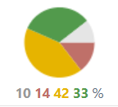  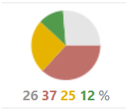  30th June 2025 (LITERACY) Same child 20th June 2026  Health & Wellbeing  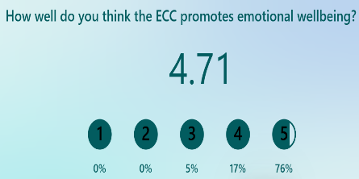  Throughout the year the team have observed, monitored and recorded wellbeing/engagement scores of children to pinpoint which children are finding things difficult and thinking of ways that we can support using a solution-based approach. The data shows which children benefit from change ideas such as breakout spaces, transition change ideas and communication friendly environments.  Small tests of change have been implemented over the course of the year both for the centre as a whole and for individual children. Improvements have been seen in all children tracked over the year. In March 2026 the Depute Manager was asked to present at an Education Scotland conference in front of over 200 people at Murrayfield in Edinburgh after the centre was recognised for its excellence in supporting children with additional support needs. Staff recognise the needs of individual children and the strategies that we need to put into place. The impact is clear and wellbeing is visible throughout planning, tracking, monitoring and My Plans.  Posts were uploaded onto Learning Journals with home support links, e.g. toilet training, NEST and Pantosaurus. 3 x children returned after Easter after the toilet training post fully toilet trained and 1 x child making some progress.  Nurture groups were run by our EEL over an 8-week block. Experiences planned to promote and further develop social/emotional development, listening and attention skills and communication and language skills. 20 x children were targeted, aiming to improve their baseline score in social and emotional skills. 17 x parents gave permission to join us; however only 15 took part due to child choice in participation. There was a significant improvement measured across the children who took part in these sessions. Data shows that 14/15 children who took part in the sessions demonstrated that they have made progress across the selected HWB trackers.  PARENT WORKSHOP - Mental Health Workshop – stations were set up that allowed a relaxed atmosphere and free flow feel to the sessions whilst still having the opportunity to learn various strategies and take souvenirs home. This suited the age and stage of more children and parents found it to be a relaxing atmosphere due to the “well-planned structure”. 10 x families came of the 12 offered spaces.  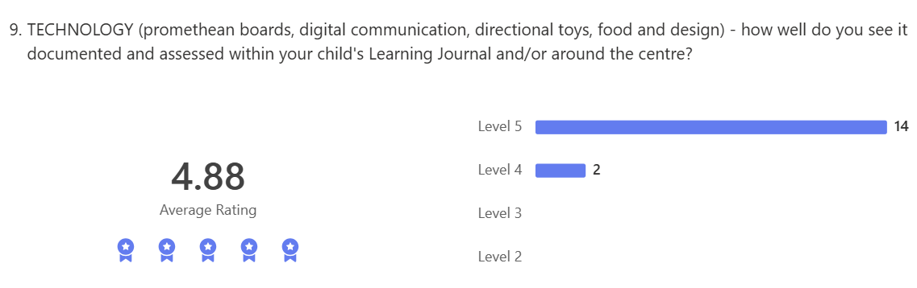  STEM  Time and research has gone into the breakdown and expectations of the National Stem Award with the decision being made that we will register to begin this journey next year. A SWAY has been started to begin collecting evidence.  An investigation station, new mud kitchen area and a science box were all created to provide children with more access to science opportunities as a continuous provision, both in and outdoors.  Unfortunately, no ECCs have engaged with us/agreed to link up. We attempted to sign up for the Google initiative put forward at a Digital meeting; however there is currently no funding for this to be rolled out. Each of these were outwith our control in session 2025-26.  PARENT WORKSHOP - this allowed parents to be part of some of the learning experiences we provide and gave staff new ideas too.  8 x parents attended with their children, each giving positive feedback - “The activities are brilliant and very engaging. I love how it encourages learning so well and it’s great to see the different activities the children have access to.”  HOME LINK - Our trial of the Family Quiz via TEAMS did not work due to parental login issues. ECC staff contacted EAC IT department to try to support this; however they were unable to provide a solution at the time.  Expressive Arts  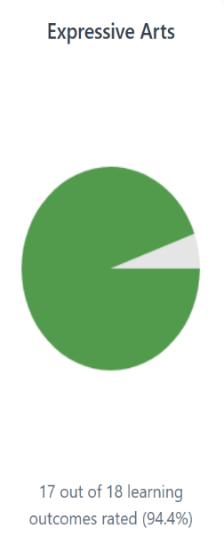  New resources were both purchased and made to promote expressive skills. Children were developing confidence acting out stories, creating their own, and enhancing their digital literacy skills by recording each other and playing back the videos. Language and communication skills, confidence and self-esteem were developed for children – taking on character and lead roles, sharing their thoughts and ideas clearly to take part using imagination in different ways as well as fine and gross motor skills from the dressing up and use of puppets.  Our Greenspace area was developed further with more art spaces and resources set up to provide EXA as a continuous provision, boosting children’s mental and physical wellbeing by having the open air and space to be creative and allowing them to take learning in different directions through the use of natural resources and messy play.  Our Curiosity Corner has been maintained throughout the year, providing children with new items to spark their curiosity and imagination. Overall, 17/18 EXA experiences and outcomes were tracked through planning.  HOME LINK - A rock snake was created in the playground as a home link to make it bright and colourful for the new children starting. This was shared at our transition day for new families to add to. So far 20 stones have been placed down.  PARENT WORKSHOP - 4 x parents and 5 x children attended the workshop where 1 x parent, in particular, was amazed at her daughter’s confidence as she took the lead role in front of the group.  Outdoor area within new 2 year old provision (The Voes)  Defined areas were established and further developed for role play, construction, mud kitchen, water park and a planting area. Resources were purchased and donations were sought from local businesses to provide stimulation and curiosity in this space.  Evidence within children’s LJ and room planner demonstrates an improvement in children’s engagement in play and has a positive impact on their emotional regulation. Children have been observed to play more co-operatively with each other, particularly when engaging in role play together outside. Child led interactions has also been a positive factor since the introduction of new resources and defined areas. Staff find accessing the outdoor areas positively impacts on de-escalating behaviours, particularly when there are sensory experiences of sand and water outside.  There has been a slight improvement to 2/2 children’s engagement scores we tracked from January to June 2026. Child A was mostly scoring 1 in January and now scores mostly 1.5 in June. Child B scored mostly 2 in January; in June he is now scoring 3.  Some children’s targets have been met whilst outdoors.  By creating more spaces to shelter from the sun and rain, children are keen to engage in accessing outdoors for longer periods of the session. Children have an appropriate space for rest and sleep out in fresh air whilst others continue to play outside. On recent warmer days, two children on two occasions have slept outside under the sheltered area.  Children also have access to water and fruit outside and use the defined outdoor snack area to consume their snack. Staff promote communication and nurture in the sheltered areas as it feels like a cosy space outside to support rest and mealtimes outside.  Prior to the changes outside, outdoors was accessed most mornings for approximately 45 minutes - 1 hour each day, during PM sessions there were barriers of children napping in the afternoon. In the afternoon, staff were responsive to children’s interests of arts activities, yoga or music and movement instead of outside. Since the changes were implemented, outdoors is accessed most afternoons, with yoga outside and other calming experiences such as cuddling on the bench with blankets and books available. On average, outdoors is open now for approximately 3 x hours per day.  Children's developmental stage of climbing has been supported with the introduction of new resources such as the chutes and wooden A – frame. Children have also developed their core strength and balance by building up their confidence of manoeuvring the balance bikes.  Due to a few of our children requiring a safety personal target for putting small objects in their mouth, we have a limited amount of small loose parts to maintain children’s safety.  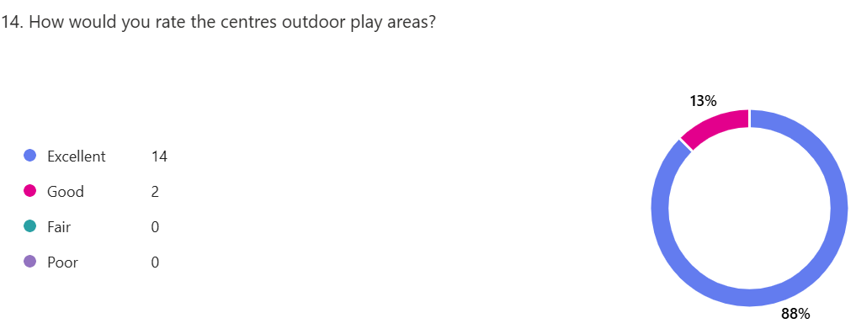  Communication station is established and explored by a few children with an adult. Some children will point to the pictures for staff to name and sign the word.  PARENT WORKSHOP - An informative PowerPoint was shared with parents before the children joined the workshop to engage in the activities on offer at the different stations. Each station was an example of Schematic Play. Parents were encouraged to engage and explore all Schemas with their children and be mindful of finding a Schema in which they personally preferred engaging in.  (6 x parents attended) Good parental engagement and positive parental feedback was documented within the QR Code sway, feedback booklet and Outdoor Champion floor book. Parent 1 – “T loved the water play and Trajection”.  Parent 2 - “N enjoyed orientation, looking through the block at mum”.  UNCRC  In 2025 8 x articles were covered, with 1 x further article being covered in 2026 where the staff, children and parents took part, giving their views and comments.  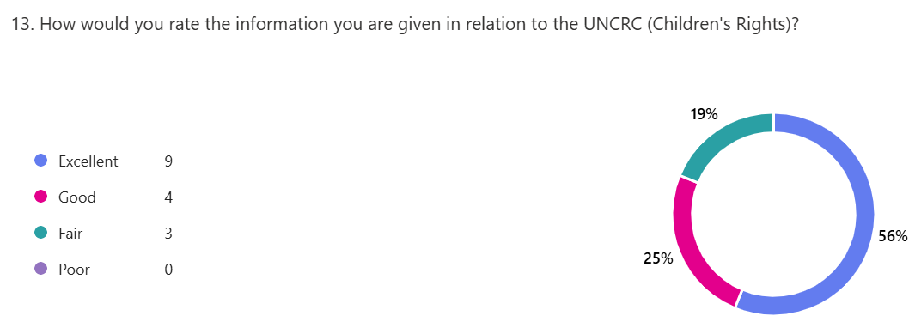  The action plan has been updated using a traffic light system and, although there has been progress, there are still a few boxes to be fulfilled. Superhero books were made with the children rights attached, making it easier for the children to pick them up and look at them, and posters added to the display area. Staff were also given their own copy of the A<B<C<D<E cards of human rights.  The children used talk boxes to boost confidence and interaction with their peers, and they continue to have their WOWs displayed on the wall outside the rooms where all the parents can see their efforts.  When asked about certain articles, many of the children were able to offer comments such as Article 6: I have the right to grow survive and develop - “you survive by breathing, eating good food and sleeping”.  Overall, about 75% to 80% of the action plan for the silver award has been completed. Parental comments are between 10 and 18 comments for each article.  Family workshops and enagement opportunities  Over the year an extensive amount of opportnities have been offered to familes to ensure they feel part of the centre, to provide support and to learn from them as main educators. Listed below are the opprtunities which were offered and the parental feedback gathered.  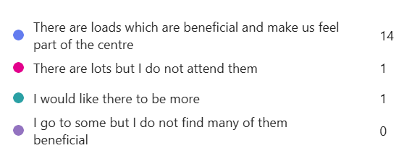
  Settling in meetings | Community Practitioner drop in sessions | Centre and community Bookbug sessions
  Schematic Play outdoor parent workshop | Progress meetings | The Big Christmas Family Fun Day
  Singing In The Square (Christmas) | Communication & Makaton parent workshop | STEM parent workshop
  Stay & Play opportunities | Easter story and song session (easter bunny) | Mental Health and wellbeing parent workshop
  Expressive Arts parent workshop | World of Work week (parent volunteers) | ECC summer family trip to Millport
  ECC and P1 inductions | Sports Day | Graduation ceremony
  Baby sensory sessions | Nurture parent workshop | PEEP sessions
Improvement Priority  Catrine ECC | Improvement Priority (Expressed as outcomes for learners)  Key Themes –  Children to be able to discuss curricular areas with confidence  Children to be able to support and lead others  Children to develop confidence when talking about their learning  Improvement Rationale – Some assessments/observations within the ECC can be carried out in a way which looks only at singular skills within that moment. We want to ensure that our children have transferable knowledge within our curriculum, and we currently have little evidence to show the true depth of understanding for children, therefore, we aim to encourage confident individuals and effective contributors who grow to develop a firm grasp of skills required to learn and continuously progress. |  | Education Service Improvement Plan Priority 2: Teaching and Learning Together  Our young people should experience a teaching, learning and curriculum offer that meets their needs, and those of our local and national context.  All staff should be supported to deliver in new and innovative ways by accessing CLPL relevant to their needs and those of our young people.
Teaching and Learning Together
Progress and Impact | Within the 3-5 playrooms, children were asked at the start of every planning cycle what they knew about the subject/theme/interest and then this same question was asked again at the end, after a month of planned experiences on offer. Responses show true progression and led to rich observations and positive tracking/monitoring attainment. 34/44 children within our 3-5 playrooms actively provided input into our progression mind maps.  By the end of the year, some children can talk about elements of Literacy, Numeracy and HWB showing a better understanding of the learning which takes place under these curricular areas:    Detail and extensions evidenced within individual Learning Journals show that all of our preschoolers moving onto P1 have progressed well in the majority of the curricular areas. With staff supporting, extending and using effective questioning children have been able to delve deeper into their understanding of concepts and gain more cross curricular understanding. Staff are more skilled in offering more multidisciplinary learning to achieve targets and depth in learning and development.  Multiple “Learning Together Groups” were not consistently taking place due to wellbeing and engagement becoming more of a priority throughout the year. This was an ambitious idea which was perhaps planned without taking into account our new cohort of children and the current confidence levels of the children at the time. We did, however, manage to set up 1 x digital group using the introduction of Minecraft Education. A group of 4 x children were targeted for this who were confident in the use of technology and required challenge. After 3 x learning sessions together, the group then led and delivered it to peers, explaining safety rules, the aim of the programme, how to navigate and overall support their understanding of it whilst the others explored it. 1 x child, in particular, was able to support extremely well, helping build others confidence as well as his own, with peers regularly thanking him for his help.  On numerous occasions small groups of children were also observed leading learning for younger children by setting up obstacle courses, demonstrating how to move and supporting them around each obstacle. This promoted leadership skills, problem solving, team building, positional language and social skills.  A few children, towards the end of the year, were able to show visitors around the ECC. Recently, one child confidently showed our new Educational Psychologist around the ECC both indoors and out, explaining the different areas, what you can do at each and some of the social expectations whilst in these areas.
   | When first asked | Progression in understanding
  LITERACY | “don’t know”  “electricity?”  “ask how your day is?” | “read books, turn pages and listen”  “use pens to write letters and words”  “ask questions when I want to know something”
  NUMERACY | “1,2,3”  “you need to work numbers”  “what does that word mean?” | “shapes is a part of numeracy and we see them every day. There are lots of shapes in the nursery”  “colours and day and night are all numeracy”  “count the money on the board” (promethean)
  HWB | “I don’t know”  “bones and skin”  “the doctors help you” | “massages and put cucumber on my eyes”  “you eat 5 a day fruit and vegetables”  “babies get milk from their mummy”  “to feel calm, relaxing music and yoga”
Next Steps | To create a continuous visual display of curricular area experiences and learning to build upon children’s understanding of concepts within each area  Staff to use the language of the curriculum more during learning experiences to allow children to make and recognise the links easier  Look to create another Leadership Group next year with a group of preschoolers

Improvement Priority  Catrine ECC | Improvement Priority  Key Themes –  To improve wellbeing scores  To embed Makaton across all areas  To support children’s emotional regulation  To work towards Silver Award in Rights Respecting Schools  Rationale – Due to higher levels of recent dysregulated behaviour and children requiring more additional support (ASN) across both the Authority and Scotland, we feel it is important to ensure all service users are aware of coping strategies, the services that can support and to ensure intervention is early and individual to each child and family. Through reflection from our previous year, as a staff team we recognised that approaches need to be looked at from a more open minded and non-judgmental stance, and with professionalism and respect. | Education Service Improvement Plan Priority 3: Our Wellbeing and Belonging  We want all of our young people to feel supported by people who know them well and feel included in all of our establishments and centres.  Our staff need to be supported in their working with our young people, especially in times of adversity.  As a key universal service, it is our vision that all young people attend our establishments on a full-time and regular basis to support them in their development at all stages.
Our Wellbeing and Belonging
Progress and Impact | 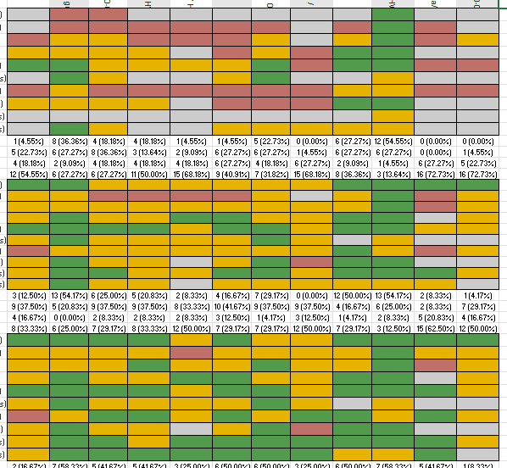  As a staff team we looked at our environment and, through the use of QI methods, we continued to develop areas ensuring that rest, quiet and relaxation areas were calming and accessible. Our EEL also redesigned our Nurture Nook outwith the main playrooms, creating an inviting space for more structured wellbeing sessions with nurture and wellbeing in mind.  Impact on children from the targeted support areas and learning outcomes is shown clearly in their tracking. Many areas which were previously shown as grey or red are now showing as orange and green in the children’s tracking  Baseline readings (shown opposite) from January to March 2026 show a clear positive change in learning outcomes from children  Children are more are able to regulate themselves and are equipped with strategies they can use to support their feelings and emotions  Children are making transitions more comfortably and are more confident in their daily approach  Children are sharing and communicating how rooms make them feel in a positive way, “I feel cosy in here” “this room makes me calm”  Staff and parents noted that children’s positive shift in behaviour came from the point in time when the nurture groups have started  Communication and language changes are evident. Children who were silent and not communicating in the busy, loud playrooms feel they can talk and be listened to in these calm nurturing spaces.  More interest has been noted in literacy, and areas are being used for reading stories and getting that solitary calm moment to pick up a book and look at it or having the quiet space to hear the words that the practitioner is saying to absorb the words.  Attention, listening and focus skills are showing improvement.  Yoga and the Mindfulness Mondays have created a calm day after the busy times and dysregulation of the weekend. Some children arrive on a Monday morning very dysregulated and are now asking for yoga to calm themselves.  They have learned about having their own space and allowing others their space. They are more aware of personal space and asking permission from others to hug or touch them, and they welcome each other in a positive way.  The sessions have allowed some children to feel safe and disclose times in their life when they haven’t felt safe and they have shared how it makes them feel. This information was passed on allowing appropriate interventions to be made.  A staff training workshop took place to inform staff of training they can access, help and support strategies to use with children to support their emotional behaviour. Staff were supported with their own wellbeing. A mindfulness trained teacher shared calming exercises and breathing techniques with Practitioners.  Staff in the Voes redesigned their indoor environment, looking at their areas for children to rest and play, and tailoring areas to suit the individual needs of the children. They made the area more nature based, calming the overall appearance of the playroom.  A parent PEEP workshop was held to share the strategies used, and resources that parents can use at home to help support their children’s emotional and social needs. The SWAY from the session was shared on all children’s journals for parents to read if they could not attend.  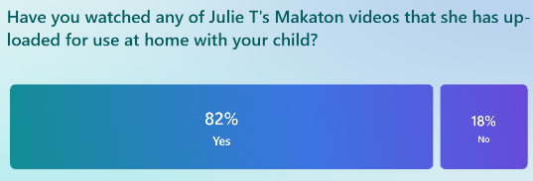  Makaton signs and staff usage have improved across the full centre. A parent workshop was led by our new Makaton Champion, and 8 x videos were uploaded onto Learning Journals. This provides children with an additional way of communicating their needs if they are requiring support with verbal language. All children know some signs, with two children regularly using it as a means of communication.  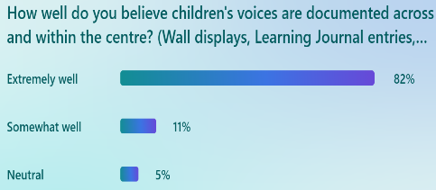  A wall of aspiration was created this year to encourage children to think about what they would like to be when they grow up, what kind of car they might want to drive. This, along with graphs showing likes and dislikes, helped to ensure children’s voices were heard and considered. Some children showed knowledge around specific roles. Staff introduced jobs which the children were unsure of and they researched them together, finding out what they would need to do the specific job e.g. go to university, carry out training.  A total of 12 x jobs was covered over the year. For some of the children the dreams aspect had an impact on them, which was visible when asked at the end of the year for Graduation what they wanted to be when they grew up as some of the children picked jobs that had been previously discussed and the majority were their own ideas, different from their peers. In previous years, we would have several similar job roles chosen. Children’s comments continue to be displayed around the ECC in relation to learning, photos and artwork.  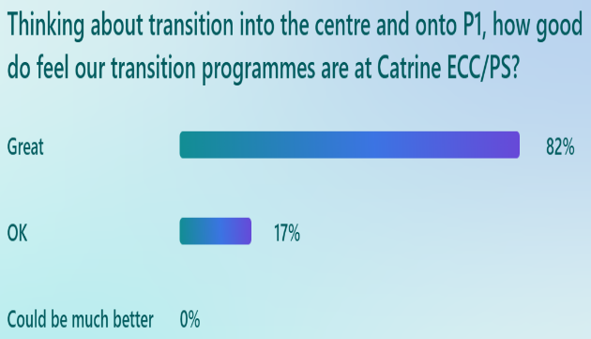  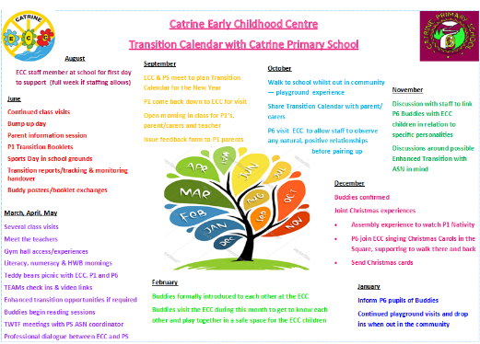  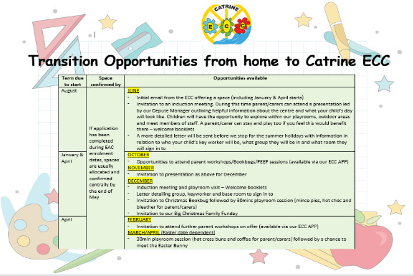  We have an extremely strong transition programme in place between ourselves and our feeder school, Catrine Primary; however no established programme for children transitioning into the centre. This was a recommendation during our audit last year, therefore a new transition calendar was devised for children coming into the ECC. Children starting in January or March 2026 were given additional visits, and invited along to Stay and Play sessions, parent workshops, Bookbug sessions and to Christmas and Easter events. This meant that by the time they were due to start they had been in the centre several times alongside their parent/carer and resulted in more settled first days and shorter settling in periods.
Next Steps | Children’s wellbeing will continue to be tracked through the use of quality improvement ideology, making the appropriate changes to support the centre as a whole including children, families, staff and agencies whom we work in partnership with  As a centre we want to further develop our children’s voices and ensure they are visible and meaningful in both our Voes and  3-5 playroom. Our new Children’s Voices Champ will look to develop and embed this further next year
Improvement Priority  Catrine ECC | Improvement Priority  Key Themes –  Increased staff confidence and working knowledge of assessment procedures  To develop our “Excellent Learning Experience”  To ensure all targets are achievable for all children, including ASN, through challenge and support opportunities  Rationale – SLT has recently become involved in an Authority training group around assessment approaches and procedures. Through conversations with staff in relation to confidence, it became apparent that some staff were unsure of how to analyse these and how they could be helpful in target setting to help raise attainment and progress. SLT will therefore aim to share learning from the group and support with these identified challenges over the year ahead. | Education Service Improvement Plan Priority 4: Our Attainment, Destinations and Achievements  We want the very best for all of our young people in East Ayrshire.  We aim to ensure that all young people secure a positive destination through excellent achievement and attainment at all levels.
Our Attainment, Destinations and Achievements
Progress and Impact | 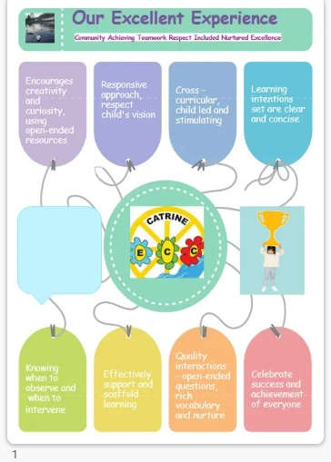  SLT have led the introduction and implementation of the new QIF, carrying out training and beginning to use the framework to evaluate and plan for improvement. Quality Indicators covered this year are - 3.1 (CI) Playing, Learning & Developing, 3.3 (HMI) Learning, Teaching & Assessment, 4.1 (CI) Nurturing Care & Support and 4.2 (HMI) Wellbeing, Inclusion & Equality, each given a rating of 5 (very good). QIs worked on at the beginning of the year have been reviewed, and the majority of plans have been put into place or achieved. We will continue to use this tool to reflect upon our practice.  Staff worked together during an in-service day to create and agree a new “Excellent Experience” proforma. This has recently been made into a draft poster and will be shared with children and parents, asking for their views, ideas and opinions before being made final. This will then be used to monitor playroom practice ensuring that experiences and interactions are of a high quality within Catrine ECC  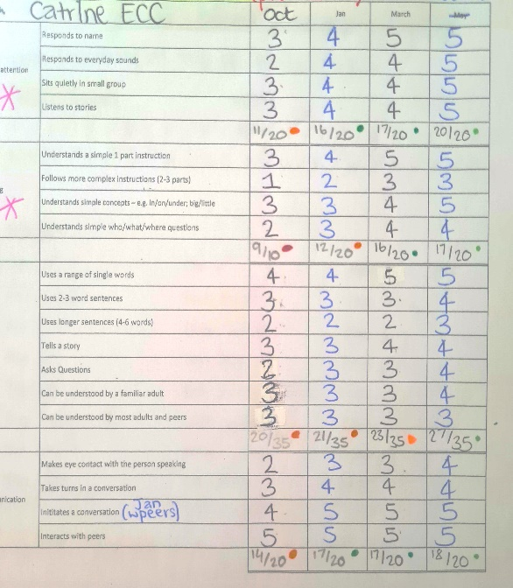  Our Communication Champion has worked with 12 x children over the year providing additional support in relation to Speech and Language. All children have shown improvements on ICan trackers under all 4 x headings (example opposite) as well as under the Literacy section on each individual Learning Tracker on their online journals.  5 x RFAs have been submitted to SALT in an effort to provide better outcomes for children, all of whom have been assessed by a therapist. Two different Speech and Language Therapists have praised our centre’s work in the support we put in place around communication, noting that our actions are providing better outcomes for the children requiring it. My Plans show progress in speech and language development and gaps in Teaching Talking assessments are closing.  2 x ELCPs and our SELCP attended a full day training on SCERTS who then fed back to the staff team on the key points. This developed their confidence in using the assessment and target tool with one child within the centre over the year. The child moved from a social partner to a language partner, showing progress over time.  A range of assessments continue to be carried out across the centre in both rooms depending on the needs of the individual children. Staff say they are more confident now in both using and analysing them to help inform appropriate support  SLT attended the Early Years Consultation Forum in relation to the new way in which specialist provision will be decided. SLT are now more confident in the paperwork required for this forum and the realistic criteria for presenting cases. This year, 1 x child from Catrine ECC will attend a specialist P1 provision following paperwork and meetings in relation to his needs. A further 4 x children have been highlighted as requiring support in P1/change in ECC and encouraged enhanced transition.  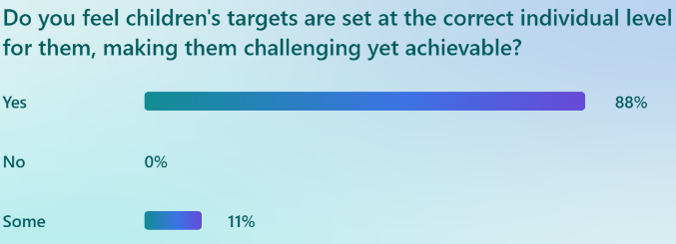  SLT has requested the support from Educational Psychologist, SALT, Health Visitors and our Community Practitioner over the year to support families, children and the centre.  Following advice from our EAC Quality Improvement officers during our audit, SLT monitored children’s targets more frequently to ensure only 2-3 were open at a time. This has been successful in ensuring targets set are achievable for all and most staff are now better at creating new targets when the previous ones have been achieved, rather than waiting until the end of a term. The majority of children are achieving the targets set in either Being Me, the Complex Milestones tracker or the EAC tracking and monitoring tool.  Taken from parent feedback form  Individual progress is well documented and clear across the curriculum on each child’s Individual Learing Journal (see below)  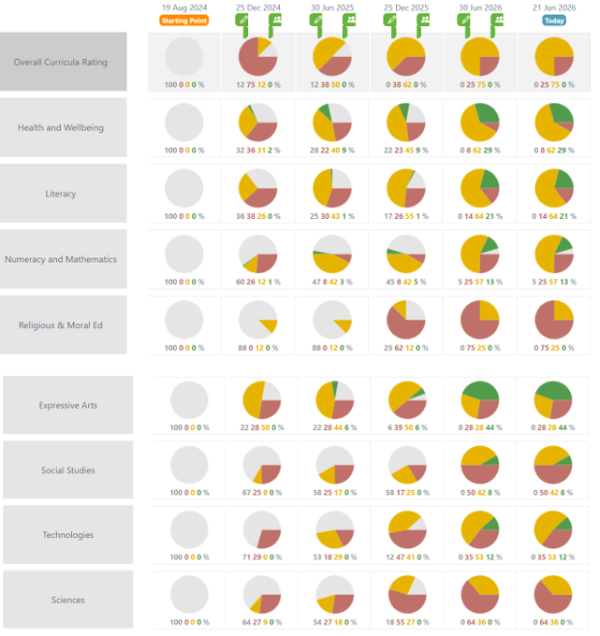  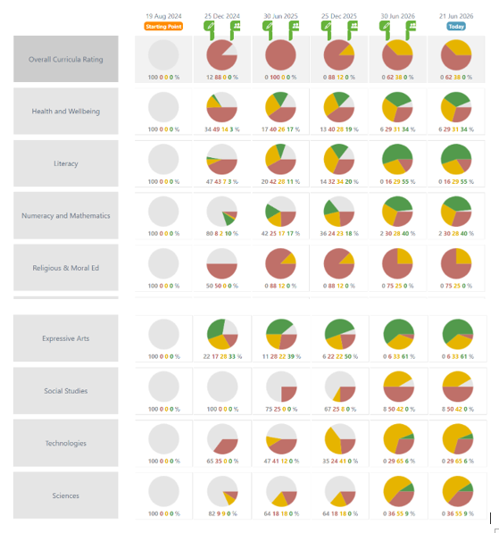  Child A Child B
Next Steps | Share our Excellent Learning Experience draft with children and parents before finalising our poster for monitoring purposes in session 2026-27  All staff to continue to move children on, creating new targets when previous ones are achieved throughout the year rather than just at the end of terms  To continue to use the QIF to review, evaluate and reflect upon more Quality Indicators  SCERTS to be used as an assessment tool for all children highlighted as having more complex communication needs

Pupil Equity Fund: Evaluation
Approach/Intervention | Amount  £ | Impact  Report on how you have improved outcomes for learners impacted by poverty | What evidence do you have of positive impact?  Outline the data that supports your findings.
Staffing  Classroom Assistants:  1 x fully PEF funded, 1 x 28 hours PEF/3.5 hours CORE funded  To have 3 x CAs with focused timetables for individual, small group and class support remits | 40,091.00 | Our most valuable PEF resource!  Tracking individual pupils’ progress in Times Tables, spelling and grammar, Reading Wise and various literacy programmes through daily short interventions in small groups  Improved social skills for targeted pupils in dinnerhall, playground and class due to planned intervention and support | Improved individual pupil results shown through class spelling and numeracy assessments  Completed Multiplication Masters charts  Fewer REDs completed in 2 x dysregulation trackers due to having CA support in P3 class throughout the week  Greater quality participation in class and school events  Improved and extended participation in outdoor play with peers
CFE Curriculum for Excellence Machine subscription  To allow all teaching staff access to work collegiately to discuss and rate current professional gradings and performance and plan next steps and priorities | 100.00 | Used to prompt professional discussion about our current status and to focus on next steps across all professional teaching and learning areas  Provides clear guidelines for future priorities as it highlights areas where we require to focus as well as areas of strength | Consistent and increased understanding of HGIOS scores and gradings from all teaching staff, backed up by their examples  Increased and improved staff confidence when making professional judgements at T&M meetings  SLT can use gradings to plan collegiate focus for next session
Twinkl subscription  To allow teaching staff access to a wide range of educational resources to expand their teaching of most curricular areas | 683.00 | Used in all classes to supplement teaching, provide interactive learning games and activities and prompt research tasks | Pupils enjoy completing Twinkl tasks as they are usually very current and in line with trends
White Rose Maths subscription  Subscription for all teaching staff to access planners, resources and online games and tasks | 220.00 | Used in classes to support and challenge pupils at all levels for all concepts  Aids teaching staff by ensuring differentiated tasks are available | Consistent individual attainment by pupils highlighted in T&M conversations  Pupils enjoy playing the games as part of their Numeracy learning tasks and like being challenged
Poverty Proofing – payments for 6 x P7 residential trip December 2025 | 235.00 | 6 x SIMD 1 pupils received a one-off payment to ensure they managed to attend the P7 residential trip to Dolphin House | SLT identified the pupils and Mrs Robertson, Senior Clerical, phoned parents individually to preserve their dignity. All were very grateful and highlighted that this assistance was much appreciated.
6 x swimming lessons and staff bus fares for P5 swimming  To pay for P5 pupils and accompanying staff to access swimming lessons | 480.00 | Swimming lessons at Visions Leisure Centre in Cumnock  We offered to obtain swimming costumes and towels for pupils who didn’t have them  We used bus passes for pupils and paid for staff bus tickets | We worked with Visions to get a good price for the lessons as we hope to continue using PEF for P5 pupils for the foreseeable future, if possible  Some P5 pupils had only been in a pool a few times and were very anxious but gained great confidence over the 6 x week course  Using their bus pass also increased their independence and having to be very quick at getting changed to catch the bus taught them a lot too!
M & M Productions – theatre show for whole school | 399.00 | To allow all pupils to experience a live theatre show and participate in related workshops | Pupils had requested more theatre show visits at Home Circles so we try to arrange for one per year
P3-P7 trip to Glasgow Science Centre | 460.83 | To allow P3-P7 pupils to experience the Science Centre and its interactive exhibitions, to attend an iMax movie and to improve their independence by being in busy public spaces with their peers | This was a very successful trip! The feedback from pupils was all positive. Again, this had been requested during a Home Circles BIG question.
P1-P2 trip to Dumfries House | 137.50 | To allow P1-P2 pupils to experience Dumfries House, its gardens and farm areas, to explore areas of the big house and to move confidently around a busy public space with their peers | Another trip that was a huge success. Again, a Home Circles request which is highlighting to pupils that when we ask for their opinions and suggestions, we act upon them too.
Bus to Dumfries House | 155.00 | As above
Nelson Spelling resources – whole school | 1377.50 | To refresh whole school spelling approach to improve attainment results in tandem with involvement and staff training in the National Improving Spelling programme | Staff training started in March 2026 and P4 teacher reports improved pupil results from assessments. Full immersion and whole school roll out planned for session 2026-27
Nelson Handwriting resources – whole school | 187.00 | To continue to improve handwriting and presentation standards across all stages by using consistent teaching resources | RBA staff commented very positively on P7 handwriting during P7-S1 transition events and we were contacted by two feeder schools to ask which resources we were using to improve handwriting as their teachers had commented too
Jotters | 49.58 | To ensure all pupils have access to requires supplies
Class materials | 205.54 | As above
Contribution costs taken by EAC | 2420.00
Contribution to ECC | 580.00 | Guinea pig costs – children who do not have a pet at home due to costs and other barriers have the opportunity to care for one within the centre.  Coalfield bus hires and petrol – children who do not get to access Dumfries House, such as families who do not drive, had the opportunity to explore the grounds and play in the parks. | Sandy, our guinea pig, hugely supports children who struggle to settle at the ECC, especially when separating from carers in the morning.  Poppet sadly passed away at the beginning of this academic year which allowed us to touch upon bereavement as part of HWB in a meaningful way for the children.  Children/families had the opportunity at holiday times to take our pets home, giving them the experience of having a pet at home for a time.  Trips out of the ECC – this was the first time a few of the children had ever been to DH. They showed excitement and parents commented after seeing the SWAY they would try to take them back as a family. This promotes HWB and family engagement/interaction outwith the centre.
Establishment Self Evaluation: How Good is Our Early Learning and Childcare? Quality Indicators
Quality Indicator 1.3 Leadership of Change |  |  |  | 5
Quality Indicator 2.3 Learning, Teaching and Assessment |  |  |  | 5
Quality Indicator 3.1 Ensuring Wellbeing, Equality and Inclusion |  |  |  | 5
Quality Indicator 3.2 Securing Children’s Progress |  |  |  | 5

Establishment Self Evaluation: How Good is Our Establishment? 4 Quality Indicators
Quality Indicator 1.3 Leadership of Change | 5
Quality Indicator 2.3 Learning, Teaching and Assessment | 4
Quality Indicator 3.1 Ensuring Wellbeing, Equality and Inclusion | 5
Quality Indicator 3.2 Raising Attainment and Achievement | 5

Establishment Capacity for Improvement
Catrine ECC - All staff across the ECC have shown good judgement in evaluating strengths and development needs, and in giving clear priority to improving outcomes for children. The quality assurance calendar supports the centre in implementing a rigorous and collaborative approach to self-evaluation, based on the new Quality Improvement Framework. All staff are clear about the ECCs strengths and areas for improvement. There is leadership at all levels and all feel empowered to lead developments and bring about positive change. Staff are confident in sharing best practice both inhouse and to other colleagues across the authority.
Parents/carers contribute via feedback forms and participation at workshops and on Learning Journals, where they feel their views are listened to, respected and acted upon. Almost all staff have developed positive relationships with families and are aware of, and sensitive to, family circumstances, challenges and barriers. All staff are committed to planning and providing family supports and opportunities.
The capacity for improvement in Catrine Early Childhood Centre is very good. The ambitious SLT team, commitment and dedication of staff, and support from parents ensures there is capacity for continuous growth and development.

