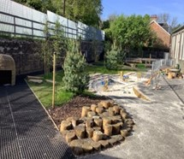
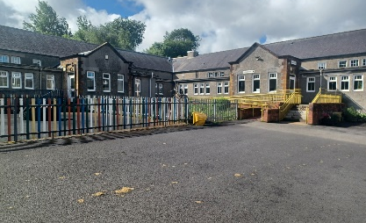


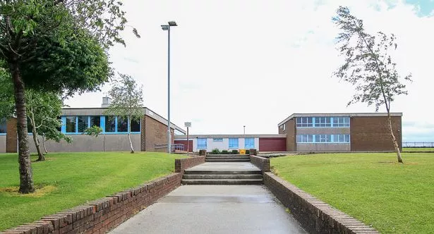
Establishment
Improvement
Plan
2026-27
Catrine Primary School
and
Catrine Early Childhood Centre
East Ayrshire Council
Education Service

Establishment Improvement Plan | Catrine Primary School and Catrine Early Childhood Centre (both establishments: green)
Head Teacher | Judith Govans
Date Submitted | Submitted to Chief Education Officer on: 07.07.26

Establishment / Centre  Vision and Values | Our Vision ~ In Catrine PS and ECC, our shared vision is to provide a nurturing, safe, happy and healthy environment for high quality learning, where every child is supported and guided in the development of their life skills, knowledge and self-esteem.  We aim for excellence in everything we do, and we value and respect the view of others.  Over the past three sessions and in full consultation with ECC and PS children, parents/carers, staff and wider communities we changed our School Values to become our CATRINE Values. We focus on these regularly with our children to ensure they have a clear understanding, and have posters/communications of our CATRINE Values throughout our establishments.  Our CATRINE Values  C – Community A – Achieving T – Teamwork  R – Respected I – Included N – Nurture E – Excellence  We also consulted with all stakeholders to update our Aims to provide a child-friendly version and new posters/communications have been created and are displayed throughout both establishments.  In Catrine PS, we award CATRINE Values trophies at our annual Prizegiving and we award weekly ‘CAUGHT ! Displaying our CATRINE Values’ certificates at our Friday FUN 31 sessions.

Checklist
In line with the Standards in Scotland’s Establishments etc. Act 2000 (amended 2016), the following checklist is designed to assist Heads of establishment with whole establishment/centre improvement planning that fulfils statutory duties in accordance with the Act. This must be completed prior to submission.
SIP Consultation included the following stakeholders: | Complete |  | Content of plan | Complete
Children and Young People | Yes |  | Takes account of strategic priorities outlined in the Education Service Improvement Plan. https://www.east-ayrshire.gov.uk/Resources/PDF/E/Education-Service-Improvement-Plan.pdf | Yes
Parent Council and Forum | Yes |  | HGIOS 4 and EYQF are used as the frameworks to inform the content of SIPs. Where appropriate.  https://education.gov.scot/media/v5sh3dqt/frwk2_hgios4.pdf  https://education.gov.scot/inspection-and-review/inspection-frameworks/quality-improvement-framework-for-the-early-learning-and-childcare-sectors/ | Yes
Teachers, practitioners and ALL establishment/centre staff | Yes |  | There is clear focus throughout the plan on measures to reduce of inequalities of outcome as a result of socio-economic disadvantage.  PEF: https://www.gov.scot/publications/pupil-equity-funding-national-operational-guidance-2023/documents/  CEF: https://www.gov.scot/publications/care-experienced-children-young-people-fund-operational-guidance-2023-24/documents/  SEF: https://www.gov.scot/publications/strategic-equity-funding-national-operational-guidance-2023/documents/ | Yes
Volunteers/ Community partners | Yes |  | Appropriate cognisance has been made of the links between the plan and the working time agreement for teaching staff. | Yes
Head Teacher signature:  Judith Govans |  |  | An accessible summary of the SIP is available and contained in this document and will be provided to parents, children and young people. | Yes

Pupil and parental strategic involvement
For session 2026-27, please describe below how children and young people will be involved in decisions relating to the operation of the establishment/centre | For session 2026-27, please describe below how parents will be involved in decisions relating to the operation of the establishment/centre
Monthly Home Circles – whole school mixed stage Circles focusing on 2 x BIG questions per month: 1 x UNCRC Article will be discussed and associated questions asked to ensure understanding and 1 X Catrine/school/community question will be asked to promote our CATRINE Values and highlight our pupils place and importance in our school and wider village community. Each Home Circle is led by a P7 scribe who collates and feed back responses. 4 x Home Circle responses are displayed each month in school and posted onto school GLOW blog to document our RRS journey and focus.  Pupil Leadership Roles – House Captains, Media, Infant Playground Helpers, FUN 31 equipment helpers, P1 Transition Buddies, Active 360 Pupil Leadership training, sports team captains, Home Circle scribes and wet weather monitors. All pupils are aware that their participation in the above roles is dependant on their behaviour and attitude as we highlight them regularly as role models to our younger pupils.  Discovery Dens – in session 2025/26 we continued with the format trialled the previous year whereby pupils were given the opportunity to experience 8 x different activities across the school session, rather than be in a Committee Group with the same focus for the whole time. Pupils indicated that they preferred this format as they tried new activities, including food preparation, arts and craft activities, mindfulness and sports sessions. We will continue with Discovery Dens in session 2026-27, basing our activities on suggestions gathered from pupils during Home Circles audit.  BIG Questions – at both October and April Parents Nights, we leave out BIG Questions for our parents/carers/family members and pupils to answer anonymously. We use the responses given to focus our planning for future changes throughout our school. All responses are collated, displayed in the school and shared on our platforms.  October 2026 – We’re updating our Curriculum Rationale this session.  - How do you think we can best support your child’s learning goals together?  - What do you hope your child achieves or improves upon in school?  - Are there any specific skills or subjects you would like us to focus on in school?  April 2026 – next session we’re focusing on Spelling and Reading.  - How can we help your child to improve in these areas?  School and Class Charters – at the start of every new session, each class creates their own Class Charter, highlighting what they are expecting their class to look, sound and be like. At assembly, we also produce updated Playground, Dinnerhall and Assembly charters, highlighting the standards of behaviour expected of all of our pupils.  HMIE Pupil questionnaires – in April 2026 every pupil completed the HMIE questionnaire that is completed prior to HMIE Inspections. The results were collated and shared with all pupils at May Home Circles, prompting discussions and allowing for SLT clarification where negative responses were recorded.  Q11: my school listens to my views – 93% strongly agree/agree  Q12:my school takes my views into account – 94% strongly agree/agree  Stay and Learn Mornings – we will continue with our very popular Stay and Learn sessions, focusing on Literacy, Numeracy and HWB and Outdoor Learning. Pupils will encourage parents/carers to participate in their learning activities and will take them for tours around the school to highlight our current learning and displays in all areas. These events are always very well attended.  Curriculum Rationale – all answers provided by both pupils, staff and parents/carers during session 2025-26 will be discussed and a draft Curriculum Rationale shared in October 2026, with a view to a final version being in place for January 2027.  Playrooms - children will continue to be consulted about the layout and focus of the playrooms producing quality discussions and child-led learning opportunities.  Outdoor Areas - children will be consulted about improvements to be made to our outdoor areas both in the Voes and Village playrooms, including the option to choose and vote for new resources.  Excellent Experience - children will be encouraged to use our Excellent Experience checklist to rate how good they believe opportunities across the centre to be.  Childrens Voice - Rena (UNCRC Champ) and Julie N (Children’s Voices Champ) will work throughout the year to encourage children’s voices, views and opinions to be heard more and improve upon the visibility of this across the centre through displays | Parent Council - Termly Parent Council meetings will continue to be held, with minutes from pervious meetings available for wider parent forum on school GLOW blog. All meetings are highlighted in advance on school GLOW blog and app to encourage new members to join. Posters have been created and displayed around the village to clarify what the Parent Council does and how to join.  PC consulted regularly about proposed PEF planned spend and fundraising ideas. Detailed summary of new SIP given at September AGM for clarity of future priorities and termly updates provided about ACEL data, progress and attainment.  BIG Questions – collation of BIG Question responses displayed in main corridor and shared on GLOW and app, answering any questions or queries raised.  HMIE Questionnaires – HMIE Parent Questionnaire posted on GLOW and app in April 2026, with 25 responses received.  Responses collated and shared in June 2026, with links to future priorities highlighted. With only 4/20 questions asked scoring a rating below 84% between a combined ‘strongly agree/agree’, the 4 x lowest responses will be addressed throughout our SIP priorities.  Q12: the school gives me advice on how to support my child’s learning at home – 67% (strongly agree/agree, 24% disagree/strongly disagree and 8% N/A)  Q13: the school takes my views into account when making changes -76% (strongly agree/agree, 16% disagree and 8% N/A)  Outdoor Learning Day – during our very successful Health Week, we held another Family Outdoor Learning Day with over 60 parents/carers and family members attending, building dens in the main hall due to the heavy rain and staying for a picnic lunch with our pupils. We will continue to ask for feedback after learning events to ensure we are constantly improving what we offer and provide for our families.  Curriculum Rationale – all answers provided by both pupils, staff and parents/carers during session 2025-26 will be discussed and a draft Curriculum Rationale shared in October 2026, with a view to a final version being in place for January 2027.  Excellent Experience - Parents will be asked early on in the year to input into what they believe makes an Excellent Experience for the children. Once consultation has taken place, our poster will be completed, and this will then be used as part of our monitoring programme.  Parental involvement - Parent will be consulted as to what supports they feel they would like/ need over the year, including parents workshops they feel would be beneficial, other agency input and focus for the potential groups for the community.  Parent/carers will continue to be asked for feedback on a variety of aspects across the setting, with opportunities to provide ideas for improvement.  Target setting - Keyworkers will continue to meet with parent/carers on a regular basis to discuss progress and set targets for literacy, numeracy and health and wellbeing together.

Community Plan East Ayrshire  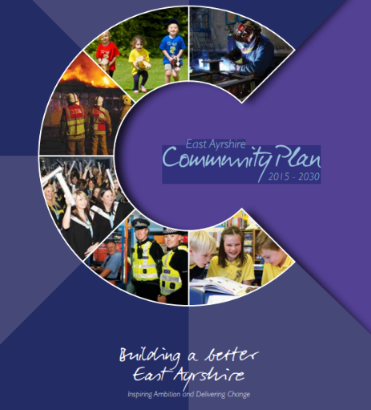  2015 - 2030 | Together, in achieving our Vision, Partners will demonstrate:  Effective leadership  We will provide clear leadership in Community Planning and engage effectively with our employees and communities  Collective ownership  We will take collective ownership for delivering on the Community Plan, the associated Single Outcome Agreement and the Community Plan Delivery Plans, and work hard to improve outcomes for local people and communities  Good governance  We will implement clear operating arrangements to support effective strategic direction, scrutiny and accountability  Democratic accountability  We will measure and report on the impact of our activities to demonstrate how effectively we are improving outcomes for local people and communities, and all partners will be held to account for their contribution.
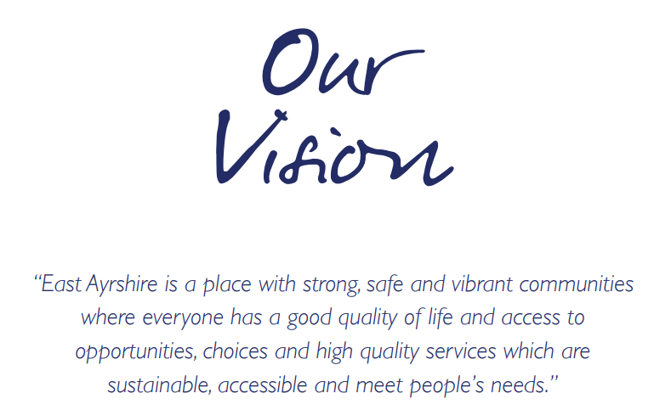  Our Partnership will continue to work to meet the needs of the people who live in our communities. Our guiding principles will be reflected in all that we do and should be evident for all to see. |  | We will:  - Promote lifelong learning.  - Promote equality and tackle inequality;  - Adopt a preventative approach;  - Ensure effective community engagement in the planning and delivery of local services;  - Utilise the strengths and resilience within communities;  - Drive efficiency and performance improvement;

National and Local Priorities
The Scottish Government’s vision for education in Scotland:  - Excellence through raising attainment and improving outcomes  - Achieving equity  Key priorities of the National Improvement Framework:  - Placing the human rights and needs of every child and young person at the centre of education  - Improvement in children and young people’s health and wellbeing  - Closing the attainment gap between the most and least disadvantaged children and young people  - Improvement in skills and sustained, positive  establishment-leaver destinations for all young people  - Improvement in attainment, particularly in literacy and numeracy | NIF drivers of improvement in the outcomes achieved by children and young people are:  - Establishment and ELC leadership  - Teacher and practitioner professionalism  - Parent/carer involvement and engagement  - Curriculum and assessment  - Establishment and ELC improvement  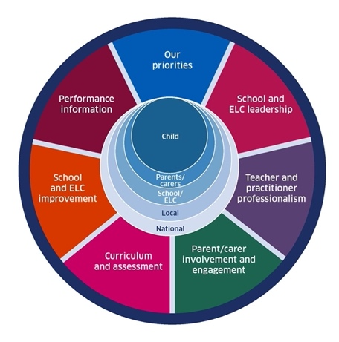  - Performance information | Scottish Attainment Challenge (SAC)  Scottish Attainment Challenge: framework for recovery and accelerating progress  Scottish Attainment Challenge Logic Model – Tackling the Poverty-Related Attainment Gap – Our Theory of Change  SAC organisers:  - Learning and teaching  - Leadership  - Families and communities

East Ayrshire Plans
Key Priorities | Education Service Improvement Plan: | Children’s Services Plan: | Community Learning and Development Plan:
1: Our Leadership | We actively support, promote and enact leadership at all levels. Our young people are supported to be leaders on their learning in our centres, Establishments and wider life experiences. All staff have ready access to appropriate CLPL and experiences to promote leadership in every classroom and centre. | Priorities for 2023-26:  - Our children and young people feel respected, listened to and influence change  - We are working collaboratively, reducing the impact of social and economic poverty on our children and young people  - Our children and young people feel safe  - Our children and young people have the best start in life  - Our children and young people’s mental health is improving | Outcomes:  - Growth  - Wellbeing  - Fairness  - Sustainability  Action areas  - Youth voice and participation  - Lifelong learning and skills development  - Empowering communities  - Wellbeing and inclusion
2: Teaching and Learning Together | Our young people should experience a teaching, learning and curriculum offer that meets their needs, and those of our local and national context. All staff should be supported to deliver in new and innovative ways by accessing CLPL relevant to their needs and those of our young people.
3: Our Wellbeing and Belonging | We want all of our young people to feel supported by people who know them well, and feel included in all of our establishments and centres. Our staff need to be supported in their working with our young people, especially in times of adversity. As a key universal service, it is our vision that all young people attend our establishments on a full-time and regular basis to support them in their development at all stages.
4: Our Attainment, Destinations and Achievements | We want the very best for all of our young people in East Ayrshire. We aim to ensure all young people secure a positive destination through excellent achievement and attainment at all levels.

Our Leadership: Improvement priority: To support and prioritise leadership at all levels to ensure the learning needs of all pupils are met
Catrine PS - Rationale – Due to major class and staff restructuring this session, our focus is going to be on clarifying leadership roles and remits, gathering and analysing associated data to inform next steps and focusing on ensuring attainments achieved in session 2025-26 are maintained and improved
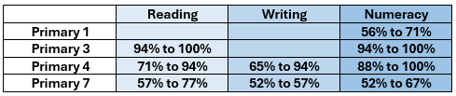

whilst targeting areas of slower attainment (August 2026: new P3, P6 and P7 stages)

NIF key drivers: | School & ELC leadership |  |  | Teacher & practitioner professionalism |  |  |  | School & ELC improvement |  |  | Select driver
HGIOS4 QIs: | 1.1 |  | 1.2 |  | 1.3 |  |  | 1.4 |  | 1.5 |  | 3.1
ESIP key priorities: | N Teaching & Learning |  |  |  |  |  |  | N Our Wellbeing |  |  | N Our attainment
Outcomes for our learners  - What do we want to improve/change?  - Who is the target group?  - By how much?  - By when? |  | Our actions/Approaches/Interventions  - What are we going to do?  - How are we going to do it? |  |  |  | PEF  Tick row if it’s PEF-related | Who  Who will lead this work? |  | Measures  - How will we measure this?  - What ongoing information will demonstrate progress?  - What does “better” look like?  - How will we recognise better when we see it? |  |  |  | Review/milestones  - Monthly?  - Termly?  - On track to meet deadlines/targets?
Improved clarity about staff roles and responsibilities due to class and staff changes |  | Audit current remits for all staff members  Discuss all areas of 2026-27 SIP and delegate specific targets to specific members of staff/groups |  |  |  |  | SLT  All staff |  | Whole school discussions at August in-service to ensure understanding of updated areas of leadership  Creation of aims for specific areas of staff responsibility  Updating of support staff timetables |  |  |  | Termly check-ins with SLT re areas of leadership to ensure staff on track to reach specified aims
Continuation of staff involvement/new staff involvement with National Improving Writing Programme (NIWP) to ensure consistency across more stages to aid in improving Writing targets |  | Continue to embed NIWP at P4 stage, building on positive results from previous two sessions  Session 25-26: Reading 71% to 94%  Writing 65% to 94%  Attend NIWP cohort 8 training and all associated twilight training sessions  Start to use NIWP strategies in class and record results |  |  |  |  | Laura McKenna  P4 teacher  Jill Ferguson  P2/3 teacher  Cheryl Burleigh  P5/6 teacher |  | Continued improvement in new P4 pupils Reading and Writing ACEL data and GL Assessment scores  Scrutiny of ACEL data during Tracking Periods from September 2026  Comparisons with GL Assessment data |  |  |  | From August 2026 onwards  From January 2027 onwards
Improvement in Spelling attainment across the school by engagement in, and adoption of, the National Improving Spelling Programme (NISP) |  | Continue to embed NISP at P4 stage, building on positive results from January 2026  Continue to lead staff training on spelling strategies  Continue to work with DHT to audit spelling resources used, purchase new spelling resource required and track progress and attainment |  |  |  |  | Laura McKenna  P4 teacher  Laura McKenna  P4 teacher  Erin Cook  P6/7 teacher  Roberta Schendel DHT |  | Input of ACEL data tracking at Tracking Periods  During Tracking and Monitoring meetings with SLT  Scrutiny of ACEL data during Tracking Periods from September 2026  Comparisons with GL Assessment data |  |  |  | From September 2026 onwards  Termly
Due to the need for composite classes at 4/5 stages and the lack of any EAST support for 2 x ASD pupils, we are aiming for increased staff and pupil understanding of differentiation strategies and resources |  | For our Leader of Learning (LOL) to attend 4 x LOL training sessions throughout the session focused on Differentiation  For LOL to lead 4 x staff collegiate sessions to disseminate LOL priorities, set professional targets/class focus tasks and set dates for collation of evidence  To ensure differentiation is observed during classroom observations by SLT and peers |  |  |  |  | Fiona McCaig P6/7 teacher  All teaching staff  SLT  SLT  Teaching staff |  | Teaching staff to complete audit about current differentiation strategies at October 2026 in-service and then complete again in June 2026 to collate if understanding, implementation and progress has improved/increased after LOL training and input  Professional discussions during Tracking and Monitoring meetings with SLT  Increased recording of differentiation being observed during Classroom Visits and associated professional discussions recorded |  |  |  | October 2026  June 2027  From September 2026 onwards  From September 2026 onwards
Continued high pupil participation and enjoyment in activities linked to Multiplication Masters across all stages |  | Continued embedding and focus of Multiplication Masters, our times tables focus, across all stages in an age and stage appropriate context in line with aims set by Numeracy Group to ensure consistency at all stages  Develop a new spreadsheet to capture more accurate attainment data  Set new attainment target of 75% of all pupils (increase of 5% from session 2025-26) |  |  |  |  | Cheryl Burleigh  P5/6 teacher  Fiona McCaig  P6/7 teacher  All teaching staff |  | Improvement in pupil attainment levels across all stages and all times tables  Completion of Times Tables passports in all Numeracy jotters  Completion of spreadsheet by all teaching staff and ensuing professional discussions to plan next steps/track progress  Track pupil attainment to target set |  |  |  | From August 2026 onwards  Termly jotter monitoring by SLT  Termly collegiate focus
Continued high pupil participation and enjoyment in activities linked to Health Week and Rights Respecting School (RRS) across all stages |  | Continued embedding and focus of Health Week and RRS across all stages in an age and stage appropriate context in line with aims set by HWB Group to ensure consistency at all stages |  |  |  | ✓ | Jacqueline Hasson  P1/2 teacher  Jill Ferguson P2/3 teacher |  | Create a RRS ‘Article of Month’ calendar for whole school focus in class and at Home Circles  Collate and display pupils’ responses to BIG RRS questions to ensure understanding  Plan a whole school Health Week, using PEF to fund visitors and activities to promote a safe, active and healthy lifestyle for all pupils and families |  |  |  | Home Circles from September 2026 then monthly  Health Week in June 2027
Continued whole school involvement in Discovery Dens format will result in development of leadership skills and capacity of pupils, encouraging them to apply skills through the curriculum into different contexts |  | Continued embedding of Discovery Dens experiences for all pupils, ensuring further wider curriculum activities are offered  To aim to invite more wider community members into school to aid with delivery of skills |  |  |  | ✓ | All teaching staff  Classroom Assistants |  | Audit pupil suggestions for Discovery Dens focus at Home Circles for professional discussion at collegiate nights to ensure pupils voice is heard  Collate pupil feedback during Home Circles to help plan future sessions to ensure quality participation and maximum learning opportunities |  |  |  | September 2026  May 2027

Teaching and Learning Together: Improvement priority: to continue to encourage pupils at all stages to be fully involved in how their curriculum develops to ensure it is constantly evolving and adapting to their interests and suggestions
Rationale – in line with Curriculum Improvement Cycle updates, we will focus on ensuring our pupils have a solid understanding of the Four Capacities of A Curriculum for Excellence, which will form the basis of our updated Curriculum Rationale. Our collegiate nights will have regular moderation sessions timetabled in, as per teaching staff requests, to ensure consistent professional judgement due to staff and stage changes. The data gathered from all staff using HMIE teaching staff and support staff questionnaires, completed in April 2026, is informing this focus.

NIF key drivers: | Curriculum & assessment |  |  | Performance information |  |  |  | School & ELC leadership |  |  | Select driver
HGIOS4 QIs: | 1.1 |  | 1.2 |  | 1.3 |  |  | 2.2 |  | 3.2 |  |  | Select QI
ESIP key priorities: | N Our Leadership |  |  |  |  |  |  | N Our Wellbeing |  |  | N Our attainment
Outcomes for our learners  - what do we want to improve/change?  - who is the target group?  - by how much?  - by when? |  | Our actions/Approaches/Interventions  - what are we going to do?  - how are we going to do it? |  |  |  | PEF  Tick row if it’s PEF-related | Who  Who will lead this work? |  | Measures  - how will we measure this?  - what ongoing information will demonstrate progress?  - what does “better” look like?  - how will we recognise better when we see it? |  |  | Review/milestones  - monthly?  - termly?  - on track to meet deadlines/targets?
To embed Our Excellent Lesson across all stages and ensure our pupils, staff and wider school community have a solid understanding of its aims and principles |  | Continued focus at monthly Home Circles, asking pupils for their understanding of the five elements involved in Our Excellent Lesson and giving examples of how that should look in our classrooms and school community  Continued sharing with wider school community across our GLOW blogs, school apps and displays in school |  |  |  |  | House Captains  All school staff |  | Auditing pupil responses from Home Circles jotters  Sharing pupil responses on GLOW blogs and school displays |  |  | First pupil audit in September 2026 and then revisited in May 2027 to ensure clarity of understanding
To refresh the knowledge and understanding of the Four Capacities of A Curriculum for Excellence for pupils, staff and wider school community |  | In line with future focus on the Curriculum Improvement Cycle, which will be shared and explained to pupils and parents as it evolves, we will focus on the Four Capacities to ensure a solid understanding  We will change our Excellent Work Wall focus from Literacy, Numeracy and Learning across the Curriculum to a pupil/pupils being highlighted each week in each stage for  being a  - Confident Individual  - Successful Learner  - Responsible Citizen and  - Effective Contributor |  |  |  |  | All teaching staff  All support staff  All pupils  Parents/carers |  | Improved pupil understanding of the Four Capacities and a consistent view of what it takes to be a  - Confident Individual  - Successful Learner  - Responsible Citizen  - Effective Contributor  Improved parental understanding of the Four Capacities and how it informs our Curriculum and assessment priorities |  |  | Weekly at whole school assemblies  BIG question at October 2026 Parents Evening for parents/carers
To finalise our updated Curriculum Rationale, drawing on feedback from all stakeholders gathered in session 2025-26, to ensure it remains current and appropriate, including correct terminology and focus, to ensure high quality and effective learning and teaching at all stages |  | Collate all feedback given and share draft with all staff to allow time for any final changes to be made  Introduce to pupils at Home Circles from October 2026 onwards, and discuss it regularly to ensure solid understanding  Poster displays across GLOW blogs and school apps to ensure wider school community is aware of changes  House Captains to record a SWAY video to explain it to both pupils and parents |  |  |  |  | All teaching staff  All pupils  Parents/carers  House Captains |  | Improved understanding from all stakeholders about WHAT we teach, WHY we teach it and HOW we teach it |  |  | Draft shared at October 2026  in-service  BIG question at April 2027 Parents Evening for parents/carers to ensure information is being accessed and understood
Based on staff feedback gained from HMIE questionnaires completed in April 2026, we will ensure moderation activities are regularly timetabled in our collegiate sessions for Literacy and Numeracy |  | Feedback collated in April 2026  Although it is evident that staff, at all levels, feel valued and included  It was also clear that work requires to be done to ensure consistency with teacher professional judgement/moderation, based on other responses  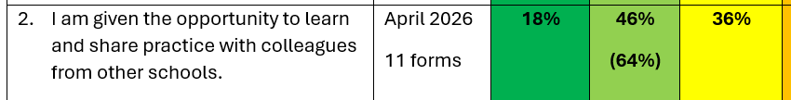  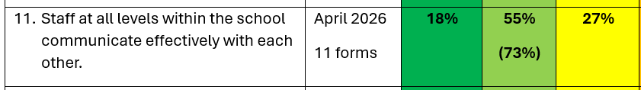  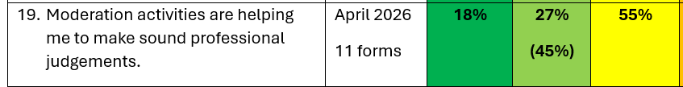  We held a Numeracy Moderation Learning Day with Mauchline PS colleagues in May 2026 and staff feedback highlighted it was successful, with stage partnerships created, resources shared, visits arranged and adaptions to practice discussed. Further sessions will be planned.  We will also continue with our Learner Exchange Programme, started in May 2026 where 2 x P7 pupils from both Catrine and Mauchline PS visited the other school and spent the morning in the P7 classroom. |  |  |  |  | All teaching staff  SLT  SLT to organise  Teaching staff  P7 teachers  P7 pupils |  | Timetabled moderation sessions throughout session  HMIE questionnaires to be completed in April 2027 and results compared to assess progress  Writing moderation sessions with Mauchline PS colleagues to be organised  Discussions around questions to be asked during visits – May 2026 visit centred around Inclusive Classroom Checklist and Excellent Lesson priorities  Possibility of more than 2 x pupils being involved at each stage to be discussed |  |  | Termly focus  May 2027 in-service  May 2027

Our Wellbeing and Belonging: Improvement priority: to improve children’s mental wellbeing and embed our approaches to equity and inclusion
Rationale – to continue to ensure all pupils are reaching their full individual potential by focusing on their mental, physical and emotional wellbeing by using a variety of strategies and resources, focusing more on the data they provide and using this data to continue to put supports in place, with parental involvement and engagement, if required

NIF key drivers: | Performance information |  |  | School & ELC improvement |  |  |  | Parent/carer involvement & engagement |  |  | Select driver
HGIOS4 QIs: | 3.1 |  | 2.4 |  | 1.5 |  |  | 3.3 |  | Select QI |  |  | Select QI
ESIP key priorities: | N Our Leadership |  |  | N Teaching & Learning |  |  |  | N Our attainment
Outcomes for our learners  - what do we want to improve/change?  - who is the target group?  - by how much?  - by when? |  | Our actions/Approaches/Interventions  - what are we going to do?  - how are we going to do it? |  |  |  | PEF  Tick row if it’s PEF-related | Who  Who will lead this work? |  | Measures  - how will we measure this?  - what ongoing information will demonstrate progress?  - what does “better” look like?  - how will we recognise better when we see it? |  |  | Review/milestones  - monthly?  - termly?  - on track to meet deadlines/targets?
Maintain our focus on pupil wellbeing through analysing PASS survey data collected |  | All stages to complete PASS surveys with every child in November 2026 and April 2027, as per school assessment calendar  Data to be analysed and areas of concern to be addressed at both individual and class level, informing SLT of any concerns  Teaching staff to use data to deliver informed HWB lessons in their class |  |  |  |  | Teaching staff  SLT |  | Professional discussions re data collected  Map any trends/consistent areas of success/concern and create whole school plan to celebrate/address these |  |  | November 2026  April 2027  Staff analysis with SLT in the months following PASS survey completion
Continue with whole school staff involvement in Keeping the Promise training to ensure CE pupils are fully included and supported |  | Whole staff attended training in October 2026 delivered by Catriona O’Neill, and completed follow up online modules  Next step in gaining KTP training to be completed |  |  |  |  | SLT  All staff |  | To continue to support our care experienced pupils and ensure all staff have the appropriate strategies to ensure consistency in approach |  |  | October 2026  in-service
To support staff to write SMART targets in ASN paperwork to ensure pupil learning plans are a practical, working document  To ensure all staff members are aware of strategies to use when dealing with dysregulated pupils in class and outside  To promote confidence in all staff when dealing with dysregulated pupils |  | DHT, as ASN coordinator, will liaise with Educational Psychologist (EP) to deliver staff training on SMART targets and ensuring an inclusive environment  Staff collegiate nights to be timetabled to include nurture review with EP to ensure a whole school approach to supporting dysregulated pupils |  |  |  |  | DHT  Teaching staff  Support staff |  | ASN paperwork will continue to be completed timeously, with all required information being included and updated  Improved staff confidence when supporting dysregulated pupils and increased staff awareness of strategies |  |  | From September 2026 onwards
Continue to focus on attendance using the EAC Attendance tracker and updated PAR dates |  | Improved attendance last year in most stages will be built upon, with particular children highlighted early and tracked closely  PAR reviews will take place every four weeks instead of every six weeks which will ensure a closer watch on attendance statistics and patterns  Parents/carers of pupils with attendance concerns will be contacted sooner by SLT to address issues and present solutions to improve attendance  Attendance information will continue to be shared at staff meetings and with the wider school community at assemblies and on GLOW blogs/app |  |  |  |  | HT  Mrs Robertson (Clerical)  HT  Mrs Robertson  Parents/carers  All teaching staff  Pupils |  | Improved attendance at all stages  Raising focus level from 90% to 92%  Improved parental understanding of the negative impacts of absence on progress and attainment |  |  | PAR dates from EAC  After every PAR date

Our Attainment, Destinations and Achievements: Improvement priority: to introduce and embed Metaskills at all stages
Catrine PS Rationale – to continue to embed GL Assessments as part of our Assessment Overview to allow for more focused interpretation of pupil attainment data to inform next steps. To introduce Metaskills across all stages to promote lifelong learning and the ease of using learned skills in different curricular and wider curricular areas confidently.

NIF key drivers: | Curriculum & assessment |  |  | School & ELC improvement |  |  |  | Select driver |  |  | Select driver
HGIOS4 QIs: | 2.2 |  | 3.1 |  | 3.2 |  |  | 3.3 |  | Select QI |  |  | Select QI
ESIP key priorities: | N Our Leadership |  |  | N Teaching & Learning |  |  |  | N Our Wellbeing
Outcomes for our learners  - what do we want to improve/change?  - who is the target group?  - by how much?  - by when? |  | Our actions/Approaches/Interventions  - what are we going to do?  - how are we going to do it? |  |  |  | PEF  Tick row if it’s PEF-related | Who  Who will lead this work? |  | Measures  - how will we measure this?  - what ongoing information will demonstrate progress?  - what does “better” look like?  - how will we recognise better when we see it? |  |  | Review/milestones  - monthly?  - termly?  - on track to meet deadlines/targets?
To introduce all pupils and wider Catrine community to Metaskills, their importance and their impact |  | Weekly reinforcement at assembly  Sharing of Metaskills language on school GLOW blog and app to ensure parental understanding  Creation of displays in school to link Metaskills to lessons being taught  Links to Metaskills in termly overviews  Class displays based on The Catrine Wheel so that Metaskills can be discussed in class during specific lessons to highlight skills being used |  |  |  |  | All teaching staff  Classroom Assistants  SLT |  |           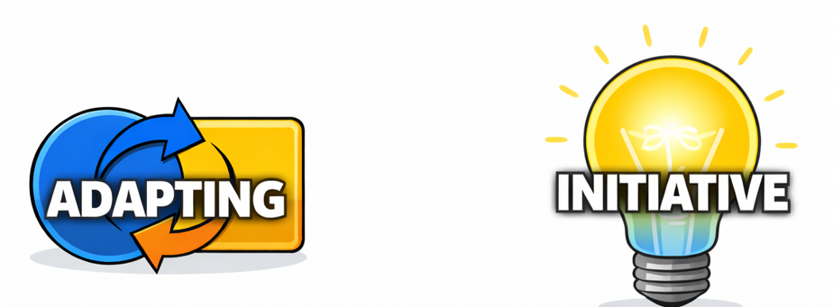  Collation of Metaskills covered during Discovery Dens session and audit of pupil feedback |  |  | Weekly verbal audit at assembly  BIG question focus during Home Circles in January 2027  BIG question focus for parents at April 2027 Parents Night
Improve professional use of pupil attainment data provided by GL Assessments and SNSA assessments to inform future targets |  | Incorporate regular moderation activities in collegiate calendar throughout session to ensure time for professional discussions based on GL Assessments and SNSA assessments to maintain consistency of approach and understanding  Plan for cross stage professional discussions, both in school and with partner establishments, to encourage sharing of good practice amongst colleagues and consistent moderation standards and expectations |  |  |  |  | All teaching staff  SLT  Mauchline PS staff  SLT |  | Improved and increased staff understanding of assessment data  Increased application of pupil data to inform next steps, recorded in Tracking and Monitoring paperwork  Strengthened collegiate links with establishment staff, visits arranged between establishments to share and view good practice, sharing of professional documents and results to promote professional discussion |  |  | From September onwards in collegiate calendar  May 2027 in-service focus
Improve individual pupil target sharing with parents/carers by establishing digital pupil profiles for P3-P7 and creating and sharing paper profiles for P1 and P2 pupils |  | To continue embedding Education Scotland digital pupil profiles for P3 – P7, started last session  To share profiles with parents/carers via open afternoon sessions and videos/SWAYS on GLOW blog and app  To encourage parents/carers/pupils to upload evidence of achievement on pupil profiles regularly  To create a paper profile for infant pupils and ensure they are completed and shared termly with parents/carers to promote discussion and increase parental understanding of targets and attainment |  |  |  |  | All teaching staff  Classroom Assistants  SLT |  | 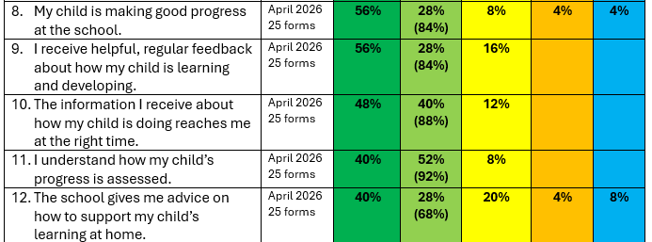  Improved parental questionnaire scores from April 2026 results:  Strongly agree/agree  Q8: my child is making good progress at school - 84%  Q9: I receive helpful, regular feedback about how my child is learning and developing – 84%  Q10: the information I receive about how my child is doing reaches me at the right time – 88% |  |  | Complete parental HMIE questionnaires in November 2026 and again in May 2027 to compare results and plan next steps

Our Leadership: Improvement priority: To continue to encourage, support and promote leadership at all levels within the centre.
Rationale – Care Inspectorate, EAC Quality Improvement Officers and feedback from parents have all highlighted our drive for improvement and praised our opportunities for individual leadership across the centre through Champion/Leadership roles. We aim to continue this empowering ethos within Catrine ECC, documenting our journey, collecting and analysing our data and reflecting upon practice through continuous self-evaluation and ambition.
NIF key drivers: | School & ELC leadership |  |  | Teacher & practitioner professionalism |  |  |  | Performance information |  |  | Select driver
QF ELC: | 1.1 |  | 1.2 |  | 1.3 |  |  | Select QI |  | Select QI |  |  | Select QI
ESIP key priorities: | N Teaching & Learning |  |  |  |  |  |  | N Our Wellbeing |  |  | N Our attainment
Outcomes for our learners  - What do we want to improve/change?  - Who is the target group?  - By how much?  - By when? |  | Our actions/Approaches/Interventions  - What are we going to do?  - How are we going to do it? |  |  |  | PEF  Tick row if it’s PEF-related | Who  Who will lead this work? |  | Measures  - How will we measure this?  - What ongoing information will demonstrate progress?  - What does “better” look like?  - How will we recognise better when we see it? |  |  | Review/milestones  - Monthly?  - Termly?  - On track to meet deadlines/targets?
By June 2027 for full staff team to have a better working knowledge and understanding of the Curriculum Improvement Cycle (CIC) |  | SLT to attend training being offered by the authority  SLT to keep updated with Education Scotland documentation and curricular updates in relation to the changes and the new Know-Do-Understand approach through the hub  SLT to provide support and guidance in the implementation of the new draft curriculum design being published this year  Staff team to receive EAC input during in-service day in August 2026 |  |  |  |  | SLT |  | Increased and improved SLT and staff confidence  Confident and frequent use of the new language  Possible changes to how we track children’s progress, achievements and next steps  “Big Ideas” visible throughout ECC  Deeper conceptual learning  Improved Self-evaluation and Monitoring programmes which provide relevant data to inform next steps |  |  | Ongoing from August 2026 with frequent reviews after training, during staff meetings and whilst carrying out self-evaluation tasks using the QIF
Language, Communication and Inclusion  By June 2027 we aim to have improved children’s speech, language and communication scores from their baseline data collected in September 2026. |  | Continue to ensure children requiring additional support with speech and language receive this universal support inhouse (communication sessions) – in particular around listening, attention and speech clarity  Continue to replenish visuals regularly, based on the individual needs of each new cohort of children  Introduce a home link specific to children within the targeted support groups for speech and language  Source further Makaton training for lead practitioner to share and embed further across the centre  All staff to be actively using Makaton in everyday experiences to go alongside language for all children, making it universal and inclusive  For Makaton bags/resources to be introduced and used by the Village playroom (new name for 3-5 areas)  For Makaton videos to continue to be uploaded to Learning Journals as a way to support learning at home |  |  |  |  | Leoni Comm Champ  Julie T Makaton Champ |  | ICan trackers  Communication cohort groups on Learning Journals to track  Individual improvements on narratives within weekly communication folder  Evidence of collaborative work with SALT including calls for advice to NHS helpline and RFA submissions  Children and staff actively using visuals on a daily basis  Children and staff actively using Makaton regularly  Children more confident in communicating in a variety of ways  Reduction in emotional dysregulation due to less frustration |  |  | Termly from August 2026
To have registered for the National STEM award by October 2026  To have created a detailed action plan in relation to the award by December 2026 |  | Make use of and plan to hire the Coalfield buses to help support World or Work Week next year to enhance more real-life experiences  Introduce Minecraft Education to the children and staff  Child leadership focus group using technology (Minecraft) to encourage exploration, learning and sharing to peers  Focus on Maths outcomes for parent workshop through Science, Technology and Engineering experiences  Audit and order new resources, if required  Attend any relevant training to support the award application |  |  |  |  | Sherrie  (STEM Champ)  Sherrie, SELCP and DM to drive buses |  | Logs/number of bus hires and destinations  PEF records for finance  Evidence of working with other agencies (fire/ police/local shops/vets)  Increases in real life opportunities to explore different job roles (session 25-26, 2 volunteers to the ECC)  Confidence in children leading learning  Confidence in peers using digital technology  An increase (currently 65% for 2025-26) in the maths coverage across the curriculum  Progress on the action plan towards our STEM award |  |  | Termly from August 2026
To further develop children’s creativity, curiosity and confidence through Expressive Arts |  | Developing music, dance and movement both indoors and out  Create a stage area for dancing/ performing which can be part of our continuous provision  Random Acts of Kindness in the community, creating artwork and delivering, giving out flowers in the community  To drive forward the importance of Nursery Rhymes in the early years and the benefits it can have in both EXA and literacy skills |  |  |  |  | Carrie (EXA Champ) |  | Improved confidence in expressing themselves  Improved coordination  Improved skills and ability to be part of an audience  Increased links with the community  Catrine Values being demonstrated  Improved listening and attention in groups  An increased knowledge of songs and rhymes  An improvement in individual trackers for understanding of rhythm, rhyme and alliteration |  |  | Termly from August 2026

Teaching and Learning Together: Improvement priority: To support and encourage children to be fully involved in how we teach our curriculum
Rationale – We want to ensure that our children and families feel part of our learning environment and that their voices are valued and respected.
We aim to improve upon our consultation with service users and how we document these views.

NIF key drivers: | Parent/carer involvement & engagement |  |  | Curriculum & assessment |  |  |  | School & ELC improvement |  |  | Select driver
QF ELC: | 1.3 |  | 2.1 |  | 3.1 |  |  | 3.2 |  | 4.2 |  |  | 4.3
ESIP key priorities: | N Our Leadership |  |  |  |  |  |  | N Our Wellbeing |  |  | N Our attainment
Outcomes for our learners  - what do we want to improve/change?  - who is the target group?  - by how much?  - by when? |  | Our actions/Approaches/Interventions  - what are we going to do?  - how are we going to do it? |  |  |  | PEF  Tick row if it’s PEF-related | Who  Who will lead this work? |  | Measures  - how will we measure this?  - what ongoing information will demonstrate progress?  - what does “better” look like?  - how will we recognise better when we see it? |  |  | Review/milestones  - monthly?  - termly?  - on track to meet deadlines/targets?
By October 2026 we want to have the final version of our Excellent Experience ready to start using for monitoring purposes |  | Consult with parents for their ideas and share staff suggestions to date  Consult with children for their ideas of what makes an Excellent Experience  Create final poster and display  Adapt playroom monitoring sheets to reflect this new idea  SLT to begin to use as working document  Create a child friendly monitoring sheet to which they can “monitor” if the experience was excellent  Link monitoring to SIP |  |  |  |  | SLT |  | Evidence of parent and child engagement/ consultation  Some children will be able to discuss the quality of experiences on offer  SLT will use new format to monitor playroom performance  ELCPs and SAs will have a clear understanding of what an Excellent Experience should look like, making monitoring procedures more transparent |  |  | Termly from August 2026, with consultations taking place in Term 1
By June 2027 for preschool children to have a better understanding of concepts and skills which sit within each curricular area |  | In Term 1, staff to ask children what they think might sit under each area  Create a visual curricular wall  Staff to use the language of the curricular areas and skills being developed more frequently during learning experiences to help develop understanding and knowledge  Staff/children to add to the walls through both visual and written descriptions to create a learning wall which children can build upon and refer to  In June 2027, children to be asked the same questions again to see progression and depth in knowledge |  |  |  |  | All staff and children |  | Children will show a better understanding of what some of the curricular areas contain and how learning about these can help us  Display boards and children’s ideas will show progression and a depth in learning over the year  WOWs  Group time posts  Tracking and monitoring progression  Mind maps  Improved and increased confidence in skills and learning |  |  | Termly from August 2026
By December 2026 clear displays should be evidenced around the centre ensuring service users feel listened to, valued, respected and validated |  | Children’s voices, opinions and views should be made more visible across the centre promoting personalisation, choice, consultation, views, opinions and preferences  Monthly focuses should be well planned for, meaningful and displayed in various ways both in the centre and online for parents to see  Parents views will be asked for and displayed, actioning any changes that may be required following this feedback |  |  |  |  | Julie N  (Children’s Voices Champ) |  | Accountability for monthly additions to displays around the centre showcasing meaningful and impactful voices, views, opinions and consultation  Children’s voices highlighted in leadership floorbook |  |  | Monthly from August 2026
By December 2027 to have both our Voes and 3-5 (Village) landscape areas improved with more engagement and better developed areas in the outdoors. This will support continuous provision in the outdoors and engagement in these spaces |  | Outdoors  Child consultation in relation to what they want in their outdoor area  Voes – to continue to work on developing the space and replenishing areas/resources.  3-5 Area (newly named as The Village) – to purchase new large resources and develop the landscape area making it more stimulating and set up more for continuous provision learning  An audit of resources to be carried out  New resources purchased, concentrating on bigger items to define areas  Risk assessments completed and shared for any new equipment |  |  |  |  | SLT  Michelle (Outdoor Champ)  All ECC staff |  | Evidence of child consultation and ideas for new resources, areas and defined spaces  PEF budget spend  Evaluation on PEF impact  Before and after photos/ displays  Outdoor champion leadership floorbook evidence and impact  Children voices  More children accessing outdoors  Less dysregulated behaviour  Less accidents and incidents in the outdoors areas  An improvement in engagement outdoors  Risk assessments  Evidence of ECC budget  Learning journal evidence in the outdoor areas |  |  | Termly from August 2026

Our Wellbeing and Belonging: Improvement priority: To focus on the wellbeing of our children and further embed our approaches to equity and inclusion
Rationale – Due to the rising numbers of children requiring additional support (ASN) and high levels of emotional dysregulation across both the authority and Scotland, we feel it is important to ensure all service users are aware of coping strategies, the services that can support and to ensure that intervention is early and personalised to each child, family and/staff member.
Each year a new cohort of families come through our doors and it is important to acknowledge that different challenges/barriers may become a focus/priority this year.
NIF key drivers: | Parent/carer involvement & engagement |  |  | Curriculum & assessment |  |  |  | School & ELC improvement |  |  | Teacher & practitioner professionalism
QF ELC: | 1.2 |  | 4.1 |  | 4.2 |  |  | 4.3 |  | Select QI |  |  | Select QI
ESIP key priorities: | N Our Leadership |  |  | N Teaching & Learning |  |  |  | N Our attainment
Outcomes for our learners  - what do we want to improve/change?  - who is the target group?  - by how much?  - by when? |  | Our actions/Approaches/Interventions  - what are we going to do?  - how are we going to do it? |  |  |  | PEF  Tick row if it’s PEF-related | Who  Who will lead this work? |  | Measures  - how will we measure this?  - what ongoing information will demonstrate progress?  - what does “better” look like?  - how will we recognise better when we see it? |  |  | Review/milestones  - monthly?  - termly?  - on track to meet deadlines/targets?
Health, wellbeing and inclusion  By June 2027 to have improved the wellbeing scores of a targeted group of children (baseline will be determined by September 2026) |  | Score children daily, work together on a fish diagram to determine the possible root causes, and begin to make informed changes through the use, knowledge and understanding of Quality Improvement methods through regular PDSA  Specifically planned opportunities for families to join us with children who have additional support needs and feel that they can be relaxed in an environment with other parents who are in the same circumstance and may understand. Aiming to offer a network of support, build and solidify relationships/friendships offering experiences that are safe and suitable for needs.  To reduce noise levels within our lunchroom to create a more inclusive environment for all  Ensure all playrooms and outdoor spaces are inclusive for all physically, developmentally and emotionally |  |  |  |  | SLT  SELCP (HWB Champ) |  | Daily wellbeing scores  Run charts  PDSA  Professional dialogue  Moderation tasks  Feedback from parent/carers of children with ASN  A quieter and more nurturing environment for lunch  Inclusive experiences for all  Confident children  A reduction in incidents  Tracking and monitoring on Learning Journals  Clear differentiation, personalisation and choice  Communication friendly environments  Evidence of multiagency working  My Plans  Ayrshare records  TWTF paperwork  Appropriate and timely RFA |  |  | Ongoing throughout the year with changes being made using quality improvement methods, when appropriate
UNCRC  By April 2027 to have achieved our Silver Award |  | To continue to work through our action plan with enthusiasm and drive to achieve  More use of our action plan as a working document to keep us on track and moving forward  To attend training in August 2026 led by Emma Williamson in-house  Following training to reflect upon action plan and add to this if necessary  Accountability by UNCRC champ to ensure an article of the month is promoted  To submit and achieve an application for our silver award  To give parents more information on the UNCRC to increase feedback scores  To complete further Module and Training on The Promise |  |  |  |  | Rena (UNCRC Champ) |  | Completed modules of The Promise  Our Silver Award granted  More information to parent/ carers and children about the articles and what they mean for our service users  Displays  Service user contributions  Parent/carer engagement  Parent/carer feedback forms  More confidence in staffs’ working knowledge of children’s rights  More visible evidence through planning across all playrooms  CPD evaluation/impact forms |  |  | Monthly from August 2026
By September 2026 for all children identified with communication concerns (in particular ASD) to have a SCERTS assessment started |  | 3 x ELCP have had training on SCERTS and will continue to use knowledge gained to support children with social and communication difficulties  Each identified child will be assessed using the tool  Targets will be made and shared with all staff to ensure consistency  Targets will be evaluated regularly and new ones set to ensure continuous progress and achievement  Staff will continue to attend further training and seek advice when required from SALT colleagues, in particular Christine Barr |  |  |  |  | Julie N  Julie T  SELCP  SLT |  | Evidence of individual SCERTS targets and reviews  Professional dialogue  Round The Table professional discussions  Tracking and monitoring  Learning Journal entries  An increase in staff confidence using the assessment tool  Evidence of CPD evaluations and impact |  |  | Termly from August 2026
From August 2026 we will focus on eliminating the pressures and expectations for children and families of those who may not yet be in a room according to their age |  | Rename our 3-5 playroom as The Village  (2 year old room is known as The Voes)  The rationale behind this is to take away any stigma from either of the rooms in relation to ages, making it more about developmental stages as opposed to chronological age for children in different playrooms |  |  |  |  | All ECC staff |  | New signs on doors/ registers  New wording on GLOW posts, Learning Journals and our ECC APP  Staff will no longer refer to rooms in age groups  Families of children with ASN will feel more respected and included due to equity approaches |  |  | By September 2026 this should be embedded

Our Attainment, Destinations and Achievements: Improvement priority: To raise the attainment of our learners through improved individualised timing of target setting and streamlining assessments and professional judgement.
Rationale – Through recent SLT monitoring and proof reading of transition reports, tracking and monitoring and targets, it was highlighted that some staff judgements/assessment criteria differ in relation to attainment and achievement.
As a centre we need to agree on coding for tracking, what needing challenged looks like and ensure that numeracy opportunities are widely available across all areas of the ECC.
NIF key drivers: | School & ELC leadership |  |  | Teacher & practitioner professionalism |  |  |  | Curriculum & assessment |  |  | Performance information
QF ELC: | 1.1 |  | 1.2 |  | 1.3 |  |  | 3.2 |  | 4.3 |  |  | Select QI
ESIP key priorities: | N Our Leadership |  |  | N Teaching & Learning |  |  |  | N Our Wellbeing
Outcomes for our learners  - what do we want to improve/change?  - who is the target group?  - by how much?  - by when? |  | Our actions/Approaches/Interventions  - what are we going to do?  - how are we going to do it? |  |  |  | PEF  Tick row if it’s PEF-related | Who  Who will lead this work? |  | Measures  - how will we measure this?  - what ongoing information will demonstrate progress?  - what does “better” look like?  - how will we recognise better when we see it? |  |  | Review/milestones  - monthly?  - termly?  - on track to meet deadlines/targets?
Moderation  We aim to ensure that all staff track and assess using the same expectations and criteria |  | Moderation consultation on what each level looks like  Moderation tasks both inhouse and with another ECC  Moderation tasks to ensure each of the below are consistent  - Transition reports  - PLPs  - Tracking and monitoring  - Expectations from targets  - Other assessments such as Teaching Talking and wellbeing scores |  |  |  |  | SLT |  | Professional discussions with other EAC colleagues  Professional discussions inhouse between staff team  Tracking and monitoring on Learning Journals  Round The Table tasks  Quality Improvement data  Keyworkers will agree with more professional judgements from other staff members  All staff will be more consistent in their terminology when report writing and when determining if a child is beginning to, making good progress or achieving within outcomes and levels |  |  | Biannually in line with Quality Improvement calendar
From August 2026 our youngest learners within The Voes playroom will access a broader curriculum covering more E & O |  | A new planning tile to be set up for the Voes playroom for session 26-27  This tile should now be used as a working document during planning, tracking coverage of the curriculum and Realising the Ambition: Being Me |  |  |  |  | SLT and Voes ELCP |  | Breadth and depth of learning will be more apparent across our Being Me curriculum |  |  | Monthly
Staff will become more proactive in relation to children’s individual stages of development |  | Currently, some staff still update and set new targets for keyworker children termly.  From now on, all staff will be encouraged and supported to set new targets for keyworker children when required and in the moment, when previous target is achieved. This will ensure that each child is being challenged and pushed to reach their full potential whilst in the ECC at a rate that is right for them. |  |  |  |  | Key-workers |  | Next steps/targets on individual Learning Journals  Children will become more confident within the centre  Keyworkers will be more aware of where each child is developmentally  Children will show higher levels of progression across the curriculum  Children’s attainment will rise |  |  | In the moment keyworker reviews  Termly SLT monitoring of reviews
When tracking coverage of planned experiences in session 2025-26, SLT were required to highlight the gaps in maths outcomes used by the end of term 2.  Although a lot of these are covered through targeted work and group times, it was felt that more could be visible thought the playrooms and continuous provision. |  | Early in Term 1 staff will audit rooms/areas in relation to maths/numeracy  New resources to be purchased  Staff to continue to use the planning tile during planning meetings to ensure maths is considered more  Look for further training on maths via the Gateway and Education Scotland websites  Visit other ECCs to refresh best practice in relation to maths  Continue to develop areas/experiences across the centre |  |  |  |  | SLT  All ECC staff |  | An increase in maths outcomes will be covered across planning cycles  More children will achieve E & O across maths  Children will become more confident in aspects of maths and numeracy  Maths will be more evident across the centre both in adult led planning and continuous provision  Every area and room will have maths opportunities |  |  | Monthly across planning  Termly within staff monitoring  Termly Learning journals and target/next step monitoring

2024-25 baseline |  |  |  |  |  | 2025-26 targets |  |  |  |  |  | 2025-26 actual
 | Reading | Writing | L&T | Literacy | Numeracy |  | Reading | Writing | L&T | Literacy | Numeracy |  | Reading | Writing | L&T | Literacy | Numeracy
P1 |  |  |  |  |  | P1 | 78% | 78% | 78% | 78% | 56% | P1 | 71% | 71% | 88% | 71% | 71%
P2 | 75% | 75% | 88% | 75% | 75% | P2 | 75% | 75% | 88% | 75% | 75% | P2 | 82% | 69% | 94% | 69% | 69%
P3 | 94% | 94% | 94% | 94% | 94% | P3 | 94% | 94% | 94% | 94% | 94% | P3 | 100% | 95% | 95% | 95% | 100%
P4 | 76% | 65% | 100% | 65% | 88% | P4 | 71% | 65% | 100% | 65% | 88% | P4 | 94% | 94% | 100% | 94% | 100%
P5 | 71% | 65% | 82% | 65% | 65% | P5 | 71% | 65% | 82% | 65% | 65% | P5 | 65% | 59% | 82% | 59% | 59%
P6 | 67% | 47% | 73% | 47% | 67% | P6 | 67% | 47% | 73% | 47% | 67% | P6 | 62% | 44% | 69% | 44% | 62%
P7 | 57% | 52% | 81% | 52% | 52% | P7 | 57% | 52% | 81% | 52% | 52% | P7 | 77% | 57% | 81% | 57% | 67%

Reading | P1 | P2 | P3 | P4 | P5 | P6 | P7 |  | Writing | P1 | P2 | P3 | P4 | P5 | P6 | P7 |  | L&T | P1 | P2 | P3 | P4 | P5 | P6 | P7 |  | Numeracy | P1 | P2 | P3 | P4 | P5 | P6 | P7
P1 |  |  |  |  |  |  |  |  | P1 |  |  |  |  |  |  |  |  | P1 |  |  |  |  |  |  |  |  | P1
P2 |  |  |  |  |  |  |  |  | P2 |  |  |  |  |  |  |  |  | P2 |  |  |  |  |  |  |  |  | P2
P3 |  |  |  |  |  |  |  |  | P3 |  |  |  |  |  |  |  |  | P3 |  |  |  |  |  |  |  |  | P3
P4 |  |  |  |  |  |  |  |  | P4 |  |  |  |  |  |  |  |  | P4 |  |  |  |  |  |  |  |  | P4
P5 |  |  |  |  |  |  |  |  | P5 |  |  |  |  |  |  |  |  | P5 |  |  |  |  |  |  |  |  | P5
P6 |  |  |  |  |  |  |  |  | P6 |  |  |  |  |  |  |  |  | P6 |  |  |  |  |  |  |  |  | P6
P7 |  |  |  |  |  |  |  |  | P7 |  |  |  |  |  |  |  |  | P7 |  |  |  |  |  |  |  |  | P7

Catrine PS and Catrine ECC – Session 2026/27
Summary of Improvement Plan directly linking to Education Service Improvement Plan
Our Leadership | Teaching and Learning Together
PS  Staff roles and responsibilities  Embedding of NIWP and NISP programmes  Spelling  Differentiation  ECC  Gaining training and understanding of Scotland’s Curriculum Improvement Cycle  Focus on individual ELCP Leadership roles including family workshops and curriculum development programmes | PS  Our Excellent Lesson  The 4 Capacities  Our Curriculum Rationale  Questionnaire feedback and future actions  Numeracy moderation  ECC  Increased consultation opportunities for children and families  The development of children’s knowledge and understanding of curricular areas
Our wellbeing and belonging | Our Attainment, Destinations and Achievements
PS  PASS Surveys  ASN and SMART targets  ECC  To continue to improve wellbeing scores  To achieve Silver Award in Rights Respecting Schools  To rename our 3-5 playroom to The Village  To ensure SCERTS is used with all identified children | PS  Metaskills  GL Assessments and SNSA interpretation of data  Target setting and sharing  ECC  To carry out moderation tasks to ensure equality  The Voes playroom to track curriculum on new planning tile to ensure breadth across the curriculum  To enhance numeracy opportunities both indoors and out

