Literacy
- Unit Study – ‘The Boy in the Striped Pyjamas’ by John Boyne
- Handwriting – Nelson
- Writing : Expository – Report Writing
- Big Talk

Numeracy
- Measure: Length, Perimeter and Area
- Patterns and Relationships
- Angles, Symmetry and Transformation

Health and Wellbeing
- PE – Sportshall athletics
- Rugby

Social Subjects
- People, Place and Environment – WW2 ( linked to class novel)

Sciences
- Energy sources and sustainability

Expressive Arts
- Drama
- Dance – Social Dancing

RME
- Traditions and Practices – The Christmas Story

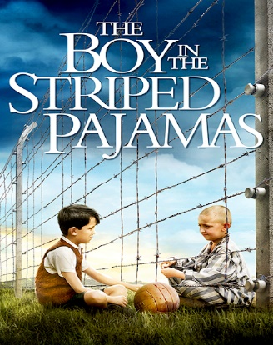
This Photo by Unknown Author is licensed under CC BY

