Literacy
- Active Literacy
- Big Talk : Me and My Family

Numeracy
- Consolidating 0-10 and build numbers 0-20 (and beyond)
- Addition

Health and Wellbeing
- PE : Creative Dance
- Social Dancing
- Attention and Listening Block
- Walking in the Community

Expressive Arts
- Halloween & Bonfire Artwork
- Christmas Crafts
- Christmas Fair Crafts
- Drama and Music : Nativity

Sciences
- Read and Respond “Tiddler” by Julia Donaldson ( underwater creatures)
RME
- Nativity
Modern Languages
- Greetings
Technology/ICT
- Chromebooks – using keyboards.
- Christmas Crafts
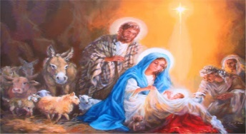
This Photo by Unknown Author is licensed under CC BY-NC-ND

