Literacy
- Active Literacy Spelling
- Writing - Instructions
- Grammar – using conjunctions (and, but, because)
- Big Talk – When I grow up ……...
- Phonics Bug reading books

Numeracy
- Addition and Subtraction
- Length and Area
- Multiplication Masters

Health and Wellbeing
- PE – Fitness based activities/Circuits/ Social Dancing
- Substance Misuse
- What to do in an emergency

Expressive Arts
- Drama - Nativity

Sciences
- Our Body – Body systems and cell inheritance

Technology/ICT
- Food and Textiles – Christmas Crafts
RME
- The Christmas Story
Modern Languages
- French – Body parts
- Similarities and differences between Scotland and France

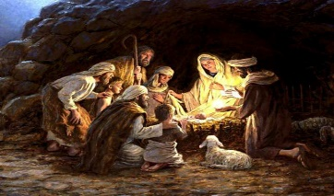
This Photo by Unknown Author is licensed under CC BY-SA-NC

