Literacy
- Active Literacy
- Class Talks
- Writing – using conjunctions to link sentences
- Book Study – ‘The Twits’ by Roald Dahl

Numeracy
- Number Talk and Multiplication Masters
- Multiplication and Division
- Shapes and Tiling

Health and Wellbeing
- Village walks around Catrine.
- Badminton and social dancing with Mrs Phillips
- Substance misuse

Expressive Arts/Social Studies
- Music
- Drama

Social Subjects
- Enterprise for Christmas Fayre
RME
- Values, issues and beliefs
Modern Languages
- French – Counting to 21 and beyond and saying how old you are

Sciences
- Materials
ICT/Technology
- Textiles
- Digital profiles

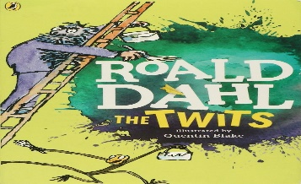
This Photo by Unknown Author is licensed under CC BY-NC-ND

