|  |
| --- |
| **Literacy**   * **Book Study – ‘Holes’ by Louis Sachar** * **Nelson Handwriting** * **Spelling Active Literacy** * **Grammar – Punctuation** |

|  |
| --- |
| **Numeracy**   * **Place value** * **Addition and Subtraction** * **Number Talks** |

|  |
| --- |
| **Health and Wellbeing**   * **Fitness** * **Managing Emotions** |

|  |
| --- |
| **Expressive Arts**   * **Music** |

|  |
| --- |
| **Technology/ICT**   * **Digital Literacy** * **Computing Science** |

|  |
| --- |
| **Modern Languages**   * **French – Greetings, numbers to 50** |

|  |
| --- |
| **Science**   * **Materials and chemical changes** |

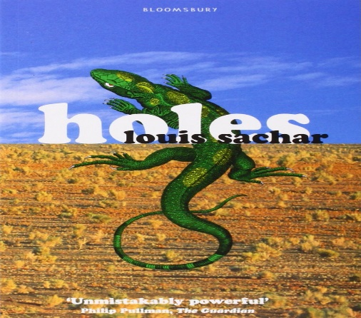

[This Photo](https://www.notesfromtheslushpile.com/2017/01/weather-or-not-quick-guide-to-writing.html) by Unknown Author is licensed under [CC BY-NC-ND](https://creativecommons.org/licenses/by-nc-nd/3.0/)