|  |
| --- |
| **Literacy**   * **Active Literacy Spelling** * **Writing descriptions** * **Bug Club Reading Books** * **Handwriting** |

|  |
| --- |
| **Numeracy**   * **Place Value – numbers to 100 and beyond** * **Estimating and rounding – estimating different quantities to 20** * **Patterns and relationships – recognising and creating patterns using shapes and numbers** |

|  |
| --- |
| **Health and Wellbeing**   * **Developing classroom routines** * **Creating our class charter linked to UNCRC** * **Feelings – comfortable and uncomfortable feelings** * **PE – invasion games – Rugby and Basketball** |

|  |
| --- |
| **Expressive Arts**   * **Music** |

|  |
| --- |
| **Sciences**   * **Forces, Electricity and Waves** |

|  |
| --- |
| **Technology/ICT**   * **Digital literacy – logging on to Chromebooks.** * **Computing science** |

|  |
| --- |
| **Modern Languages**   * **French – saying how we feel.** * **Numbers 1 – 31** * **Items of Clothing** |

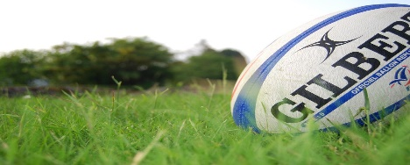

[This Photo](https://www.flickr.com/photos/nwinton/539303432/) by Unknown Author is licensed under [CC BY-NC-ND](https://creativecommons.org/licenses/by-nc-nd/3.0/)