|  |
| --- |
| **Literacy**   * **Active Literacy** * **Descriptive Writing** * **Book Study – ‘The Twits’ by Roald Dahl** |

|  |
| --- |
| **Numeracy**   * **Number Talk and Multiplication Masters** * **Place Value** * **Addition and subtraction** |

|  |
| --- |
| **Health and Wellbeing**   * **Village walks around Catrine.** * **PE with Mrs Phillips** * **Feelings and Emotions** |

|  |
| --- |
| **Expressive Arts/Social Studies**   * **Music** |

**RME**

* **Traditions and Practices**

**Modern Languages**

* **French – meeting and greeting people.**
* **Spelling in French**

**Sciences**

* **Planet Earth**

|  |
| --- |
| **ICT**   * **Digital Literacy** * **Computing Science** |

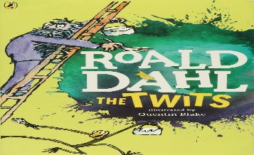

[This Photo](https://mtcrenshaw.blogspot.com/) by Unknown Author is licensed under [CC BY-NC-ND](https://creativecommons.org/licenses/by-nc-nd/3.0/)