
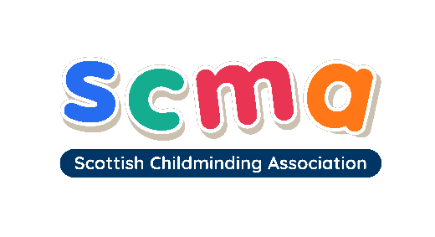

Programme for Scotland’s Childminding Future

Would You Like a Rewarding New Career That Fits Around Your Own Family? Professional Childminders Are Urgently Needed in East Ayrshire.
The Scottish Government has committed funding for a three-year national childminder retention and recruitment programme. ‘The Programme for Scotland’s Childminding Future’ (PSCF) aims to grow the workforce and bring about positive change for childminding. SCMA is proud to be at the forefront of securing and delivering this Scottish Government commitment to childminding and has developed a new model of childminder recruitment which has been successfully piloted in remote and rural and urban local authority areas.

The Scottish Childminding Association is supporting the recruitment and training of new professional childminders in East Ayrshire - identified as having an urgent need for more high-quality, flexible childcare. If you’re looking for a new career that’s flexible and allows you to earn an income while caring for your own family, childminding could be for you!

Childminders come from a wide range of backgrounds and many choose to join the profession to start a new career which combines running a business with caring for their own children. A career in childminding would enable you to:

- work with children and support families in your local community
- have a flexible career that fits around you and caring for your own family
- contribute to children’s development, learning and wellbeing
- run your own business from home
- develop new skills and qualifications
Jackie Madeley recently set up her childminding business through PSCF and is now a professional Childminder in Castle Douglas in Dumfries and Galloway.
“Childminding is so worthwhile. I love that I can plan our days around what the children are interested in and that I can choose the hours I work. To anyone who is passionate about working with children – go for it!”

What Support Is Available In Starting My New Business?
Those who apply and are accepted on to PSCF will be supported every step of the way by a dedicated Workforce Officer who will support you through induction training and the registration process. On completion of registration with the Care Inspectorate and HMRC, new childminders have access to:

- Free induction training
- Continued one-to-one support from a dedicated Workforce Officer, plus your first year of SCMA membership free
- £750* business start-up grant to help with the initial costs associated with setting up your new business from home
- Free start-up package of three childminding-specific training courses

Do I Need Any Previous Qualifications or Childcare Experience?
There are no specific professional qualifications needed but it is essential that you have a passion for working with and supporting the learning and development of children. There will be induction training to complete and an ongoing requirement for completing 12 hours of continued professional learning (CPL) per year to ensure the high quality of your childminding business. All professional childminders are registered with the Care Inspectorate.

I’m Interested – What’s The Next Step?
Visit www.childminding.org/getstarted to register your interest and we will be in touch. If you’d like an informal chat about childminding and whether it could be the career for you, please contact SCMA on 01786 449063 or email Amy.Watt@childminding.org - we’d love to hear from you!

*T&Cs apply. To find out more, please visit www.childminding.org/getstarted

