**P7 Parent/Carer Transition Evening – 26th May 5pm – 7pm**

Dear Parent/Carers,

With August fast approaching we are so excited to welcome our Primary 7 pupils to The Robert Burns Academy. We would like to invite you to a Parent/Carer evening on Monday 26th May from 5pm – 7pm at The Robert Burns Academy. During this evening there will be a short presentation to provide you with information about the school, and arrangements for the new S1s starting in August.

You will be invited to take a tour of the school with some of our current S1 pupils and ‘Lochnorris Ambassadors’ who will ‘meet and greet’ and be your tour guides. During the tour departments will be offering a chance for you to meet staff and take part in taster sessions. Situated in the hub of the school there will be a variety of partners for you to speak to such as: The Campus Police Officer, NEST and The Exchange Counselling Service and our Catering team will be there with food samples. The Guidance Team and I, as S1 Year Head, will also be there to answer any questions you may have.

Moving into June there will be two ‘Bump up Days’ for Primary 7 pupils on the 10th and 11th June. More information will be issued about this soon.

Please scan the QR code below, follow the link and complete the form below if you would like to attend the P7 Parent/Carer Transition Evening on the 26th May.

The form will close on Wednesday 21st May at 3pm.

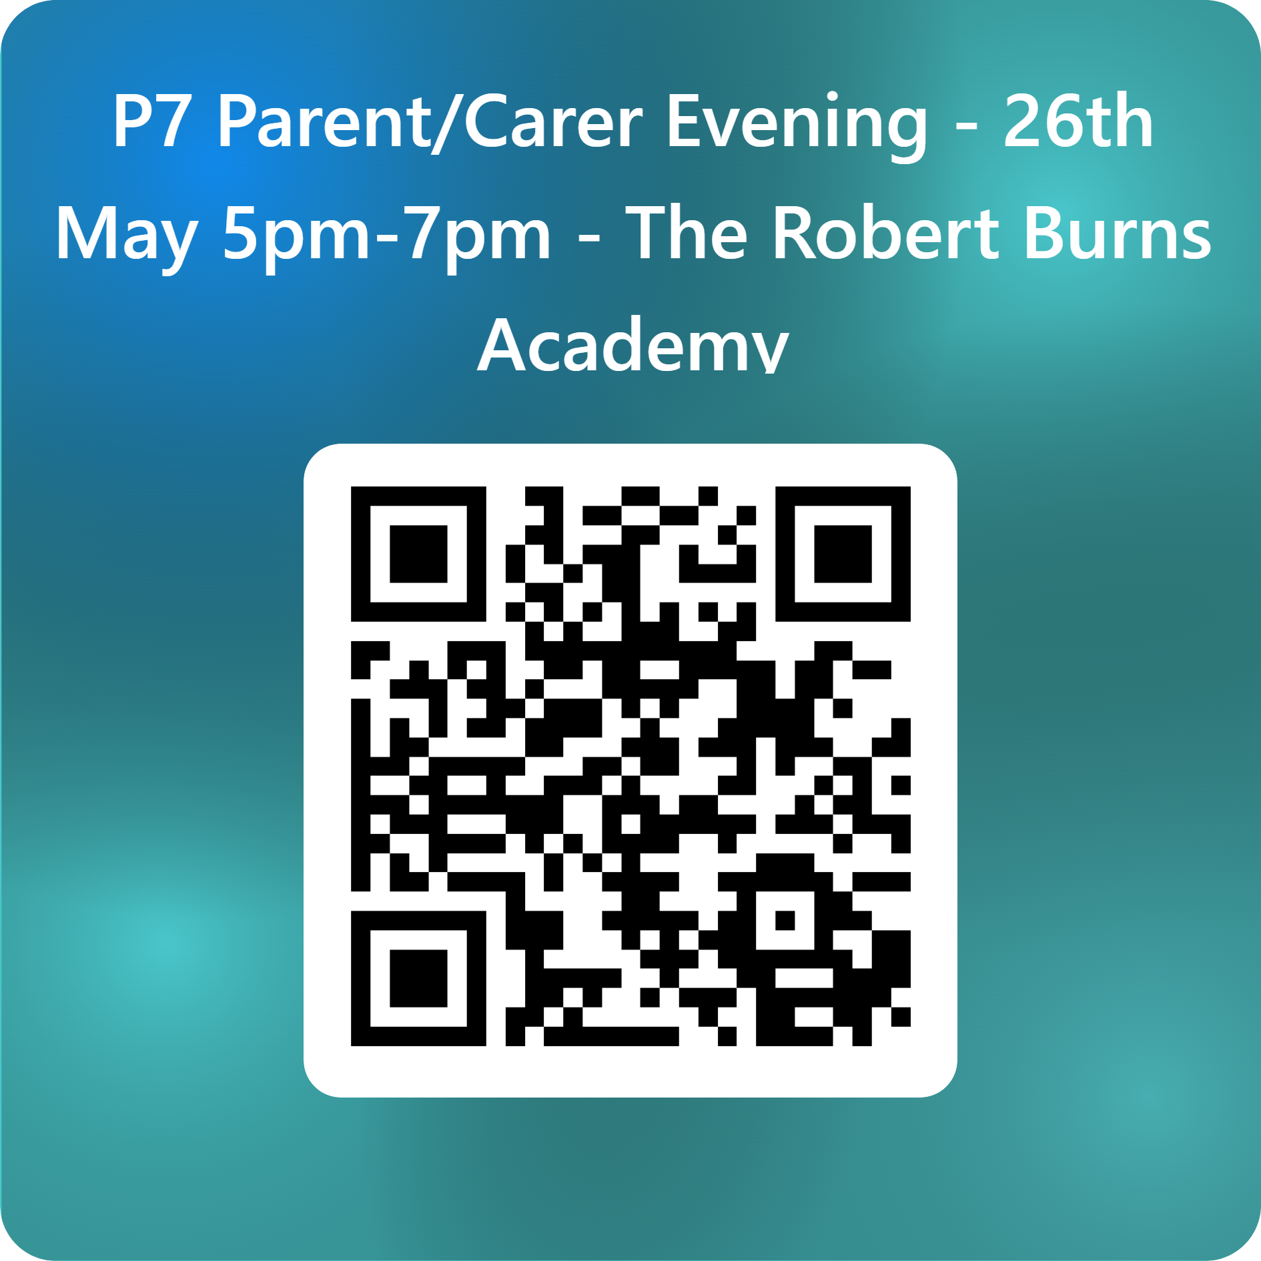

Yours sincerely,



M Anderson

Depute Head Teacher (Year Head S1)

The Robert Burns Academy

Tel: 01290 427280