Literacy
- Persuasive writing
- Debating and expression
- Tools for writing
- Active literacy spelling and grammar

Numeracy
- Fractions
- Time
- Expressions and Equations

Health and Wellbeing
- HWB – Relationships
- Travel Safety
- Exploring feelings and emotions

Expressive Arts
- Drawing and sketching – the landscape around us

Social Subjects
- People, place and environment – Exploring Catrine

Technology/ICT
- Technological Development in Business and Society

Modern Languages
- French – Greetings
- Simple Conversations

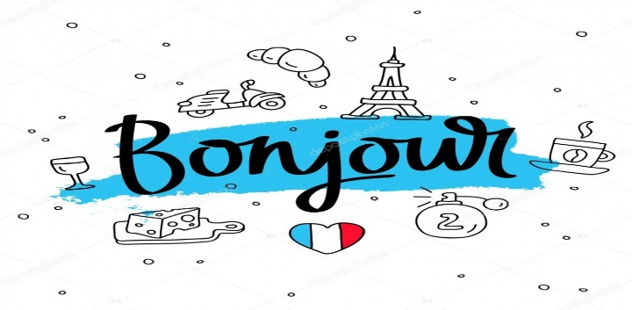
This Photo by Unknown Author is licensed under CC BY

