Dear Parent/Carers,

Primary 7 PE Activities Evening - Wednesday 14th May 2025 - 4pm – 5:30pm

The PE Department are organising an Activities Evening on Wednesday 14th May between 4pm – 5:30pm. This is an opportunity for Primary 7 pupils and parents/carers to attend The Robert Burns Academy to see the PE Department, and take part in a variety of activities. We would love you all to come along and take part!

This event will:

- Promote physical activity and increase pupil and parent/carer awareness of the PE Department
- Allow you to meet various PE staff members and peer mentors
- Give Primary 7 pupils the opportunity to meet pupils from other schools in an informal way
- Encourage pupils and parents/carers to take part in physical activities together
- Allow parent/carers to meet other parent/carers from across the education group
- Get to know the PE department and school layout

Things to bring
- Pupils should bring an adult with them who is willing to take part in the activities
- Pupils and adults should wear comfy clothing and trainers
- A bottle of water to stay hydrated

To sign up to the Primary 7 PE Activities Evening Please scan the QR code below using the camera on your phone, press the link and it will take you to the form to complete.

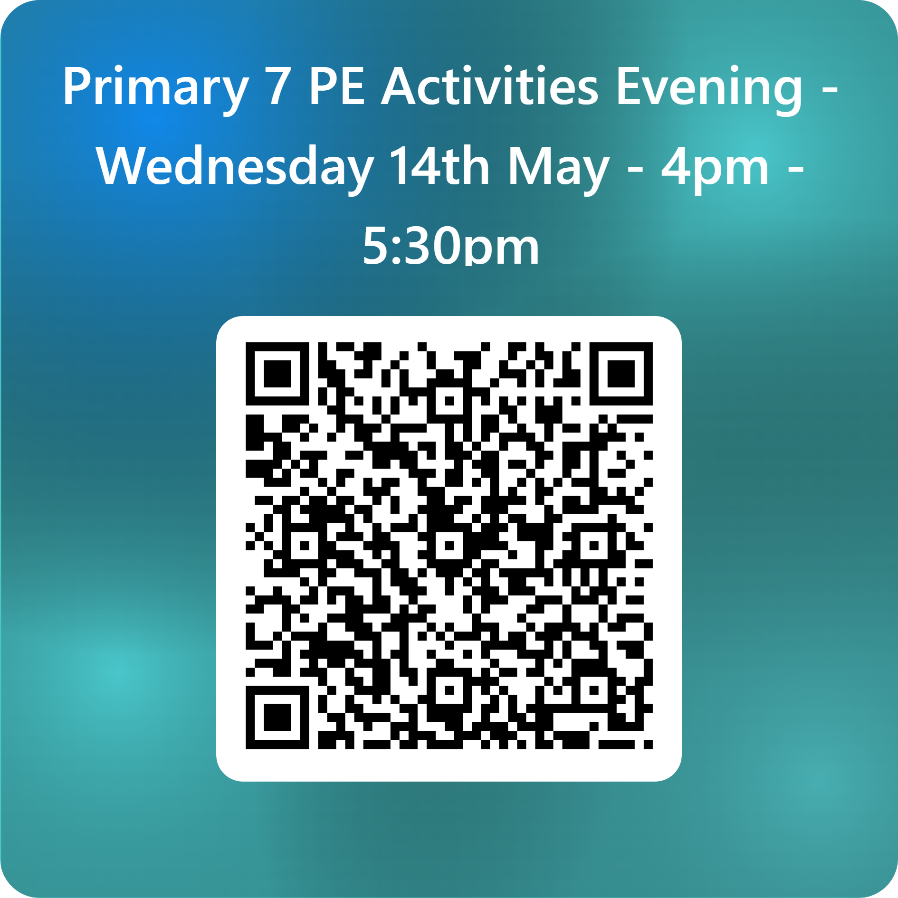

Thank you for your support and I hope to see you all on Thursday 14th May.

Yours Sincerely,

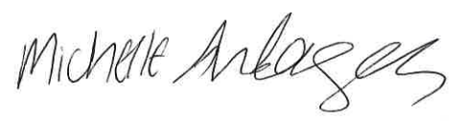
M. Anderson
Depute Head Teacher (S1 Year Head)

Tel: 01290 427280

