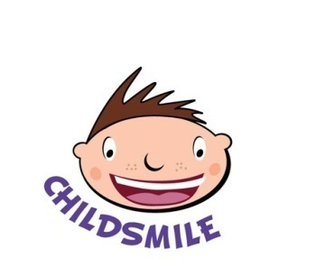

**PRIMARY AND URGENT CARE SERVICES**

Telephone: 01292 616980 Email: [childsmileteam@aapct.scot.nhs.uk](mailto:childsmileteam@aapct.scot.nhs.uk)

Ref: RM/AC

Date: August 2024

**Childsmile Fluoride Varnish Application and Data Protection Statement**

You have been provided with a separate form in which we ask for your consent for your child to have fluoride varnish applied to his or her teeth as part of the Childsmile Fluoride Varnish Programme. This letter simply provides some information about the data gathered by the NHS as part of the Childsmile Fluoride Varnish Programme and what happens to that data.

Specially trained Dental Nurses or Hygienists employed by NHS visit your child’s School or Nursery to apply the varnish to your child’s teeth.

Information provided by you about your child will be used by NHS Ayrshire & Arran to help us ensure your child gets the appropriate treatment at the right time. If your child is not registered with an NHS Dentist we will offer you help finding a Dentist for your child.

NHS staff will send a letter to you if there is anything in your child’s mouth which they think should be seen by a Dentist. To ensure your child gets the help and support they need, when they need it, we may also share information with other services such as education.

NHS Ayrshire & Arran and NHS National Services Scotland (NHS NSS) will use the information gathered to help plan and deliver the Childsmile Fluoride Varnish Programme across Scotland. Occasionally this information will also be used to carry out research so that we can, for example, assess the oral health of Scotland’s children and the effectiveness of the Childsmile Programme. When information is used in this way your child cannot be identified.

Information from your child’s Fluoride Varnish applications will be held in the Childsmile Patient System which stores all information gathered throughout the whole Childsmile Programme. The System is very secure and access to it is strictly controlled. The NHS will make sure that your child’s information is stored safely, stays private and is only accessed by authorised staff. All NHS staff have a legal and contractual duty to keep personal health information secure and confidential and have mandatory training in Data Protection, confidentiality and IT Security.

The legal basis for use of this information by NHS Ayrshire & Arran and NHS NSS is that it is necessary for the purpose of promoting and improving the health of your child and other patients and/or for managing the NHS health care system and services in Scotland.

You have various rights in relation to your child’s information. For further details on this and the period for which the information will be held, please see the Data Protection pages of NHS at and NHS NSS at <https://www.nss.nhs.scot/how-nss-works/data-protection/>

If you have any queries about the Childsmile Programme, please do not hesitate to contact me.

Yours sincerely



Roselyn Murphy Assistant Dental Services Manager

NHS Ayrshire and Arran